Proiect SGBD

anul II

Mujdar milan

**Cuprins**

Cerinta 1. Prezentați pe scurt baza de date (utilitatea ei) 1

Cerinta 2. Realizați diagrama entitate-relație (ERD) 2

Cerinta 3. Pornind de la diagrama entitate-relație realizați diagrama conceptuală a modelului propus 3

Cerinta 4. Implementați în Oracle diagrama conceptuală realizată 4

Cerinta 5. Adăugați informații coerente în tabelele create 14

Cerinta 6. Formulați în limbaj natural o problemă pe care să o rezolvați folosind un subprogram stocat independent care să utilizeze toate cele 3 tipuri de colecții studiate. Apelați subprogramul. 61

Cerinta 7. Formulați în limbaj natural o problemă pe care să o rezolvați folosind un subprogram stocat independent care să utilizeze 2 tipuri diferite de cursoare studiate, unul dintre acestea fiind cursor parametrizat, dependent de celălalt cursor. Apelați subprogramul. 68

Cerinta 8. Formulați în limbaj natural o problemă pe care să o rezolvați folosind un subprogram stocat independent de tip funcție care să utilizeze într-o singură comandă SQL 3 dintre tabelele definite. Definiți minim 2 excepții proprii. Apelați subprogramul astfel încât să evidențiați toate cazurile definite și tratate. 72

Cerinta 9. Formulați în limbaj natural o problemă pe care să o rezolvați folosind un subprogram stocat independent de tip procedură care să utilizeze într-o singură comandă SQL 5 dintre tabelele definite. Tratați toate excepțiile care pot apărea, incluzând excepțiile NO_DATA_FOUND și TOO_MANY_ROWS. Apelați subprogramul astfel încât să evidențiați toate cazurile tratate. 76

Cerinta 10. Definiți un trigger de tip LMD la nivel de comandă. Declanșați trigger-ul. 82

Cerinta 11. Definiți un trigger de tip LMD la nivel de linie. Declanșați trigger-ul. 84

Cerinta 12. Definiți un trigger de tip LDD. Declanșați trigger-ul. 88

Cerinta 13. Definiți un pachet care să conțină toate obiectele definite în cadrul proiectului. 94

Cerinta 14. Definiți un pachet care să includă tipuri de date complexe și obiecte necesare unui flux de acțiuni integrate, specifice bazei de date definite (minim 2 tipuri de date, minim 2 funcții, minim 2 proceduri). 104

# Cerinta 1. Prezentați pe scurt baza de date (utilitatea ei)

Baza de date a unei baze militare este o colectie de informatii despre personalul militar si civil , echipamente si vehicule, precum si despre alte aspecte ale functionarii bazei militare. Scopul principal al bazei de date este de a pastra si gestiona informatiile necesare pentr a asigura functionalitatea eficienta si sigura a bazei militare. Baza de date permite utilizatorilor sa acceseze si sa actualizeze informatii cu usurinta, dar in acelasi timp respecta regulile de confidentialitate si securitate necesara intr-un mediu militar.

Regulile de functionare includ cerintele de securitate ale informatiilor, cerintele de acces si actualizare a informatiilor, precum si cerintele legale pentru gestionarea informatiilor militare. In plus, baza de date trebuie sa aiba o structura clara si coerenta, cu entitati si relatii bine definite, pentru a asigura o utilizare eficienta si precisa a informatiilor aflate la dispozitie.

Practic, baza de date a unei baze militare este un instrument esential pentru gestionarea si asigurarea funcitonalitatii eficiente si sigure a bazei militare, respectand in acelasi timp cerintele de securitate si confidentialitate necesare intr-un mediu militar.

# Cerinta 2. Realizați diagrama entitate-relație (ERD)

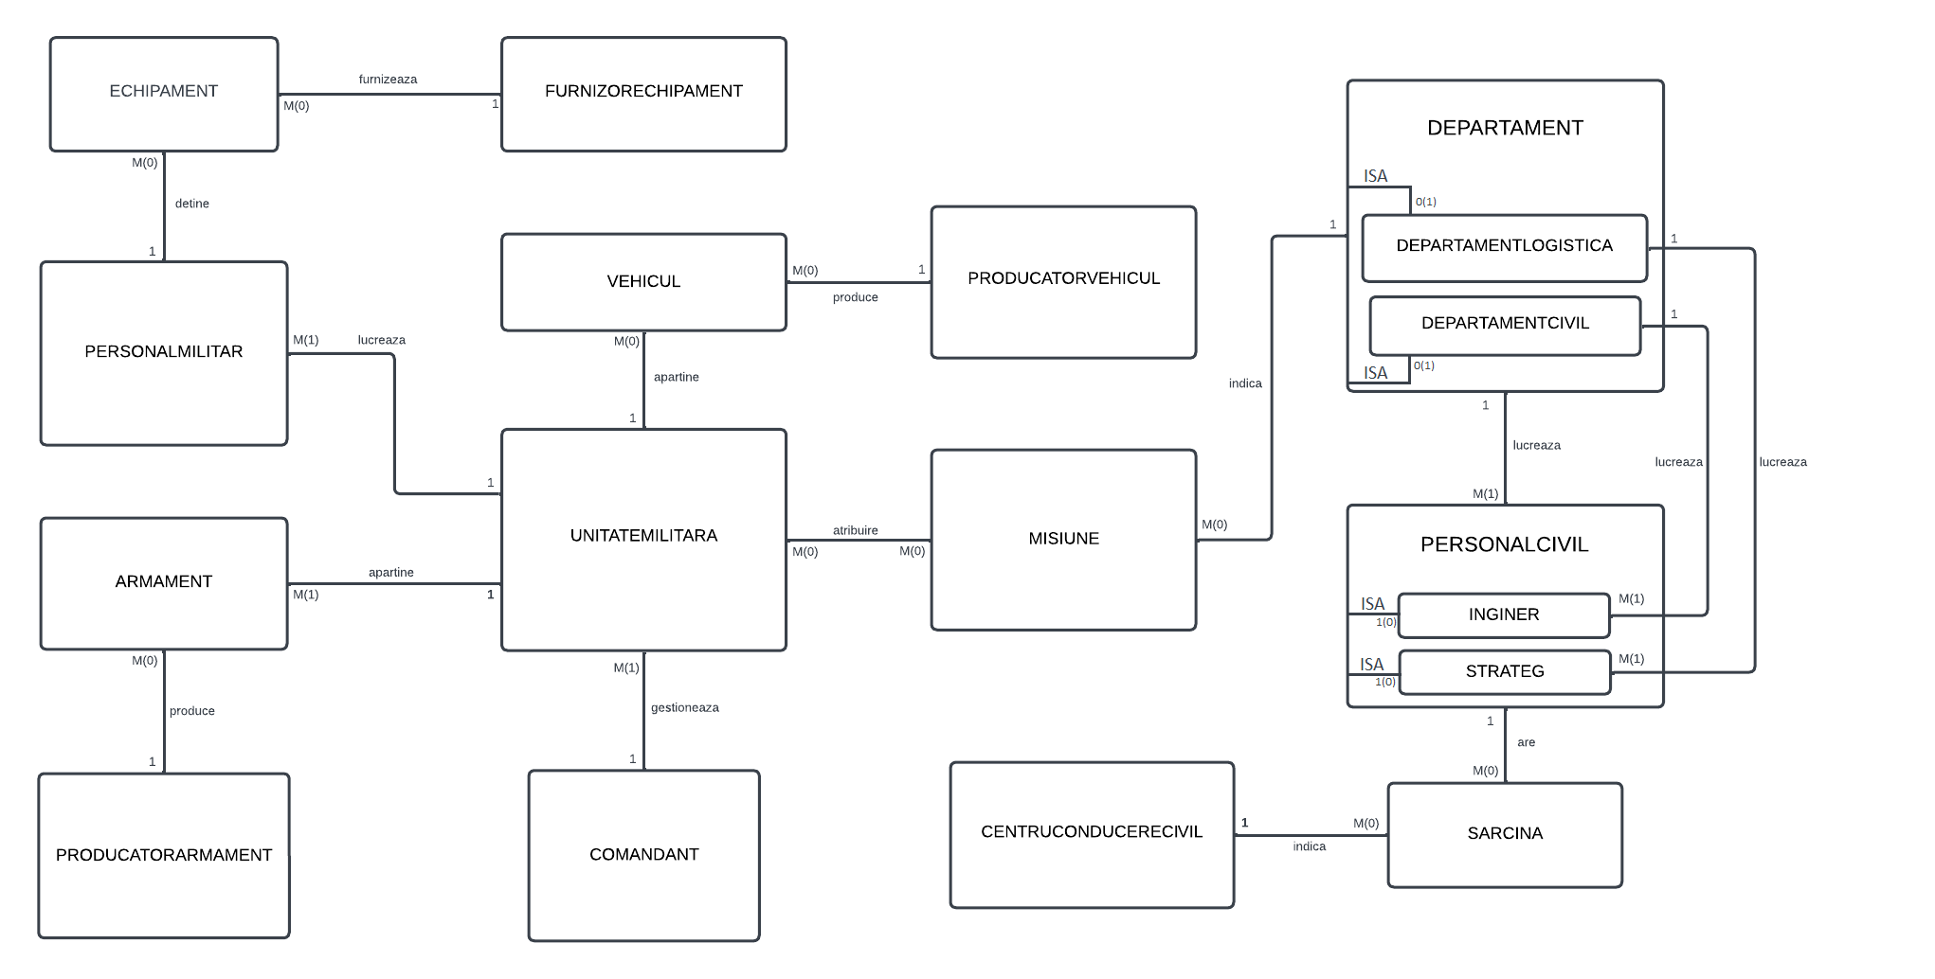

( Posibil sa nu se vada toata imaginea daca fisierul nu este deschis in Word )

# Cerinta 3. Pornind de la diagrama entitate-relație realizați diagrama conceptuală a modelului propus

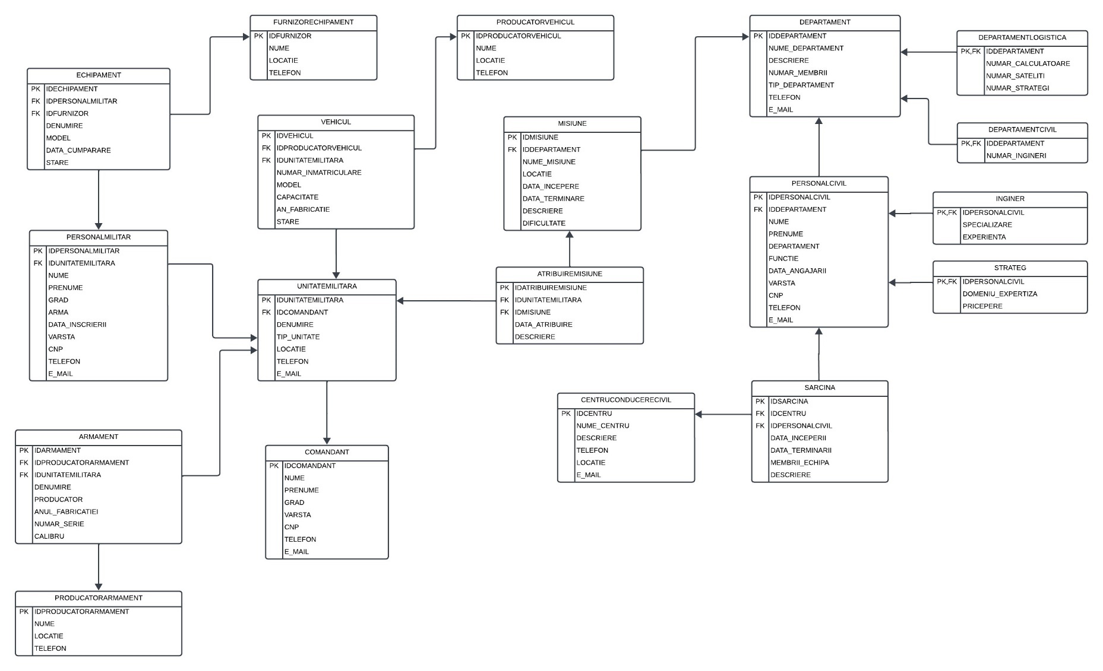

( Posibil sa nu se vada toata imaginea daca fisierul nu este deschis in Word )

# Cerinta 4. Implementați în Oracle diagrama conceptuală realizată

|  |
| --- |
| **create** **table** Comandant (  IDComandant number,  Nume varchar2(**50**),  Prenume varchar2(**50**),  Grad varchar2(**50**),  Varsta number,  CNP varchar2(**13**),  Telefon varchar2(**15**),  E_mail varchar2(**50**),  **constraint** PK_Comandant **primary** **key** (IDComandant),  **constraint** UQ_Comandant_CNP **unique** (CNP),  **constraint** UQ_Comandant_Telefon **unique** (Telefon),  **constraint** UQ_Comandant_Email **unique** (E_mail)  );  **create** **table** UnitateMilitara (  IDUnitateMilitara number,  IDComandant number,  Denumire varchar2(**50**),  Tip_Unitate varchar2(**50**) **default** 'Neprecizat',  Locatie varchar2(**50**),  Telefon varchar2(**15**),  E_mail varchar2(**50**),  **constraint** PK_UnitateMilitara **primary** **key** (IDUnitateMilitara),  **constraint** FK_UnitateMilitara_Comandant **foreign** **key** (IDComandant) **references** Comandant(IDComandant),  **constraint** UQ_UnitateMilitara_Telefon **unique** (Telefon),  **constraint** UQ_UnitateMilitara_Email **unique** (E_mail)  );  **create** **table** PersonalMilitar (  IDPersonalMilitar number,  IDUnitateMilitara number,  Nume varchar2(**50**),  Prenume varchar2(**50**),  Grad varchar2(**50**),  Arma varchar2(**50**),  Data_Inscrierii date,  Varsta number,  CNP varchar2(**13**),  Telefon varchar2(**15**),  E_mail varchar2(**50**),  **constraint** PK_PersonalMilitar **primary** **key** (IDPersonalMilitar),  **constraint** FK_PersonalMilitar_UnitateMilitara **foreign** **key** (IDUnitateMilitara) **references** UnitateMilitara(IDUnitateMilitara),  **constraint** UQ_PersonalMilitar_CNP **unique** (CNP),  **constraint** UQ_PersonalMilitar_Telefon **unique** (Telefon),  **constraint** UQ_PersonalMilitar_Email **unique** (E_mail)  );  **create** **table** FurnizorEchipament (  IDFurnizor number,  Nume varchar(**50**),  Locatie varchar(**50**),  Telefon varchar2(**15**),  **constraint** PK_FurnizorEchipament **primary** **key** (IDFurnizor)  );  **create** **table** Echipament (  IDEchipament number,  IDPersonalMilitar number,  IDFurnizor number,  Denumire varchar2(**50**),  Model varchar2(**50**),  Data_Cumparare date,  Stare varchar2(**30**),  **constraint** PK_Echipament **primary** **key** (IDEchipament),  **constraint** FK_Echipament_IDPerosnalMilitar **foreign** **key** (IDPersonalMilitar) **references** PersonalMilitar(IDPersonalMilitar),  **constraint** FK_Echipament_IDFrunizor **foreign** **key** (IDFurnizor) **references** FurnizorEchipament(IDFurnizor)  );  **create** **table** ProducatorArmament (  IDProducatorArmament number,  Nume varchar2(**50**),  Locatie varchar2(**50**),  Telefon varchar2(**15**),  **constraint** PK_ProducatorArmament **primary** **key** (IDProducatorArmament)  );  **create** **table** Armament (  IDArmament number,  IDProducatorArmament number,  IDUnitateMilitara number,  Denumire varchar2(**50**),  Producator varchar2(**50**),  Anul_Fabricatiei number,  Numar_Serie varchar2(**50**),  Calibru number,  **constraint** PK_Armament **primary** **key** (IDArmament),  **constraint** FK_Armament_ProducatorArmament **foreign** **key** (IDProducatorArmament) **references** ProducatorArmament(IDProducatorArmament),  **constraint** FK_Armament_UnitateMilitara **foreign** **key** (IDUnitateMilitara) **references** UnitateMilitara(IDUnitateMilitara)  );  **create** **table** ProducatorVehicul (  IDProducatorVehicul number,  Nume varchar2(**50**),  Locatie varchar2(**50**),  Telefon varchar2(**15**),  **constraint** PK_ProducatorVehicul **primary** **key** (IDProducatorVehicul)  );  **create** **table** Vehicul (  IDVehicul number,  IDProducatorVehicul number,  IDUnitateMilitara number,  Numar_Inmatriculare varchar2(**30**),  Model varchar2(**50**),  Capacitate number,  An_Fabricatie number,  Stare varchar2(**50**),  **constraint** PK_Vehicul **primary** **key** (IDVehicul),  **constraint** FK_Vehicul_UnitateMilitara **foreign** **key** (IDUnitateMilitara) **references** UnitateMilitara(IDUnitateMilitara),  **constraint** FK_Vehicul_ProducatorVehicul **foreign** **key** (IDProducatorVehicul) **references** ProducatorVehicul(IDProducatorVehicul),  **constraint** UQ_Vehicul_NRInmatriculare **unique** (Numar_Inmatriculare)  );  **create** **table** Departament (  IDDepartament number,  Nume_Departament varchar2(**500**),  Descriere varchar2(**900**),  Numar_Membrii number,  Tip_Departament varchar2(**50**) **default** 'Neprecizat',  Telefon varchar2(**25**),  E_mail varchar2(**80**),  **constraint** PK_Departament **primary** **key** (IDDepartament),  **constraint** UQ_Departament_Telefon **unique** (Telefon),  **constraint** UQ_Departament_Email **unique** (E_mail)  );  **create** **table** DepartamentCivil (  IDDepartament number,  Numar_Ingineri number,  **constraint** PK_DepartamentCivil **primary** **key** ( IDDepartament ),  **constraint** FK_DepartamentCivil_Departament **foreign** **key** ( IDDepartament ) **references** Departament(IDDepartament)  );  **create** **table** DepartamentLogistica (  IDDepartament number,  Numar_Calculatoare number,  Numar_Sateliti number,  Numar_Strategi number,  **constraint** PK_DepartamentLogistica **primary** **key** ( IDDepartament ),  **constraint** FK_DepartamentLogistica_Departament **foreign** **key** ( IDDepartament ) **references** Departament(IDDepartament)  );  **create** **table** Misiune (  IDMisiune number,  IDDepartament number,  Nume_Misiune varchar2(**500**),  Locatie varchar2(**50**),  Data_Incepere date,  Data_Terminare date,  Descriere varchar2(**900**),  Dificultate number,  **constraint** PK_Misiune **primary** **key** (IDMisiune),  **constraint** FK_Misiune_Departament **foreign** **key** (IDDepartament) **references** Departament(IDDepartament)  );  **create** **table** PersonalCivil (  IDPersonalCivil number,  IDDepartament number,  Nume varchar2(**50**),  Prenume varchar2(**50**),  Departament varchar2(**50**),  Functie varchar2(**50**), -- tipul de personal  Data_Angajarii date,  Varsta number,  CNP varchar2(**13**),  Telefon varchar2(**15**),  E_mail varchar2(**50**),  **constraint** PK_PersonalCivil **primary** **key** (IDPersonalCivil),  **constraint** FK_PersonalCivil_Departament **foreign** **key** (IDDepartament) **references** Departament(IDDepartament),  **constraint** UQ_PersonalCivil_CNP **unique** (CNP),  **constraint** UQ_PersonalCivil_Telefon **unique** (Telefon),  **constraint** UQ_PersonalCivil_Email **unique** (E_mail),  **constraint** CK_PersonalCivil_Tip **check** ( **lower**(Functie) **in** ('inginer','strateg') )  );  **create** **table** Inginer (  IDPersonalCivil number,  Specializare varchar2(**100**),  Experienta number,  **constraint** PK_Inginer **primary** **key** (IDPersonalCivil),  **constraint** FK_Inginer_PersonalCivil **foreign** **key** (IDPersonalCivil) **references** PersonalCivil(IDPersonalCivil)  );  **create** **table** Strateg (  IDPersonalCivil number,  Domeniu_Expertiza varchar2(**100**),  Pricepere number,  **constraint** PK_Strateg **primary** **key** (IDPersonalCivil),  **constraint** FK_Strateg_PersonalCivil **foreign** **key** (IDPersonalCivil) **references** PersonalCivil(IDPersonalCivil)  );  **create** **table** CentruConducereCivil (  IDCentru number,  Nume_Centru varchar2(**50**),  Descriere varchar2(**500**),  Telefon varchar2(**15**),  Locatie varchar2(**50**),  E_mail varchar2(**50**),  **constraint** PK_CentruConducereCivil **primary** **key** (IDCentru)  );  **create** **table** Sarcina (  IDSarcina number,  IDCentru number,  IDPersonalCivil number,  Data_Inceperii date,  Data_Terminarii date,  Membrii_Echipa number,  Descriere varchar2(**500**),  **constraint** PK_Sarcina **primary** **key** (IDSarcina),  **constraint** FK_Sarcina_CentruConducereCivil **foreign** **key** (IDCentru) **references** CentruConducereCivil(IDCentru),  **constraint** FK_Sarcina_PersonalCivil **foreign** **key** (IDPersonalCivil) **references** PersonalCivil(IDPersonalCivil)  );  **create** **table** AtribuireMisiune (  IDAtribuireMisiune number,  IDUnitateMilitara number,  IDMisiune number,  Data_Atribuire date,  Descriere varchar2(**500**),  **constraint** PK_AtribuireMisiune **primary** **key** (IDAtribuireMisiune),  **constraint** FK_AtribuireMisiune_UnitateMilitara **foreign** **key** (IDUnitateMilitara) **references** UnitateMilitara(IDUnitateMilitara),  **constraint** FK_AtribuireMisiune_Misiune **foreign** **key** (IDMisiune) **references** Misiune(IDMisiune)  ); |

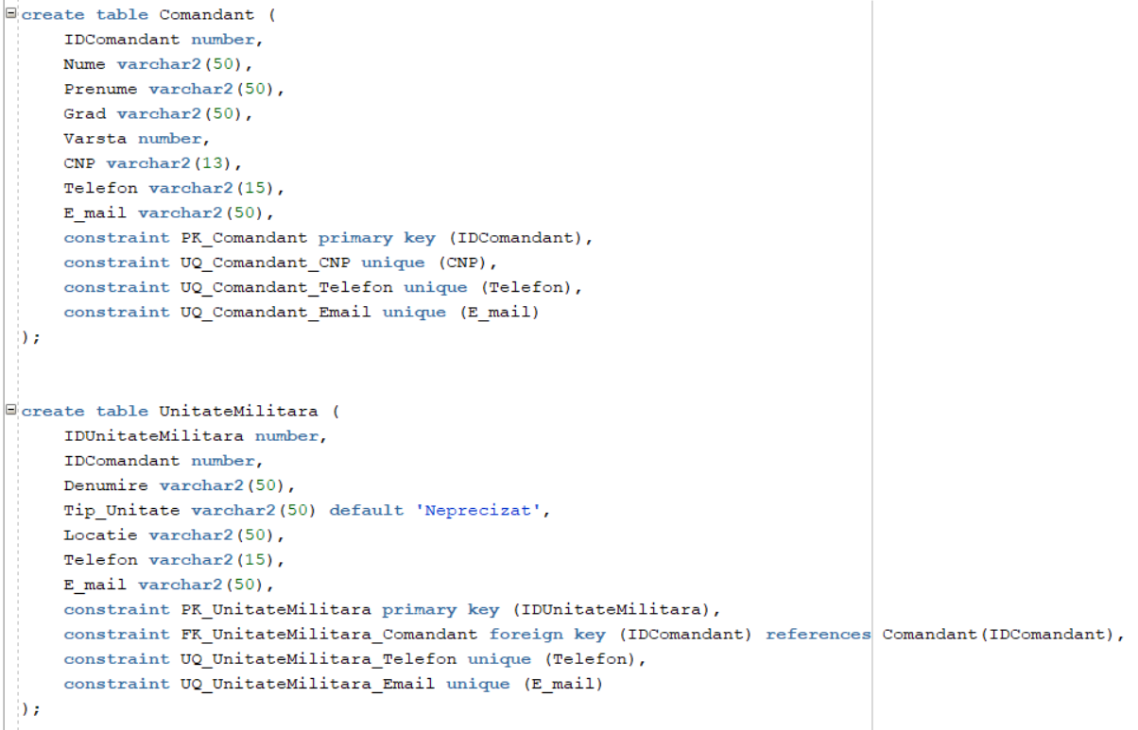

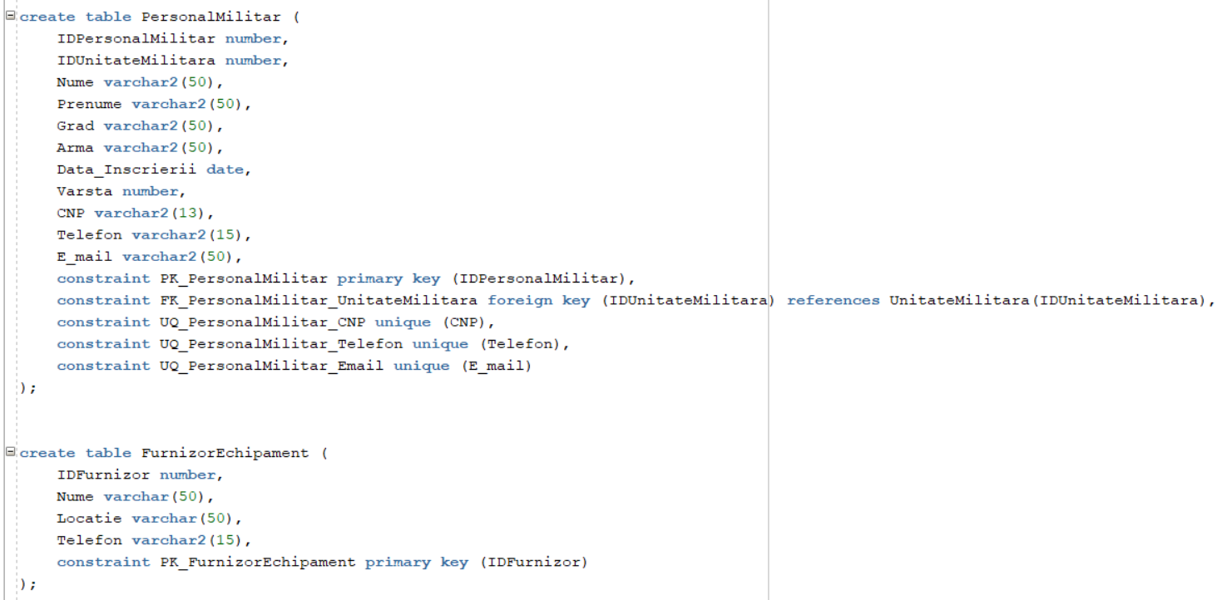

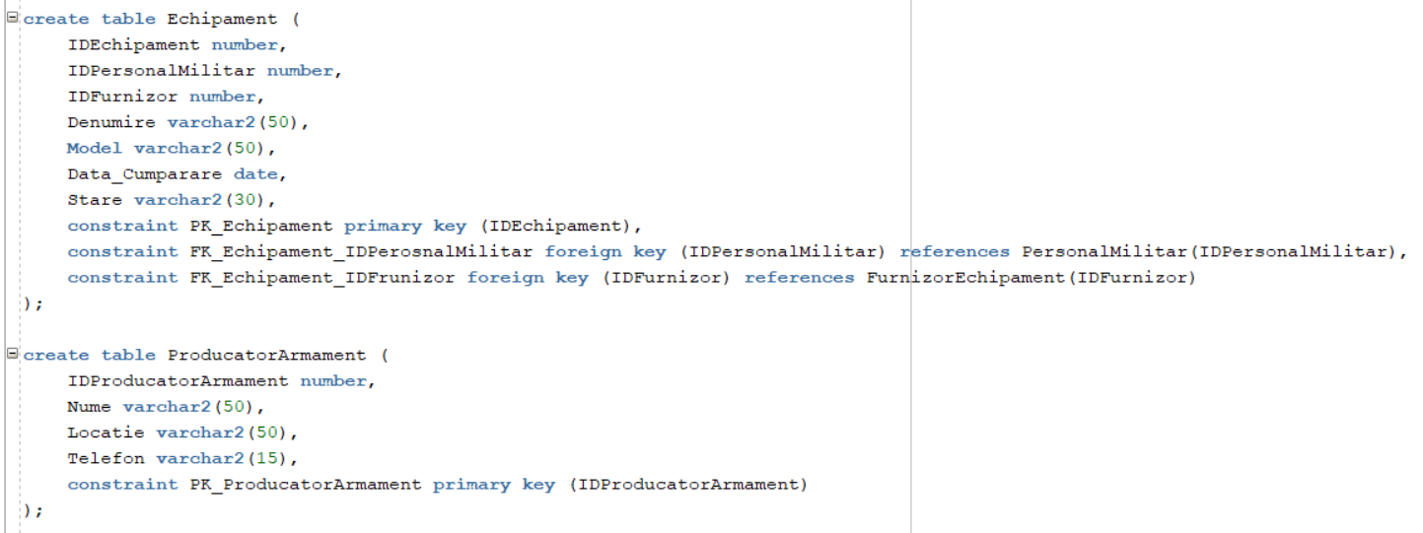

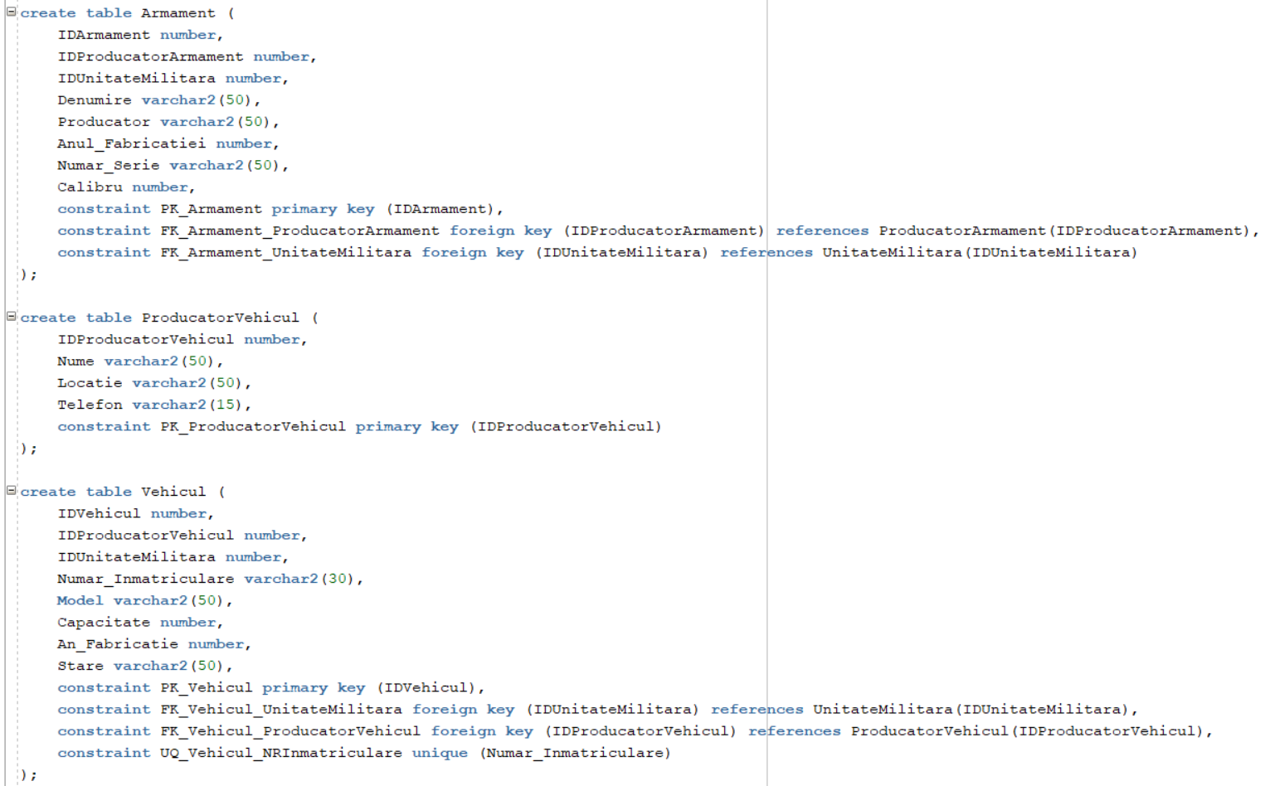

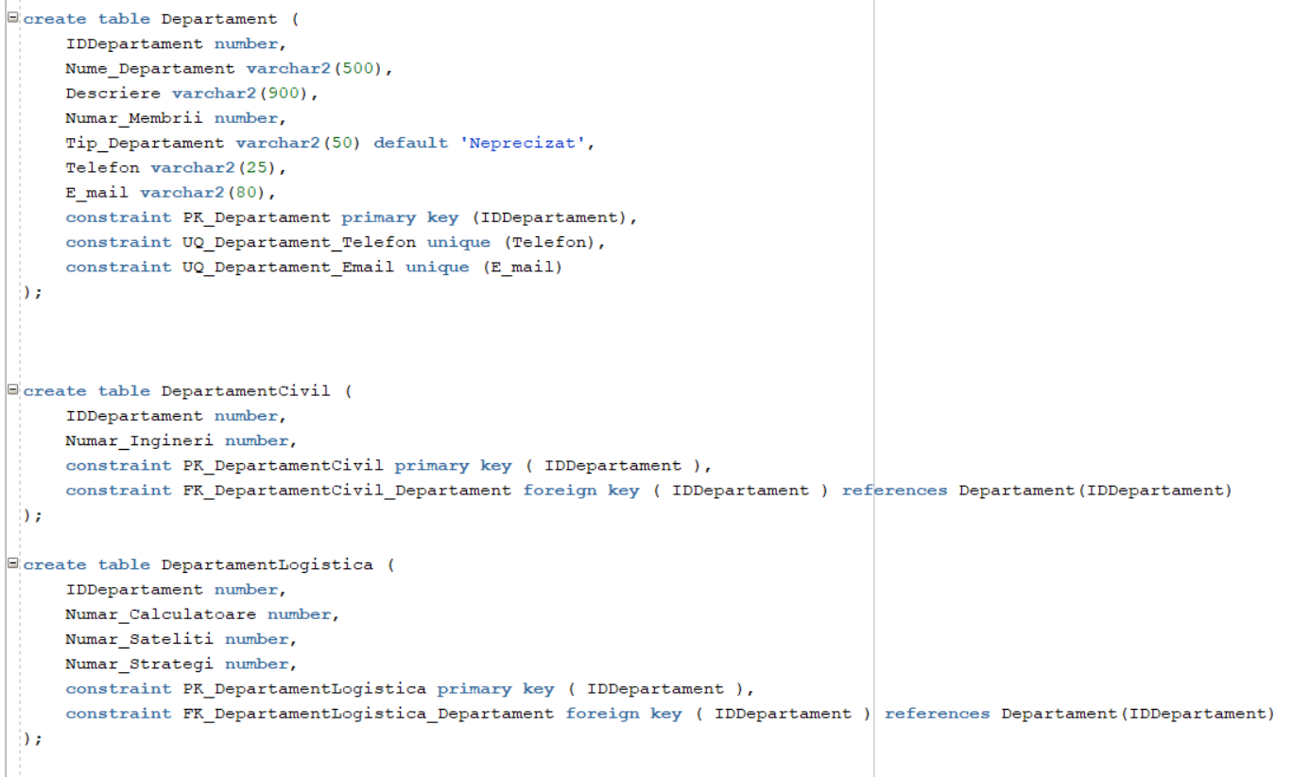

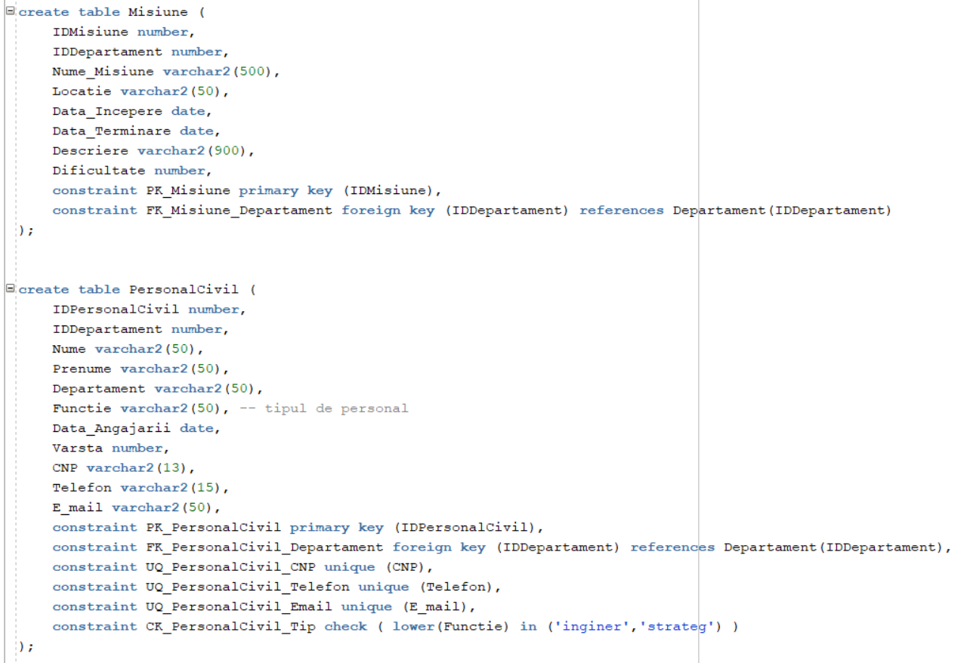

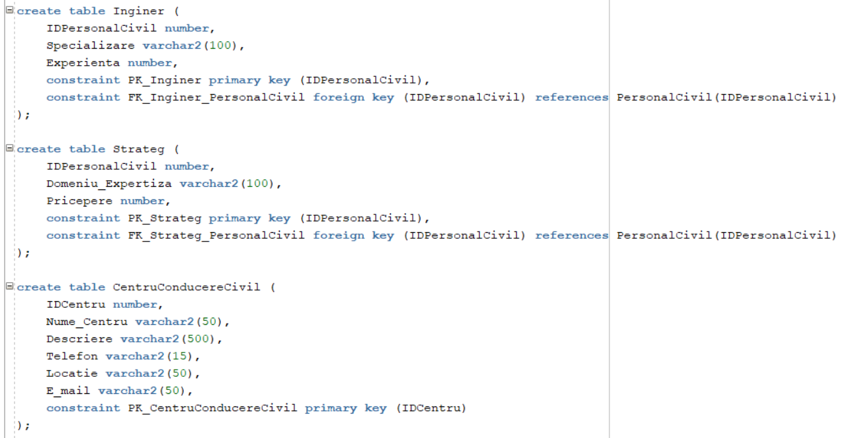

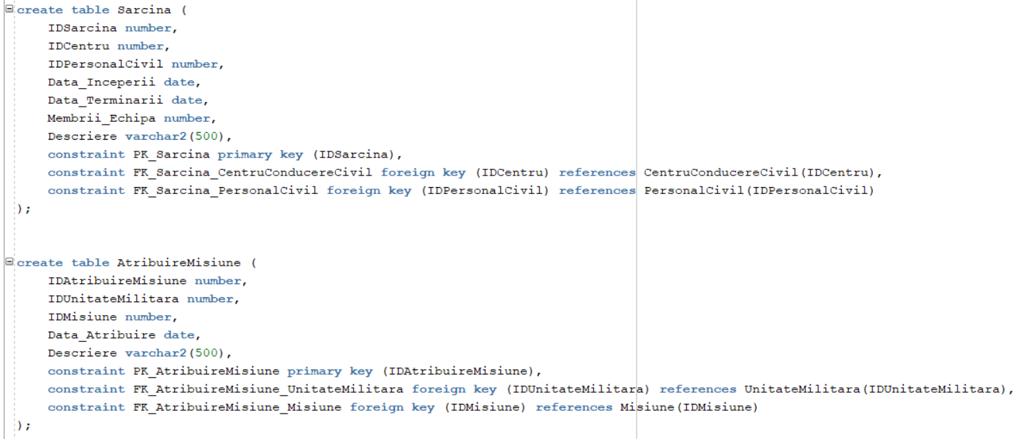

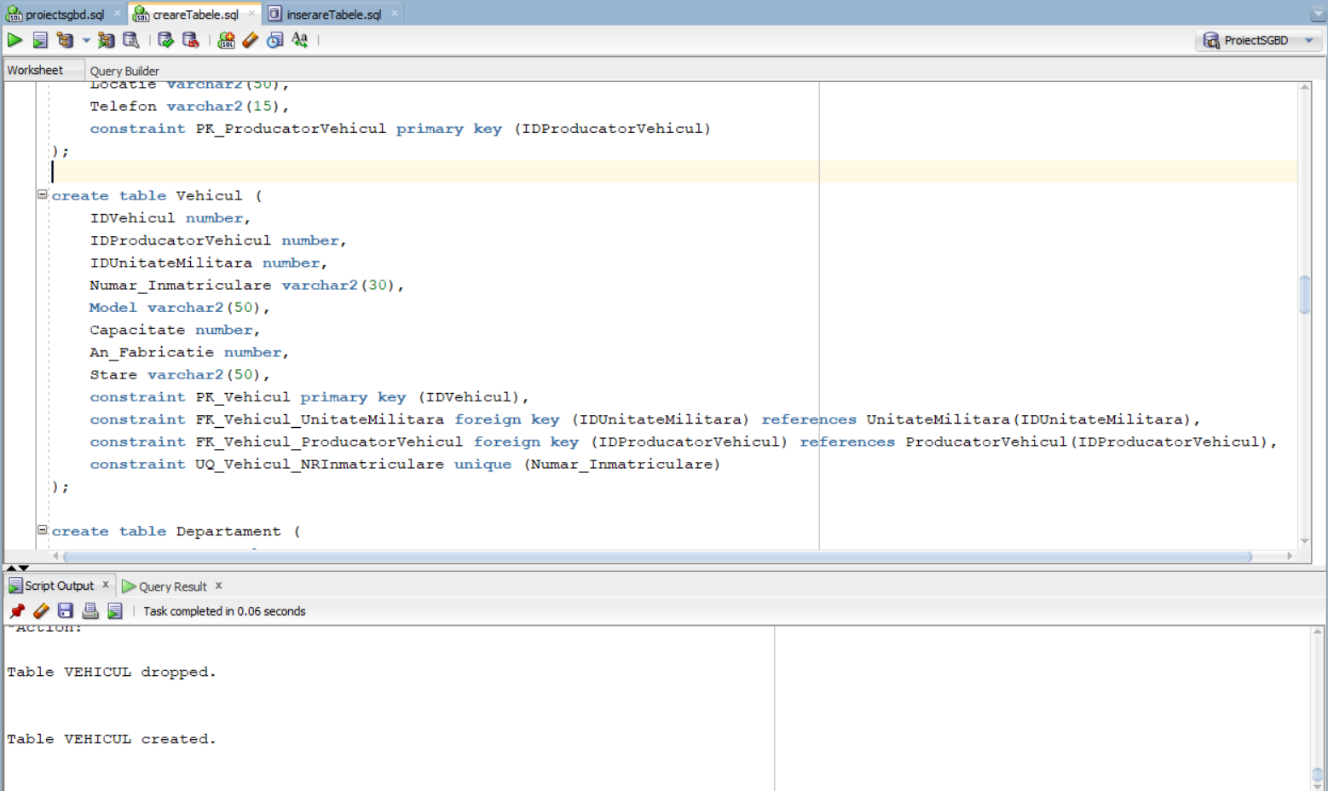

# Cerinta 5. Adăugați informații coerente în tabelele create

|  |
| --- |
| **insert** **into** Comandant(IDComandant,Nume,Prenume,Grad,Varsta,CNP,Telefon,E_mail)  **values** (**1**,'Popescu','Ion','General',**43**,'1800101123456','0712345678','ion.popescu@armata.ro');  **insert** **into** Comandant(IDComandant,Nume,Prenume,Grad,Varsta,CNP,Telefon,E_mail)  **values** (**2**,'Ionescu','Alexandru','Maior',**32**,'1800106123456','0767890123','ionescu.alexandru@armata.ro');  **insert** **into** Comandant(IDComandant,Nume,Prenume,Grad,Varsta,CNP,Telefon,E_mail)  **values** (**4**,'Stoica','Adrian','Sergent',**31**,'1800108123456','0767896144','stoica.adrian@armata.ro');  **insert** **into** Comandant(IDComandant,Nume,Prenume,Grad,Varsta,CNP,Telefon,E_mail)  **values** (**5**,'Moldovan','Ioana','Locotenent',**27**,'2720103123556','0743896154','moldovan.ioana@armata.ro');  **insert** **into** Comandant(IDComandant,Nume,Prenume,Grad,Varsta,CNP,Telefon,E_mail)  **values** (**6**,'Moldovan','Andrei','Caporal',**22**,'1851203143836','0753591499','moldovan.andrei@armata.ro');  **insert** **into** Comandant(IDComandant,Nume,Prenume,Grad,Varsta,CNP,Telefon,E_mail)  **values** (**3**,'Mihai','Dragos','Sergent',**29**,'1751893648837','0754297413','mihai.dragos@armata.ro');  **insert** **into** Comandant(IDComandant,Nume,Prenume,Grad,Varsta,CNP,Telefon,E_mail)  **values** (**7**,'Dumitrescu','David','General',**51**,'1831982177844','0740901822','dumitrescu.david@armata.ro');  **insert** **into** Comandant(IDComandant,Nume,Prenume,Grad,Varsta,CNP,Telefon,E_mail)  **values** (**8**,'Pricop','Dorel','Caporal',**33**,'1841582667813','0742701321','pricop.dorel@armata.ro');  ----------------------------------------------------------------------------------------------------  **insert** **into** UnitateMilitara(IDUnitateMilitara,IDComandant,Tip_Unitate,Telefon,E_mail,Locatie,Denumire)  **values** (**10**,**1**,'Marina','0772819526','marina_constanta@unitate.ro','Coasta Constanta','Fortele Speciale ale Marinei Romaniei');  **insert** **into** UnitateMilitara(IDUnitateMilitara,IDComandant,Tip_Unitate,Telefon,E_mail,Locatie,Denumire)  **values** (**11**,**4**,'Marina','0772819527','marina_sulina@unitate.ro','Coasta Sulina','Fortele Speciale ale Marinei Romaniei');  **insert** **into** UnitateMilitara(IDUnitateMilitara,IDComandant,Tip_Unitate,Telefon,E_mail,Locatie,Denumire)  **values** (**12**,**2**,'Marina','0772819528','marina_vamaveche@unitate.ro','Vama Veche','Fortele Speciale ale Marinei Romaniei');  **insert** **into** UnitateMilitara(IDUnitateMilitara,IDComandant,Tip_Unitate,Telefon,E_mail,Locatie,Denumire)  **values** (**13**,**3**,'Infanterie','0741218772','infanteria_desa@unitate.ro','Desa','Batalionul 107 al Armatei Romane');  **insert** **into** UnitateMilitara(IDUnitateMilitara,IDComandant,Tip_Unitate,Telefon,E_mail,Locatie,Denumire)  **values** (**14**,**3**,'Infanterie','0741218773','infanteria_giurgiu@unitate.ro','Giurgiu','Batalionul 107 al Armatei Romane');  **insert** **into** UnitateMilitara(IDUnitateMilitara,IDComandant,Tip_Unitate,Telefon,E_mail,Locatie,Denumire)  **values** (**15**,**6**,'Infanterie','0741218774','infanteria_calarasi@unitate.ro','Calarasi','Batalionul 107 al Armatei Romane');  **insert** **into** UnitateMilitara(IDUnitateMilitara,IDComandant,Tip_Unitate,Telefon,E_mail,Locatie,Denumire)  **values** (**16**,**7**,'Infanterie','0741218775','infanteria_arad@unitate.ro','Arad','Batalionul 107 al Armatei Romane');  **insert** **into** UnitateMilitara(IDUnitateMilitara,IDComandant,Tip_Unitate,Telefon,E_mail,Locatie,Denumire)  **values** (**17**,**7**,'Artilerie','0345113221','artileria_arad@unitate.ro','Satu Mare','Artileria Beta Nord-Vest RO');  **insert** **into** UnitateMilitara(IDUnitateMilitara,IDComandant,Tip_Unitate,Telefon,E_mail,Locatie,Denumire)  **values** (**18**,**5**,'Artilerie','0345113222','artileria_oradea@unitate.ro','Oradea','Artileria Beta Nord-Vest RO');  **insert** **into** UnitateMilitara(IDUnitateMilitara,IDComandant,Tip_Unitate,Telefon,E_mail,Locatie,Denumire)  **values** (**19**,**8**,'Aeriana','0665128217','aeriana_iasi@unitate.ro','Iasi','Trupele RO-Aeriene EST');  **insert** **into** UnitateMilitara(IDUnitateMilitara,IDComandant,Tip_Unitate,Telefon,E_mail,Locatie,Denumire)  **values** (**20**,**8**,'Aeriana','0665128218','aeriana_bucuresti@unitate.ro','Bucuresti','Trupele RO-Aeriene SUD');  **insert** **into** UnitateMilitara(IDUnitateMilitara,IDComandant,Tip_Unitate,Telefon,E_mail,Locatie,Denumire)  **values** (**21**,**7**,'Forte Speciale','0241003923','fortespeciale_maramures@unitate.ro','Maramures','Diviza Nokk a Armatei Romane');  **insert** **into** UnitateMilitara(IDUnitateMilitara,IDComandant,Tip_Unitate,Telefon,E_mail,Locatie,Denumire)  **values** (**22**,**8**,'Forte Speciale','0241003924','fortespeciale_suceava@unitate.ro','Suceava','Diviza Nokk a Armatei Romane');  ----------------------------------------------------------------------------------------------------  **insert** **into** ProducatorVehicul(IDProducatorVehicul,Nume,Locatie,Telefon)  **values** (**1**,'Lockheed Martin Corporation','SUA','55512345678');  **insert** **into** ProducatorVehicul(IDProducatorVehicul,Nume,Locatie,Telefon)  **values** (**2**,'General Dynamics Corporation','SUA','55512332100');  **insert** **into** ProducatorVehicul(IDProducatorVehicul,Nume,Locatie,Telefon)  **values** (**3**,'BAE Systems plc','Regatul Unit','27312341171');  **insert** **into** ProducatorVehicul(IDProducatorVehicul,Nume,Locatie,Telefon)  **values** (**4**,'Boeing Defense, Space and Security','USA','55512345678');  **insert** **into** ProducatorVehicul(IDProducatorVehicul,Nume,Locatie,Telefon)  **values** (**5**,'Rheinmetall AG','Germania','54411117890');  **insert** **into** ProducatorVehicul(IDProducatorVehicul,Nume,Locatie,Telefon)  **values** (**6**,'Nexter Systems','Franta','25512340008');  **insert** **into** ProducatorVehicul(IDProducatorVehicul,Nume,Locatie,Telefon)  **values** (**7**,'Rosoboronexport','Rusia','45512775678');  **insert** **into** ProducatorVehicul(IDProducatorVehicul,Nume,Locatie,Telefon)  **values** (**8**,'Mitsubishi Heavy Industries','Japonia','55500008901');  ----------------------------------------------------------------------------------------------------  **insert** **into** Vehicul(IDVehicul,IDProducatorVehicul,IDUnitateMilitara,Numar_Inmatriculare,Model,Capacitate,An_Fabricatie,Stare)  **values** (**100**,**8**,**10**,'FSMR1000','P282',**45**,**2001**,'Foarte buna');  **insert** **into** Vehicul(IDVehicul,IDProducatorVehicul,IDUnitateMilitara,Numar_Inmatriculare,Model,Capacitate,An_Fabricatie,Stare)  **values** (**101**,**6**,**10**,'FSMR1001','P282',**45**,**2001**,'Foarte buna');  **insert** **into** Vehicul(IDVehicul,IDProducatorVehicul,IDUnitateMilitara,Numar_Inmatriculare,Model,Capacitate,An_Fabricatie,Stare)  **values** (**102**,**2**,**10**,'FSMR1002','P282',**45**,**2001**,'Foarte buna');  **insert** **into** Vehicul(IDVehicul,IDProducatorVehicul,IDUnitateMilitara,Numar_Inmatriculare,Model,Capacitate,An_Fabricatie,Stare)  **values** (**103**,**6**,**10**,'FSMR1003','P282',**45**,**2001**,'Excelent');  **insert** **into** Vehicul(IDVehicul,IDProducatorVehicul,IDUnitateMilitara,Numar_Inmatriculare,Model,Capacitate,An_Fabricatie,Stare)  **values** (**104**,**3**,**10**,'FSMR1004','P282',**45**,**2001**,'Buna');  **insert** **into** Vehicul(IDVehicul,IDProducatorVehicul,IDUnitateMilitara,Numar_Inmatriculare,Model,Capacitate,An_Fabricatie,Stare)  **values** (**105**,**6**,**10**,'FSMR1005','LHA-6',**1800**,**2014**,'Excelent');  **insert** **into** Vehicul(IDVehicul,IDProducatorVehicul,IDUnitateMilitara,Numar_Inmatriculare,Model,Capacitate,An_Fabricatie,Stare)  **values** (**106**,**8**,**11**,'FSMR1006','LHA-6',**1800**,**2014**,'Excelent');  **insert** **into** Vehicul(IDVehicul,IDProducatorVehicul,IDUnitateMilitara,Numar_Inmatriculare,Model,Capacitate,An_Fabricatie,Stare)  **values** (**107**,**5**,**11**,'FSMR1007','LHA-6',**1800**,**2014**,'Foarte buna');  **insert** **into** Vehicul(IDVehicul,IDProducatorVehicul,IDUnitateMilitara,Numar_Inmatriculare,Model,Capacitate,An_Fabricatie,Stare)  **values** (**108**,**8**,**11**,'FSMR1008','SSN-774',**134**,**2004**,'Foarte buna');  **insert** **into** Vehicul(IDVehicul,IDProducatorVehicul,IDUnitateMilitara,Numar_Inmatriculare,Model,Capacitate,An_Fabricatie,Stare)  **values** (**109**,**4**,**11**,'FSMR1009','SSN-774',**134**,**2004**,'Buna');  **insert** **into** Vehicul(IDVehicul,IDProducatorVehicul,IDUnitateMilitara,Numar_Inmatriculare,Model,Capacitate,An_Fabricatie,Stare)  **values** (**110**,**3**,**11**,'FSMR1010','SSN-774',**134**,**2004**,'Excelent');  **insert** **into** Vehicul(IDVehicul,IDProducatorVehicul,IDUnitateMilitara,Numar_Inmatriculare,Model,Capacitate,An_Fabricatie,Stare)  **values** (**111**,**5**,**11**,'FSMR1011','SSN-774',**134**,**2004**,'Excelent');  **insert** **into** Vehicul(IDVehicul,IDProducatorVehicul,IDUnitateMilitara,Numar_Inmatriculare,Model,Capacitate,An_Fabricatie,Stare)  **values** (**112**,**7**,**11**,'FSMR1012','P282',**45**,**2001**,'Foarte buna');  **insert** **into** Vehicul(IDVehicul,IDProducatorVehicul,IDUnitateMilitara,Numar_Inmatriculare,Model,Capacitate,An_Fabricatie,Stare)  **values** (**113**,**1**,**11**,'FSMR1013','P282',**45**,**2001**,'Foarte buna');  **insert** **into** Vehicul(IDVehicul,IDProducatorVehicul,IDUnitateMilitara,Numar_Inmatriculare,Model,Capacitate,An_Fabricatie,Stare)  **values** (**114**,**7**,**10**,'FSMR1014','FFH-330',**225**,**1989**,'Buna');  **insert** **into** Vehicul(IDVehicul,IDProducatorVehicul,IDUnitateMilitara,Numar_Inmatriculare,Model,Capacitate,An_Fabricatie,Stare)  **values** (**115**,**6**,**11**,'FSMR1015','FFH-330',**225**,**1989**,'Buna');  **insert** **into** Vehicul(IDVehicul,IDProducatorVehicul,IDUnitateMilitara,Numar_Inmatriculare,Model,Capacitate,An_Fabricatie,Stare)  **values** (**116**,**2**,**12**,'FSMR1016','FFH-330',**225**,**1989**,'Buna');  **insert** **into** Vehicul(IDVehicul,IDProducatorVehicul,IDUnitateMilitara,Numar_Inmatriculare,Model,Capacitate,An_Fabricatie,Stare)  **values** (**117**,**3**,**12**,'FSMR1017','FFH-330',**225**,**1989**,'Buna');  **insert** **into** Vehicul(IDVehicul,IDProducatorVehicul,IDUnitateMilitara,Numar_Inmatriculare,Model,Capacitate,An_Fabricatie,Stare)  **values** (**118**,**3**,**12**,'FSMR1018','FFH-330',**225**,**1989**,'Foarte buna');  **insert** **into** Vehicul(IDVehicul,IDProducatorVehicul,IDUnitateMilitara,Numar_Inmatriculare,Model,Capacitate,An_Fabricatie,Stare)  **values** (**119**,**7**,**12**,'FSMR1019','SSN-774',**134**,**2004**,'Excelent');  **insert** **into** Vehicul(IDVehicul,IDProducatorVehicul,IDUnitateMilitara,Numar_Inmatriculare,Model,Capacitate,An_Fabricatie,Stare)  **values** (**120**,**7**,**12**,'FSMR1020','P282',**45**,**2001**,'Foarte buna');  **insert** **into** Vehicul(IDVehicul,IDProducatorVehicul,IDUnitateMilitara,Numar_Inmatriculare,Model,Capacitate,An_Fabricatie,Stare)  **values** (**121**,**8**,**13**,'B1AR2000','Stryker',**11**,**2000**,'Foarte buna');  **insert** **into** Vehicul(IDVehicul,IDProducatorVehicul,IDUnitateMilitara,Numar_Inmatriculare,Model,Capacitate,An_Fabricatie,Stare)  **values** (**122**,**8**,**13**,'B1AR2001','Stryker',**11**,**2000**,'Foarte buna');  **insert** **into** Vehicul(IDVehicul,IDProducatorVehicul,IDUnitateMilitara,Numar_Inmatriculare,Model,Capacitate,An_Fabricatie,Stare)  **values** (**123**,**5**,**13**,'B1AR2002','Stryker',**11**,**2000**,'Buna');  **insert** **into** Vehicul(IDVehicul,IDProducatorVehicul,IDUnitateMilitara,Numar_Inmatriculare,Model,Capacitate,An_Fabricatie,Stare)  **values** (**124**,**7**,**13**,'B1AR2003','BTR-80',**10**,**1984**,'Buna');  **insert** **into** Vehicul(IDVehicul,IDProducatorVehicul,IDUnitateMilitara,Numar_Inmatriculare,Model,Capacitate,An_Fabricatie,Stare)  **values** (**125**,**2**,**13**,'B1AR2004','BTR-80',**10**,**1984**,'Rea');  **insert** **into** Vehicul(IDVehicul,IDProducatorVehicul,IDUnitateMilitara,Numar_Inmatriculare,Model,Capacitate,An_Fabricatie,Stare)  **values** (**126**,**6**,**13**,'B1AR2005','BTR-80',**10**,**1984**,'Excelent');  **insert** **into** Vehicul(IDVehicul,IDProducatorVehicul,IDUnitateMilitara,Numar_Inmatriculare,Model,Capacitate,An_Fabricatie,Stare)  **values** (**127**,**3**,**14**,'B1AR2006','BTR-80',**10**,**1984**,'Excelent');  **insert** **into** Vehicul(IDVehicul,IDProducatorVehicul,IDUnitateMilitara,Numar_Inmatriculare,Model,Capacitate,An_Fabricatie,Stare)  **values** (**128**,**1**,**15**,'B1AR2007','BTR-80',**10**,**1984**,'Excelent');  **insert** **into** Vehicul(IDVehicul,IDProducatorVehicul,IDUnitateMilitara,Numar_Inmatriculare,Model,Capacitate,An_Fabricatie,Stare)  **values** (**129**,**3**,**16**,'B1AR2008','BTR-80',**10**,**1984**,'Excelent');  **insert** **into** Vehicul(IDVehicul,IDProducatorVehicul,IDUnitateMilitara,Numar_Inmatriculare,Model,Capacitate,An_Fabricatie,Stare)  **values** (**130**,**7**,**13**,'B1AR2009','CV90',**10**,**1984**,'Excelent');  **insert** **into** Vehicul(IDVehicul,IDProducatorVehicul,IDUnitateMilitara,Numar_Inmatriculare,Model,Capacitate,An_Fabricatie,Stare)  **values** (**131**,**1**,**13**,'B1AR2010','CV90',**10**,**1984**,'Excelent');  **insert** **into** Vehicul(IDVehicul,IDProducatorVehicul,IDUnitateMilitara,Numar_Inmatriculare,Model,Capacitate,An_Fabricatie,Stare)  **values** (**132**,**6**,**14**,'B1AR2011','CV90',**10**,**1984**,'Excelent');  **insert** **into** Vehicul(IDVehicul,IDProducatorVehicul,IDUnitateMilitara,Numar_Inmatriculare,Model,Capacitate,An_Fabricatie,Stare)  **values** (**133**,**6**,**14**,'B1AR2012','CV90',**10**,**1984**,'Excelent');  **insert** **into** Vehicul(IDVehicul,IDProducatorVehicul,IDUnitateMilitara,Numar_Inmatriculare,Model,Capacitate,An_Fabricatie,Stare)  **values** (**134**,**6**,**15**,'B1AR2013','CV90',**10**,**1984**,'Excelent');  **insert** **into** Vehicul(IDVehicul,IDProducatorVehicul,IDUnitateMilitara,Numar_Inmatriculare,Model,Capacitate,An_Fabricatie,Stare)  **values** (**135**,**7**,**15**,'B1AR2014','CV90',**10**,**1984**,'Excelent');  **insert** **into** Vehicul(IDVehicul,IDProducatorVehicul,IDUnitateMilitara,Numar_Inmatriculare,Model,Capacitate,An_Fabricatie,Stare)  **values** (**136**,**8**,**16**,'B1AR2015','CV90',**10**,**1984**,'Excelent');  **insert** **into** Vehicul(IDVehicul,IDProducatorVehicul,IDUnitateMilitara,Numar_Inmatriculare,Model,Capacitate,An_Fabricatie,Stare)  **values** (**137**,**3**,**16**,'B1AR2016','CV90',**10**,**1984**,'Foarte buna');  **insert** **into** Vehicul(IDVehicul,IDProducatorVehicul,IDUnitateMilitara,Numar_Inmatriculare,Model,Capacitate,An_Fabricatie,Stare)  **values** (**138**,**5**,**16**,'B1AR2017','M113',**11**,**1960**,'Foarte buna');  **insert** **into** Vehicul(IDVehicul,IDProducatorVehicul,IDUnitateMilitara,Numar_Inmatriculare,Model,Capacitate,An_Fabricatie,Stare)  **values** (**139**,**1**,**13**,'B1AR2018','M113',**11**,**1960**,'Foarte buna');  **insert** **into** Vehicul(IDVehicul,IDProducatorVehicul,IDUnitateMilitara,Numar_Inmatriculare,Model,Capacitate,An_Fabricatie,Stare)  **values** (**140**,**1**,**13**,'B1AR2019','M113',**11**,**1960**,'Rea');  **insert** **into** Vehicul(IDVehicul,IDProducatorVehicul,IDUnitateMilitara,Numar_Inmatriculare,Model,Capacitate,An_Fabricatie,Stare)  **values** (**141**,**3**,**13**,'B1AR2020','M113',**11**,**1960**,'Rea');  **insert** **into** Vehicul(IDVehicul,IDProducatorVehicul,IDUnitateMilitara,Numar_Inmatriculare,Model,Capacitate,An_Fabricatie,Stare)  **values** (**142**,**6**,**14**,'B1AR2021','M113',**11**,**1960**,'Rea');  **insert** **into** Vehicul(IDVehicul,IDProducatorVehicul,IDUnitateMilitara,Numar_Inmatriculare,Model,Capacitate,An_Fabricatie,Stare)  **values** (**143**,**7**,**14**,'B1AR2022','M113',**11**,**1960**,'Buna');  **insert** **into** Vehicul(IDVehicul,IDProducatorVehicul,IDUnitateMilitara,Numar_Inmatriculare,Model,Capacitate,An_Fabricatie,Stare)  **values** (**144**,**3**,**15**,'B1AR2023','M113',**11**,**1960**,'Excelent');  **insert** **into** Vehicul(IDVehicul,IDProducatorVehicul,IDUnitateMilitara,Numar_Inmatriculare,Model,Capacitate,An_Fabricatie,Stare)  **values** (**145**,**1**,**15**,'B1AR2024','M113',**11**,**1960**,'Rea');  **insert** **into** Vehicul(IDVehicul,IDProducatorVehicul,IDUnitateMilitara,Numar_Inmatriculare,Model,Capacitate,An_Fabricatie,Stare)  **values** (**146**,**6**,**17**,'ABNVR2025','M109 Paladin',**6**,**1963**,'Foarte buna');  **insert** **into** Vehicul(IDVehicul,IDProducatorVehicul,IDUnitateMilitara,Numar_Inmatriculare,Model,Capacitate,An_Fabricatie,Stare)  **values** (**147**,**2**,**17**,'ABNVR2026','M109 Paladin',**6**,**1963**,'Foarte buna');  **insert** **into** Vehicul(IDVehicul,IDProducatorVehicul,IDUnitateMilitara,Numar_Inmatriculare,Model,Capacitate,An_Fabricatie,Stare)  **values** (**148**,**7**,**17**,'ABNVR2027','M109 Paladin',**6**,**1963**,'Excelent');  **insert** **into** Vehicul(IDVehicul,IDProducatorVehicul,IDUnitateMilitara,Numar_Inmatriculare,Model,Capacitate,An_Fabricatie,Stare)  **values** (**149**,**1**,**18**,'ABNVR2028','M109 Paladin',**6**,**1963**,'Excelent');  **insert** **into** Vehicul(IDVehicul,IDProducatorVehicul,IDUnitateMilitara,Numar_Inmatriculare,Model,Capacitate,An_Fabricatie,Stare)  **values** (**150**,**2**,**18**,'ABNVR2029','M109 Paladin',**6**,**1963**,'Excelent');  **insert** **into** Vehicul(IDVehicul,IDProducatorVehicul,IDUnitateMilitara,Numar_Inmatriculare,Model,Capacitate,An_Fabricatie,Stare)  **values** (**151**,**2**,**17**,'ABNVR2030','2S19 Msta-S',**5**,**1989**,'Foarte buna');  **insert** **into** Vehicul(IDVehicul,IDProducatorVehicul,IDUnitateMilitara,Numar_Inmatriculare,Model,Capacitate,An_Fabricatie,Stare)  **values** (**152**,**3**,**17**,'ABNVR2031','2S19 Msta-S',**5**,**1989**,'Foarte buna');  **insert** **into** Vehicul(IDVehicul,IDProducatorVehicul,IDUnitateMilitara,Numar_Inmatriculare,Model,Capacitate,An_Fabricatie,Stare)  **values** (**153**,**6**,**17**,'ABNVR2032','2S19 Msta-S',**5**,**1989**,'Excelent');  **insert** **into** Vehicul(IDVehicul,IDProducatorVehicul,IDUnitateMilitara,Numar_Inmatriculare,Model,Capacitate,An_Fabricatie,Stare)  **values** (**154**,**6**,**18**,'ABNVR2033','2S19 Msta-S',**5**,**1989**,'Excelent');  **insert** **into** Vehicul(IDVehicul,IDProducatorVehicul,IDUnitateMilitara,Numar_Inmatriculare,Model,Capacitate,An_Fabricatie,Stare)  **values** (**155**,**6**,**18**,'ABNVR2034','2S19 Msta-S',**5**,**1989**,'Rea');  **insert** **into** Vehicul(IDVehicul,IDProducatorVehicul,IDUnitateMilitara,Numar_Inmatriculare,Model,Capacitate,An_Fabricatie,Stare)  **values** (**156**,**4**,**17**,'ABNVR2035','G6 Rhino',**6**,**1988**,'Buna');  **insert** **into** Vehicul(IDVehicul,IDProducatorVehicul,IDUnitateMilitara,Numar_Inmatriculare,Model,Capacitate,An_Fabricatie,Stare)  **values** (**157**,**8**,**17**,'ABNVR2036','G6 Rhino',**6**,**1988**,'Buna');  **insert** **into** Vehicul(IDVehicul,IDProducatorVehicul,IDUnitateMilitara,Numar_Inmatriculare,Model,Capacitate,An_Fabricatie,Stare)  **values** (**158**,**3**,**17**,'ABNVR2037','G6 Rhino',**6**,**1988**,'Foarte buna');  **insert** **into** Vehicul(IDVehicul,IDProducatorVehicul,IDUnitateMilitara,Numar_Inmatriculare,Model,Capacitate,An_Fabricatie,Stare)  **values** (**159**,**1**,**18**,'ABNVR2038','G6 Rhino',**6**,**1988**,'Foarte buna');  **insert** **into** Vehicul(IDVehicul,IDProducatorVehicul,IDUnitateMilitara,Numar_Inmatriculare,Model,Capacitate,An_Fabricatie,Stare)  **values** (**160**,**2**,**18**,'ABNVR2039','G6 Rhino',**6**,**1988**,'Foarte buna');  **insert** **into** Vehicul(IDVehicul,IDProducatorVehicul,IDUnitateMilitara,Numar_Inmatriculare,Model,Capacitate,An_Fabricatie,Stare)  **values** (**161**,**1**,**17**,'ABNVR2040','PLZ-05',**5**,**2005**,'Excelent');  **insert** **into** Vehicul(IDVehicul,IDProducatorVehicul,IDUnitateMilitara,Numar_Inmatriculare,Model,Capacitate,An_Fabricatie,Stare)  **values** (**162**,**4**,**17**,'ABNVR2041','PLZ-05',**5**,**2005**,'Excelent');  **insert** **into** Vehicul(IDVehicul,IDProducatorVehicul,IDUnitateMilitara,Numar_Inmatriculare,Model,Capacitate,An_Fabricatie,Stare)  **values** (**163**,**8**,**17**,'ABNVR2042','PLZ-05',**5**,**2005**,'Excelent');  **insert** **into** Vehicul(IDVehicul,IDProducatorVehicul,IDUnitateMilitara,Numar_Inmatriculare,Model,Capacitate,An_Fabricatie,Stare)  **values** (**164**,**7**,**18**,'ABNVR2043','PLZ-05',**5**,**2005**,'Excelent');  **insert** **into** Vehicul(IDVehicul,IDProducatorVehicul,IDUnitateMilitara,Numar_Inmatriculare,Model,Capacitate,An_Fabricatie,Stare)  **values** (**165**,**5**,**19**,'TRAS3000','F-16 Fighting Falcon',**1**,**1976**,'Excelent');  **insert** **into** Vehicul(IDVehicul,IDProducatorVehicul,IDUnitateMilitara,Numar_Inmatriculare,Model,Capacitate,An_Fabricatie,Stare)  **values** (**166**,**2**,**19**,'TRAS3001','F-16 Fighting Falcon',**1**,**1976**,'Excelent');  **insert** **into** Vehicul(IDVehicul,IDProducatorVehicul,IDUnitateMilitara,Numar_Inmatriculare,Model,Capacitate,An_Fabricatie,Stare)  **values** (**167**,**3**,**19**,'TRAS3002','F-16 Fighting Falcon',**1**,**1976**,'Excelent');  **insert** **into** Vehicul(IDVehicul,IDProducatorVehicul,IDUnitateMilitara,Numar_Inmatriculare,Model,Capacitate,An_Fabricatie,Stare)  **values** (**168**,**6**,**19**,'TRAS3003','F-16 Fighting Falcon',**1**,**1976**,'Foarte buna');  **insert** **into** Vehicul(IDVehicul,IDProducatorVehicul,IDUnitateMilitara,Numar_Inmatriculare,Model,Capacitate,An_Fabricatie,Stare)  **values** (**169**,**3**,**20**,'TRAS3004','F-16 Fighting Falcon',**1**,**1976**,'Foarte buna');  **insert** **into** Vehicul(IDVehicul,IDProducatorVehicul,IDUnitateMilitara,Numar_Inmatriculare,Model,Capacitate,An_Fabricatie,Stare)  **values** (**170**,**2**,**20**,'TRAS3005','AH-64 Apache',**2**,**1983**,'Foarte buna');  **insert** **into** Vehicul(IDVehicul,IDProducatorVehicul,IDUnitateMilitara,Numar_Inmatriculare,Model,Capacitate,An_Fabricatie,Stare)  **values** (**171**,**8**,**20**,'TRAS3006','AH-64 Apache',**2**,**1983**,'Foarte buna');  **insert** **into** Vehicul(IDVehicul,IDProducatorVehicul,IDUnitateMilitara,Numar_Inmatriculare,Model,Capacitate,An_Fabricatie,Stare)  **values** (**172**,**1**,**20**,'TRAS3007','AH-64 Apache',**2**,**1983**,'Foarte buna');  **insert** **into** Vehicul(IDVehicul,IDProducatorVehicul,IDUnitateMilitara,Numar_Inmatriculare,Model,Capacitate,An_Fabricatie,Stare)  **values** (**173**,**2**,**20**,'TRAS3008','Su-35 Flanker-E',**1**,**2008**,'Excelent');  **insert** **into** Vehicul(IDVehicul,IDProducatorVehicul,IDUnitateMilitara,Numar_Inmatriculare,Model,Capacitate,An_Fabricatie,Stare)  **values** (**174**,**5**,**20**,'TRAS3009','Su-35 Flanker-E',**1**,**2008**,'Excelent');  **insert** **into** Vehicul(IDVehicul,IDProducatorVehicul,IDUnitateMilitara,Numar_Inmatriculare,Model,Capacitate,An_Fabricatie,Stare)  **values** (**175**,**7**,**20**,'TRAS3010','Su-35 Flanker-E',**1**,**2008**,'Rea');  **insert** **into** Vehicul(IDVehicul,IDProducatorVehicul,IDUnitateMilitara,Numar_Inmatriculare,Model,Capacitate,An_Fabricatie,Stare)  **values** (**176**,**6**,**20**,'TRAS3011','AH-1Z Viper',**2**,**2000**,'Foarte buna');  **insert** **into** Vehicul(IDVehicul,IDProducatorVehicul,IDUnitateMilitara,Numar_Inmatriculare,Model,Capacitate,An_Fabricatie,Stare)  **values** (**177**,**5**,**20**,'TRAS3012','AH-1Z Viper',**2**,**2000**,'Foarte buna');  **insert** **into** Vehicul(IDVehicul,IDProducatorVehicul,IDUnitateMilitara,Numar_Inmatriculare,Model,Capacitate,An_Fabricatie,Stare)  **values** (**178**,**2**,**20**,'TRAS3013','AH-1Z Viper',**2**,**2000**,'Foarte buna');  **insert** **into** Vehicul(IDVehicul,IDProducatorVehicul,IDUnitateMilitara,Numar_Inmatriculare,Model,Capacitate,An_Fabricatie,Stare)  **values** (**179**,**2**,**19**,'TRAE3014','AH-1Z Viper',**2**,**2000**,'Foarte buna');  **insert** **into** Vehicul(IDVehicul,IDProducatorVehicul,IDUnitateMilitara,Numar_Inmatriculare,Model,Capacitate,An_Fabricatie,Stare)  **values** (**180**,**5**,**19**,'TRAE3015','AH-1Z Viper',**2**,**2000**,'Foarte buna');  **insert** **into** Vehicul(IDVehicul,IDProducatorVehicul,IDUnitateMilitara,Numar_Inmatriculare,Model,Capacitate,An_Fabricatie,Stare)  **values** (**181**,**4**,**19**,'TRAE3016','AH-1Z Viper',**2**,**2000**,'Excelent');  **insert** **into** Vehicul(IDVehicul,IDProducatorVehicul,IDUnitateMilitara,Numar_Inmatriculare,Model,Capacitate,An_Fabricatie,Stare)  **values** (**182**,**6**,**19**,'TRAE3017','Su-35 Flanker-E',**1**,**2008**,'Excelent');  **insert** **into** Vehicul(IDVehicul,IDProducatorVehicul,IDUnitateMilitara,Numar_Inmatriculare,Model,Capacitate,An_Fabricatie,Stare)  **values** (**183**,**6**,**19**,'TRAE3018','Su-35 Flanker-E',**1**,**2008**,'Excelent');  **insert** **into** Vehicul(IDVehicul,IDProducatorVehicul,IDUnitateMilitara,Numar_Inmatriculare,Model,Capacitate,An_Fabricatie,Stare)  **values** (**184**,**1**,**19**,'TRAE3019','Ka-52 Alligator',**2**,**1997**,'Foarte buna');  **insert** **into** Vehicul(IDVehicul,IDProducatorVehicul,IDUnitateMilitara,Numar_Inmatriculare,Model,Capacitate,An_Fabricatie,Stare)  **values** (**185**,**8**,**19**,'TRAE3020','Ka-52 Alligator',**2**,**1997**,'Foarte buna');  **insert** **into** Vehicul(IDVehicul,IDProducatorVehicul,IDUnitateMilitara,Numar_Inmatriculare,Model,Capacitate,An_Fabricatie,Stare)  **values** (**186**,**3**,**19**,'TRAE3021','Ka-52 Alligator',**2**,**1997**,'Buna');  **insert** **into** Vehicul(IDVehicul,IDProducatorVehicul,IDUnitateMilitara,Numar_Inmatriculare,Model,Capacitate,An_Fabricatie,Stare)  **values** (**187**,**7**,**20**,'TRAS3022','Ka-52 Alligator',**2**,**1997**,'Buna');  **insert** **into** Vehicul(IDVehicul,IDProducatorVehicul,IDUnitateMilitara,Numar_Inmatriculare,Model,Capacitate,An_Fabricatie,Stare)  **values** (**188**,**4**,**20**,'TRAS3023','Ka-52 Alligator',**2**,**1997**,'Buna');  **insert** **into** Vehicul(IDVehicul,IDProducatorVehicul,IDUnitateMilitara,Numar_Inmatriculare,Model,Capacitate,An_Fabricatie,Stare)  **values** (**189**,**4**,**21**,'DNAR4000','LAV-25',**9**,**1983**,'Foarte buna');  **insert** **into** Vehicul(IDVehicul,IDProducatorVehicul,IDUnitateMilitara,Numar_Inmatriculare,Model,Capacitate,An_Fabricatie,Stare)  **values** (**190**,**4**,**21**,'DNAR4001','LAV-25',**9**,**1983**,'Foarte buna');  **insert** **into** Vehicul(IDVehicul,IDProducatorVehicul,IDUnitateMilitara,Numar_Inmatriculare,Model,Capacitate,An_Fabricatie,Stare)  **values** (**191**,**2**,**21**,'DNAR4002','LAV-25',**9**,**1983**,'Foarte buna');  **insert** **into** Vehicul(IDVehicul,IDProducatorVehicul,IDUnitateMilitara,Numar_Inmatriculare,Model,Capacitate,An_Fabricatie,Stare)  **values** (**192**,**2**,**22**,'DNAR4003','LAV-25',**9**,**1983**,'Foarte buna');  **insert** **into** Vehicul(IDVehicul,IDProducatorVehicul,IDUnitateMilitara,Numar_Inmatriculare,Model,Capacitate,An_Fabricatie,Stare)  **values** (**193**,**3**,**22**,'DNAR4004','LAV-25',**9**,**1983**,'Buna');  **insert** **into** Vehicul(IDVehicul,IDProducatorVehicul,IDUnitateMilitara,Numar_Inmatriculare,Model,Capacitate,An_Fabricatie,Stare)  **values** (**194**,**7**,**22**,'DNAR4005','LAV-25',**9**,**1983**,'Excelent');  **insert** **into** Vehicul(IDVehicul,IDProducatorVehicul,IDUnitateMilitara,Numar_Inmatriculare,Model,Capacitate,An_Fabricatie,Stare)  **values** (**195**,**4**,**21**,'DNAR4006','MRZR-D2',**6**,**2017**,'Excelent');  **insert** **into** Vehicul(IDVehicul,IDProducatorVehicul,IDUnitateMilitara,Numar_Inmatriculare,Model,Capacitate,An_Fabricatie,Stare)  **values** (**196**,**5**,**21**,'DNAR4007','MRZR-D2',**6**,**2017**,'Excelent');  **insert** **into** Vehicul(IDVehicul,IDProducatorVehicul,IDUnitateMilitara,Numar_Inmatriculare,Model,Capacitate,An_Fabricatie,Stare)  **values** (**197**,**1**,**21**,'DNAR4008','MRZR-D2',**6**,**2017**,'Excelent');  **insert** **into** Vehicul(IDVehicul,IDProducatorVehicul,IDUnitateMilitara,Numar_Inmatriculare,Model,Capacitate,An_Fabricatie,Stare)  **values** (**198**,**5**,**21**,'DNAR4009','MRZR-D2',**6**,**2017**,'Excelent');  **insert** **into** Vehicul(IDVehicul,IDProducatorVehicul,IDUnitateMilitara,Numar_Inmatriculare,Model,Capacitate,An_Fabricatie,Stare)  **values** (**199**,**8**,**22**,'DNAR4010','MRZR-D2',**6**,**2017**,'Excelent');  **insert** **into** Vehicul(IDVehicul,IDProducatorVehicul,IDUnitateMilitara,Numar_Inmatriculare,Model,Capacitate,An_Fabricatie,Stare)  **values** (**200**,**7**,**22**,'DNAR4011','MRZR-D2',**6**,**2017**,'Buna');  **insert** **into** Vehicul(IDVehicul,IDProducatorVehicul,IDUnitateMilitara,Numar_Inmatriculare,Model,Capacitate,An_Fabricatie,Stare)  **values** (**201**,**2**,**22**,'DNAR4012','MRZR-D2',**6**,**2017**,'Rea');  **insert** **into** Vehicul(IDVehicul,IDProducatorVehicul,IDUnitateMilitara,Numar_Inmatriculare,Model,Capacitate,An_Fabricatie,Stare)  **values** (**202**,**4**,**21**,'DNAR4013','VBCI',**11**,**2013**,'Excelent');  **insert** **into** Vehicul(IDVehicul,IDProducatorVehicul,IDUnitateMilitara,Numar_Inmatriculare,Model,Capacitate,An_Fabricatie,Stare)  **values** (**203**,**7**,**21**,'DNAR4014','VBCI',**11**,**2013**,'Excelent');  **insert** **into** Vehicul(IDVehicul,IDProducatorVehicul,IDUnitateMilitara,Numar_Inmatriculare,Model,Capacitate,An_Fabricatie,Stare)  **values** (**204**,**5**,**21**,'DNAR4015','VBCI',**11**,**2013**,'Buna');  **insert** **into** Vehicul(IDVehicul,IDProducatorVehicul,IDUnitateMilitara,Numar_Inmatriculare,Model,Capacitate,An_Fabricatie,Stare)  **values** (**205**,**6**,**22**,'DNAR4016','VBCI',**11**,**2013**,'Buna');  **insert** **into** Vehicul(IDVehicul,IDProducatorVehicul,IDUnitateMilitara,Numar_Inmatriculare,Model,Capacitate,An_Fabricatie,Stare)  **values** (**206**,**1**,**22**,'DNAR4017','VBCI',**11**,**2013**,'Buna');  **insert** **into** Vehicul(IDVehicul,IDProducatorVehicul,IDUnitateMilitara,Numar_Inmatriculare,Model,Capacitate,An_Fabricatie,Stare)  **values** (**207**,**1**,**22**,'DNAR4018','VBCI',**11**,**2013**,'Rea');  **insert** **into** Vehicul(IDVehicul,IDProducatorVehicul,IDUnitateMilitara,Numar_Inmatriculare,Model,Capacitate,An_Fabricatie,Stare)  **values** (**208**,**2**,**22**,'DNAR4019','VBCI',**11**,**2013**,'Rea');  **insert** **into** Vehicul(IDVehicul,IDProducatorVehicul,IDUnitateMilitara,Numar_Inmatriculare,Model,Capacitate,An_Fabricatie,Stare)  **values** (**209**,**4**,**22**,'DNAR4020','VBCI',**11**,**2013**,'Foarte buna');  **insert** **into** Vehicul(IDVehicul,IDProducatorVehicul,IDUnitateMilitara,Numar_Inmatriculare,Model,Capacitate,An_Fabricatie,Stare)  **values** (**210**,**3**,**22**,'DNAR4021','G-Class',**6**,**1994**,'Foarte buna');  **insert** **into** Vehicul(IDVehicul,IDProducatorVehicul,IDUnitateMilitara,Numar_Inmatriculare,Model,Capacitate,An_Fabricatie,Stare)  **values** (**211**,**7**,**22**,'DNAR4022','G-Class',**6**,**1994**,'Foarte buna');  **insert** **into** Vehicul(IDVehicul,IDProducatorVehicul,IDUnitateMilitara,Numar_Inmatriculare,Model,Capacitate,An_Fabricatie,Stare)  **values** (**212**,**5**,**22**,'DNAR4023','G-Class',**6**,**1994**,'Foarte buna');  **insert** **into** Vehicul(IDVehicul,IDProducatorVehicul,IDUnitateMilitara,Numar_Inmatriculare,Model,Capacitate,An_Fabricatie,Stare)  **values** (**213**,**2**,**22**,'DNAR4024','G-Class',**6**,**1994**,'Buna');  **insert** **into** Vehicul(IDVehicul,IDProducatorVehicul,IDUnitateMilitara,Numar_Inmatriculare,Model,Capacitate,An_Fabricatie,Stare)  **values** (**214**,**4**,**21**,'DNAR4025','G-Class',**6**,**1994**,'Excelent');  **insert** **into** Vehicul(IDVehicul,IDProducatorVehicul,IDUnitateMilitara,Numar_Inmatriculare,Model,Capacitate,An_Fabricatie,Stare)  **values** (**215**,**2**,**21**,'DNAR4026','G-Class',**6**,**1994**,'Excelent');  **insert** **into** Vehicul(IDVehicul,IDProducatorVehicul,IDUnitateMilitara,Numar_Inmatriculare,Model,Capacitate,An_Fabricatie,Stare)  **values** (**216**,**4**,**21**,'DNAR4027','G-Class',**6**,**1994**,'Rea');  **insert** **into** Vehicul(IDVehicul,IDProducatorVehicul,IDUnitateMilitara,Numar_Inmatriculare,Model,Capacitate,An_Fabricatie,Stare)  **values** (**217**,**2**,**21**,'DNAR4028','G-Class',**6**,**1994**,'Rea');  **insert** **into** Vehicul(IDVehicul,IDProducatorVehicul,IDUnitateMilitara,Numar_Inmatriculare,Model,Capacitate,An_Fabricatie,Stare)  **values** (**218**,**1**,**21**,'DNAR4029','G-Class',**6**,**1994**,'Excelent');  -------------------------------------------------------------------------------------------------  **insert** **into** ProducatorArmament(IDProducatorArmament,Nume,Locatie,Telefon)  **values** (**1**,'Lockheed Martin','SUA','0780162831');  **insert** **into** ProducatorArmament(IDProducatorArmament,Nume,Locatie,Telefon)  **values** (**2**,'BAE Systems','Regatul Unit','2780562831');  **insert** **into** ProducatorArmament(IDProducatorArmament,Nume,Locatie,Telefon)  **values** (**3**,'Northrop Grumman','SUA','1750162831');  **insert** **into** ProducatorArmament(IDProducatorArmament,Nume,Locatie,Telefon)  **values** (**4**,'Thales Group','Franta','9110161831');  **insert** **into** ProducatorArmament(IDProducatorArmament,Nume,Locatie,Telefon)  **values** (**5**,'Saab AB','Suedia','4581262831');  **insert** **into** ProducatorArmament(IDProducatorArmament,Nume,Locatie,Telefon)  **values** (**6**,'Rheinmetall AG','Germania','4780162830');  **insert** **into** ProducatorArmament(IDProducatorArmament,Nume,Locatie,Telefon)  **values** (**7**,'Kalashnikov Concern','Rusia','1780162231');  **insert** **into** ProducatorArmament(IDProducatorArmament,Nume,Locatie,Telefon)  **values** (**8**,'Raytheon Technologies','SUA','2782122830');  -------------------------------------------------------------------------------------------------  **insert** **into** Armament(IDArmament,IDProducatorArmament,IDUnitateMilitara,Anul_Fabricatiei,Numar_Serie,Calibru,Producator,Denumire)  **values** (**1**,**1**,**10**,**1947**,'AK1234',**7**.**62**,'Izhmash','AK-47');  **insert** **into** Armament(IDArmament,IDProducatorArmament,IDUnitateMilitara,Anul_Fabricatiei,Numar_Serie,Calibru,Producator,Denumire)  **values** (**2**,**6**,**10**,**1947**,'AK1235',**7**.**62**,'Izhmash','AK-47');  **insert** **into** Armament(IDArmament,IDProducatorArmament,IDUnitateMilitara,Anul_Fabricatiei,Numar_Serie,Calibru,Producator,Denumire)  **values** (**3**,**3**,**10**,**1947**,'AK1236',**7**.**62**,'Izhmash','AK-47');  **insert** **into** Armament(IDArmament,IDProducatorArmament,IDUnitateMilitara,Anul_Fabricatiei,Numar_Serie,Calibru,Producator,Denumire)  **values** (**4**,**2**,**10**,**1947**,'AK1237',**7**.**62**,'Izhmash','AK-47');  **insert** **into** Armament(IDArmament,IDProducatorArmament,IDUnitateMilitara,Anul_Fabricatiei,Numar_Serie,Calibru,Producator,Denumire)  **values** (**5**,**6**,**11**,**1947**,'AK1238',**7**.**62**,'Izhmash','AK-47');  **insert** **into** Armament(IDArmament,IDProducatorArmament,IDUnitateMilitara,Anul_Fabricatiei,Numar_Serie,Calibru,Producator,Denumire)  **values** (**6**,**7**,**11**,**1947**,'AK1239',**7**.**62**,'Izhmash','AK-47');  **insert** **into** Armament(IDArmament,IDProducatorArmament,IDUnitateMilitara,Anul_Fabricatiei,Numar_Serie,Calibru,Producator,Denumire)  **values** (**7**,**5**,**11**,**1947**,'AK1240',**7**.**62**,'Izhmash','AK-47');  **insert** **into** Armament(IDArmament,IDProducatorArmament,IDUnitateMilitara,Anul_Fabricatiei,Numar_Serie,Calibru,Producator,Denumire)  **values** (**8**,**5**,**11**,**1947**,'AK1241',**7**.**62**,'Izhmash','AK-47');  **insert** **into** Armament(IDArmament,IDProducatorArmament,IDUnitateMilitara,Anul_Fabricatiei,Numar_Serie,Calibru,Producator,Denumire)  **values** (**9**,**4**,**12**,**1947**,'AK1242',**7**.**62**,'Izhmash','AK-47');  **insert** **into** Armament(IDArmament,IDProducatorArmament,IDUnitateMilitara,Anul_Fabricatiei,Numar_Serie,Calibru,Producator,Denumire)  **values** (**10**,**5**,**12**,**1947**,'AK1243',**7**.**62**,'Izhmash','AK-47');  **insert** **into** Armament(IDArmament,IDProducatorArmament,IDUnitateMilitara,Anul_Fabricatiei,Numar_Serie,Calibru,Producator,Denumire)  **values** (**11**,**7**,**12**,**1947**,'AK1244',**7**.**62**,'Izhmash','AK-47');  **insert** **into** Armament(IDArmament,IDProducatorArmament,IDUnitateMilitara,Anul_Fabricatiei,Numar_Serie,Calibru,Producator,Denumire)  **values** (**12**,**7**,**12**,**1947**,'AK1245',**7**.**62**,'Izhmash','AK-47');  **insert** **into** Armament(IDArmament,IDProducatorArmament,IDUnitateMilitara,Anul_Fabricatiei,Numar_Serie,Calibru,Producator,Denumire)  **values** (**13**,**6**,**12**,**1947**,'AK1246',**7**.**62**,'Izhmash','AK-47');  **insert** **into** Armament(IDArmament,IDProducatorArmament,IDUnitateMilitara,Anul_Fabricatiei,Numar_Serie,Calibru,Producator,Denumire)  **values** (**14**,**4**,**10**,**1982**,'GLK1247',**9**,'Glock Ges.m.b.H','Glock 17');  **insert** **into** Armament(IDArmament,IDProducatorArmament,IDUnitateMilitara,Anul_Fabricatiei,Numar_Serie,Calibru,Producator,Denumire)  **values** (**15**,**1**,**10**,**1982**,'GLK1248',**9**,'Glock Ges.m.b.H','Glock 17');  **insert** **into** Armament(IDArmament,IDProducatorArmament,IDUnitateMilitara,Anul_Fabricatiei,Numar_Serie,Calibru,Producator,Denumire)  **values** (**16**,**7**,**10**,**1982**,'GLK1249',**9**,'Glock Ges.m.b.H','Glock 17');  **insert** **into** Armament(IDArmament,IDProducatorArmament,IDUnitateMilitara,Anul_Fabricatiei,Numar_Serie,Calibru,Producator,Denumire)  **values** (**17**,**4**,**10**,**1982**,'GLK1250',**9**,'Glock Ges.m.b.H','Glock 17');  **insert** **into** Armament(IDArmament,IDProducatorArmament,IDUnitateMilitara,Anul_Fabricatiei,Numar_Serie,Calibru,Producator,Denumire)  **values** (**18**,**8**,**11**,**1982**,'GLK1251',**9**,'Glock Ges.m.b.H','Glock 17');  **insert** **into** Armament(IDArmament,IDProducatorArmament,IDUnitateMilitara,Anul_Fabricatiei,Numar_Serie,Calibru,Producator,Denumire)  **values** (**19**,**8**,**11**,**1982**,'GLK1252',**9**,'Glock Ges.m.b.H','Glock 17');  **insert** **into** Armament(IDArmament,IDProducatorArmament,IDUnitateMilitara,Anul_Fabricatiei,Numar_Serie,Calibru,Producator,Denumire)  **values** (**20**,**3**,**11**,**1982**,'GLK1253',**9**,'Glock Ges.m.b.H','Glock 17');  **insert** **into** Armament(IDArmament,IDProducatorArmament,IDUnitateMilitara,Anul_Fabricatiei,Numar_Serie,Calibru,Producator,Denumire)  **values** (**21**,**4**,**12**,**1982**,'GLK1254',**9**,'Glock Ges.m.b.H','Glock 17');  **insert** **into** Armament(IDArmament,IDProducatorArmament,IDUnitateMilitara,Anul_Fabricatiei,Numar_Serie,Calibru,Producator,Denumire)  **values** (**22**,**3**,**12**,**1982**,'GLK1255',**9**,'Glock Ges.m.b.H','Glock 17');  **insert** **into** Armament(IDArmament,IDProducatorArmament,IDUnitateMilitara,Anul_Fabricatiei,Numar_Serie,Calibru,Producator,Denumire)  **values** (**23**,**3**,**12**,**1982**,'GLK1256',**9**,'Glock Ges.m.b.H','Glock 17');  **insert** **into** Armament(IDArmament,IDProducatorArmament,IDUnitateMilitara,Anul_Fabricatiei,Numar_Serie,Calibru,Producator,Denumire)  **values** (**24**,**5**,**12**,**1982**,'GLK1257',**9**,'Glock Ges.m.b.H','Glock 17');  **insert** **into** Armament(IDArmament,IDProducatorArmament,IDUnitateMilitara,Anul_Fabricatiei,Numar_Serie,Calibru,Producator,Denumire)  **values** (**25**,**3**,**10**,**1963**,'DSVD1258',**7**.**62**,'Izhmash','Dragunov SVD');  **insert** **into** Armament(IDArmament,IDProducatorArmament,IDUnitateMilitara,Anul_Fabricatiei,Numar_Serie,Calibru,Producator,Denumire)  **values** (**26**,**4**,**10**,**1963**,'DSVD1259',**7**.**62**,'Izhmash','Dragunov SVD');  **insert** **into** Armament(IDArmament,IDProducatorArmament,IDUnitateMilitara,Anul_Fabricatiei,Numar_Serie,Calibru,Producator,Denumire)  **values** (**27**,**2**,**10**,**1963**,'DSVD1260',**7**.**62**,'Izhmash','Dragunov SVD');  **insert** **into** Armament(IDArmament,IDProducatorArmament,IDUnitateMilitara,Anul_Fabricatiei,Numar_Serie,Calibru,Producator,Denumire)  **values** (**28**,**3**,**11**,**1963**,'DSVD1261',**7**.**62**,'Izhmash','Dragunov SVD');  **insert** **into** Armament(IDArmament,IDProducatorArmament,IDUnitateMilitara,Anul_Fabricatiei,Numar_Serie,Calibru,Producator,Denumire)  **values** (**29**,**2**,**11**,**1963**,'DSVD1262',**7**.**62**,'Izhmash','Dragunov SVD');  **insert** **into** Armament(IDArmament,IDProducatorArmament,IDUnitateMilitara,Anul_Fabricatiei,Numar_Serie,Calibru,Producator,Denumire)  **values** (**30**,**5**,**11**,**1963**,'DSVD1263',**7**.**62**,'Izhmash','Dragunov SVD');  **insert** **into** Armament(IDArmament,IDProducatorArmament,IDUnitateMilitara,Anul_Fabricatiei,Numar_Serie,Calibru,Producator,Denumire)  **values** (**31**,**3**,**12**,**1963**,'DSVD1264',**7**.**62**,'Izhmash','Dragunov SVD');  **insert** **into** Armament(IDArmament,IDProducatorArmament,IDUnitateMilitara,Anul_Fabricatiei,Numar_Serie,Calibru,Producator,Denumire)  **values** (**32**,**2**,**12**,**1963**,'DSVD1265',**7**.**62**,'Izhmash','Dragunov SVD');  **insert** **into** Armament(IDArmament,IDProducatorArmament,IDUnitateMilitara,Anul_Fabricatiei,Numar_Serie,Calibru,Producator,Denumire)  **values** (**33**,**7**,**17**,**1963**,'RPG1266',**40**,'Bazalt','RPG-7');  **insert** **into** Armament(IDArmament,IDProducatorArmament,IDUnitateMilitara,Anul_Fabricatiei,Numar_Serie,Calibru,Producator,Denumire)  **values** (**34**,**2**,**17**,**1963**,'RPG1267',**40**,'Bazalt','RPG-7');  **insert** **into** Armament(IDArmament,IDProducatorArmament,IDUnitateMilitara,Anul_Fabricatiei,Numar_Serie,Calibru,Producator,Denumire)  **values** (**35**,**2**,**17**,**1963**,'RPG1268',**40**,'Bazalt','RPG-7');  **insert** **into** Armament(IDArmament,IDProducatorArmament,IDUnitateMilitara,Anul_Fabricatiei,Numar_Serie,Calibru,Producator,Denumire)  **values** (**36**,**5**,**17**,**1963**,'RPG1269',**40**,'Bazalt','RPG-7');  **insert** **into** Armament(IDArmament,IDProducatorArmament,IDUnitateMilitara,Anul_Fabricatiei,Numar_Serie,Calibru,Producator,Denumire)  **values** (**37**,**5**,**17**,**1963**,'RPG1270',**40**,'Bazalt','RPG-7');  **insert** **into** Armament(IDArmament,IDProducatorArmament,IDUnitateMilitara,Anul_Fabricatiei,Numar_Serie,Calibru,Producator,Denumire)  **values** (**38**,**5**,**18**,**1963**,'RPG1271',**40**,'Bazalt','RPG-7');  **insert** **into** Armament(IDArmament,IDProducatorArmament,IDUnitateMilitara,Anul_Fabricatiei,Numar_Serie,Calibru,Producator,Denumire)  **values** (**39**,**4**,**18**,**1963**,'RPG1272',**40**,'Bazalt','RPG-7');  **insert** **into** Armament(IDArmament,IDProducatorArmament,IDUnitateMilitara,Anul_Fabricatiei,Numar_Serie,Calibru,Producator,Denumire)  **values** (**40**,**3**,**18**,**1963**,'RPG1273',**40**,'Bazalt','RPG-7');  **insert** **into** Armament(IDArmament,IDProducatorArmament,IDUnitateMilitara,Anul_Fabricatiei,Numar_Serie,Calibru,Producator,Denumire)  **values** (**41**,**6**,**18**,**1963**,'RPG1274',**40**,'Bazalt','RPG-7');  **insert** **into** Armament(IDArmament,IDProducatorArmament,IDUnitateMilitara,Anul_Fabricatiei,Numar_Serie,Calibru,Producator,Denumire)  **values** (**42**,**2**,**17**,**1963**,'GAU1275',**30**,'General Electric','GAU-8/A Avenger');  **insert** **into** Armament(IDArmament,IDProducatorArmament,IDUnitateMilitara,Anul_Fabricatiei,Numar_Serie,Calibru,Producator,Denumire)  **values** (**43**,**6**,**17**,**1963**,'GAU1276',**30**,'General Electric','GAU-8/A Avenger');  **insert** **into** Armament(IDArmament,IDProducatorArmament,IDUnitateMilitara,Anul_Fabricatiei,Numar_Serie,Calibru,Producator,Denumire)  **values** (**44**,**2**,**17**,**1963**,'GAU1277',**30**,'General Electric','GAU-8/A Avenger');  **insert** **into** Armament(IDArmament,IDProducatorArmament,IDUnitateMilitara,Anul_Fabricatiei,Numar_Serie,Calibru,Producator,Denumire)  **values** (**45**,**6**,**17**,**1963**,'GAU1278',**30**,'General Electric','GAU-8/A Avenger');  **insert** **into** Armament(IDArmament,IDProducatorArmament,IDUnitateMilitara,Anul_Fabricatiei,Numar_Serie,Calibru,Producator,Denumire)  **values** (**46**,**5**,**18**,**1963**,'GAU1279',**30**,'General Electric','GAU-8/A Avenger');  **insert** **into** Armament(IDArmament,IDProducatorArmament,IDUnitateMilitara,Anul_Fabricatiei,Numar_Serie,Calibru,Producator,Denumire)  **values** (**47**,**2**,**18**,**1963**,'GAU1280',**30**,'General Electric','GAU-8/A Avenger');  **insert** **into** Armament(IDArmament,IDProducatorArmament,IDUnitateMilitara,Anul_Fabricatiei,Numar_Serie,Calibru,Producator,Denumire)  **values** (**48**,**8**,**18**,**1963**,'GAU1281',**30**,'General Electric','GAU-8/A Avenger');  **insert** **into** Armament(IDArmament,IDProducatorArmament,IDUnitateMilitara,Anul_Fabricatiei,Numar_Serie,Calibru,Producator,Denumire)  **values** (**49**,**6**,**18**,**1963**,'GAU1282',**30**,'General Electric','GAU-8/A Avenger');  **insert** **into** Armament(IDArmament,IDProducatorArmament,IDUnitateMilitara,Anul_Fabricatiei,Numar_Serie,Calibru,Producator,Denumire)  **values** (**50**,**6**,**18**,**1963**,'GAU1283',**30**,'General Electric','GAU-8/A Avenger');  **insert** **into** Armament(IDArmament,IDProducatorArmament,IDUnitateMilitara,Anul_Fabricatiei,Numar_Serie,Calibru,Producator,Denumire)  **values** (**51**,**3**,**17**,**1932**,'GAU1284',**40**,'Bofors AB','Bofors 40 mm');  **insert** **into** Armament(IDArmament,IDProducatorArmament,IDUnitateMilitara,Anul_Fabricatiei,Numar_Serie,Calibru,Producator,Denumire)  **values** (**52**,**7**,**17**,**1932**,'GAU1285',**40**,'Bofors AB','Bofors 40 mm');  **insert** **into** Armament(IDArmament,IDProducatorArmament,IDUnitateMilitara,Anul_Fabricatiei,Numar_Serie,Calibru,Producator,Denumire)  **values** (**53**,**6**,**18**,**1932**,'GAU1286',**40**,'Bofors AB','Bofors 40 mm');  **insert** **into** Armament(IDArmament,IDProducatorArmament,IDUnitateMilitara,Anul_Fabricatiei,Numar_Serie,Calibru,Producator,Denumire)  **values** (**54**,**5**,**18**,**1932**,'GAU1287',**40**,'Bofors AB','Bofors 40 mm');  **insert** **into** Armament(IDArmament,IDProducatorArmament,IDUnitateMilitara,Anul_Fabricatiei,Numar_Serie,Calibru,Producator,Denumire)  **values** (**55**,**3**,**18**,**1932**,'GAU1288',**40**,'Bofors AB','Bofors 40 mm');  **insert** **into** Armament(IDArmament,IDProducatorArmament,IDUnitateMilitara,Anul_Fabricatiei,Numar_Serie,Calibru,Producator,Denumire)  **values** (**56**,**7**,**10**,**1977**,'HR1289',**324**,'Boeing Defense','Harpoon');  **insert** **into** Armament(IDArmament,IDProducatorArmament,IDUnitateMilitara,Anul_Fabricatiei,Numar_Serie,Calibru,Producator,Denumire)  **values** (**57**,**6**,**10**,**1977**,'HR1290',**324**,'Boeing Defense','Harpoon');  **insert** **into** Armament(IDArmament,IDProducatorArmament,IDUnitateMilitara,Anul_Fabricatiei,Numar_Serie,Calibru,Producator,Denumire)  **values** (**58**,**2**,**10**,**1977**,'HR1291',**324**,'Boeing Defense','Harpoon');  **insert** **into** Armament(IDArmament,IDProducatorArmament,IDUnitateMilitara,Anul_Fabricatiei,Numar_Serie,Calibru,Producator,Denumire)  **values** (**59**,**7**,**11**,**1977**,'HR1292',**324**,'Boeing Defense','Harpoon');  **insert** **into** Armament(IDArmament,IDProducatorArmament,IDUnitateMilitara,Anul_Fabricatiei,Numar_Serie,Calibru,Producator,Denumire)  **values** (**60**,**8**,**11**,**1977**,'HR1293',**324**,'Boeing Defense','Harpoon');  **insert** **into** Armament(IDArmament,IDProducatorArmament,IDUnitateMilitara,Anul_Fabricatiei,Numar_Serie,Calibru,Producator,Denumire)  **values** (**61**,**6**,**11**,**1977**,'HR1294',**324**,'Boeing Defense','Harpoon');  **insert** **into** Armament(IDArmament,IDProducatorArmament,IDUnitateMilitara,Anul_Fabricatiei,Numar_Serie,Calibru,Producator,Denumire)  **values** (**62**,**6**,**11**,**1977**,'HR1295',**324**,'Boeing Defense','Harpoon');  **insert** **into** Armament(IDArmament,IDProducatorArmament,IDUnitateMilitara,Anul_Fabricatiei,Numar_Serie,Calibru,Producator,Denumire)  **values** (**63**,**4**,**12**,**1977**,'HR1296',**324**,'Boeing Defense','Harpoon');  **insert** **into** Armament(IDArmament,IDProducatorArmament,IDUnitateMilitara,Anul_Fabricatiei,Numar_Serie,Calibru,Producator,Denumire)  **values** (**64**,**2**,**12**,**1977**,'HR1297',**324**,'Boeing Defense','Harpoon');  **insert** **into** Armament(IDArmament,IDProducatorArmament,IDUnitateMilitara,Anul_Fabricatiei,Numar_Serie,Calibru,Producator,Denumire)  **values** (**65**,**1**,**21**,**1996**,'HK1298',**0**.**45**,'Heckler and Koch','Heckler and Koch Mark 23');  **insert** **into** Armament(IDArmament,IDProducatorArmament,IDUnitateMilitara,Anul_Fabricatiei,Numar_Serie,Calibru,Producator,Denumire)  **values** (**66**,**3**,**21**,**1996**,'HK1299',**0**.**45**,'Heckler and Koch','Heckler and Koch Mark 23');  **insert** **into** Armament(IDArmament,IDProducatorArmament,IDUnitateMilitara,Anul_Fabricatiei,Numar_Serie,Calibru,Producator,Denumire)  **values** (**67**,**1**,**21**,**1996**,'HK1300',**0**.**45**,'Heckler and Koch','Heckler and Koch Mark 23');  **insert** **into** Armament(IDArmament,IDProducatorArmament,IDUnitateMilitara,Anul_Fabricatiei,Numar_Serie,Calibru,Producator,Denumire)  **values** (**68**,**5**,**21**,**1996**,'HK1301',**0**.**45**,'Heckler and Koch','Heckler and Koch Mark 23');  **insert** **into** Armament(IDArmament,IDProducatorArmament,IDUnitateMilitara,Anul_Fabricatiei,Numar_Serie,Calibru,Producator,Denumire)  **values** (**69**,**8**,**22**,**1996**,'HK1302',**0**.**45**,'Heckler and Koch','Heckler and Koch Mark 23');  **insert** **into** Armament(IDArmament,IDProducatorArmament,IDUnitateMilitara,Anul_Fabricatiei,Numar_Serie,Calibru,Producator,Denumire)  **values** (**70**,**1**,**22**,**1996**,'HK1303',**0**.**45**,'Heckler and Koch','Heckler and Koch Mark 23');  **insert** **into** Armament(IDArmament,IDProducatorArmament,IDUnitateMilitara,Anul_Fabricatiei,Numar_Serie,Calibru,Producator,Denumire)  **values** (**71**,**3**,**22**,**1996**,'HK1304',**0**.**45**,'Heckler and Koch','Heckler and Koch Mark 23');  **insert** **into** Armament(IDArmament,IDProducatorArmament,IDUnitateMilitara,Anul_Fabricatiei,Numar_Serie,Calibru,Producator,Denumire)  **values** (**72**,**5**,**22**,**1996**,'HK1305',**0**.**45**,'Heckler and Koch','Heckler and Koch Mark 23');  **insert** **into** Armament(IDArmament,IDProducatorArmament,IDUnitateMilitara,Anul_Fabricatiei,Numar_Serie,Calibru,Producator,Denumire)  **values** (**73**,**4**,**22**,**2001**,'HK1306',**0**.**45**,'Heckler and Koch','Heckler and Koch MP7');  **insert** **into** Armament(IDArmament,IDProducatorArmament,IDUnitateMilitara,Anul_Fabricatiei,Numar_Serie,Calibru,Producator,Denumire)  **values** (**74**,**5**,**22**,**2001**,'HK1307',**0**.**45**,'Heckler and Koch','Heckler and Koch MP7');  **insert** **into** Armament(IDArmament,IDProducatorArmament,IDUnitateMilitara,Anul_Fabricatiei,Numar_Serie,Calibru,Producator,Denumire)  **values** (**75**,**8**,**22**,**2001**,'HK1308',**0**.**45**,'Heckler and Koch','Heckler and Koch MP7');  **insert** **into** Armament(IDArmament,IDProducatorArmament,IDUnitateMilitara,Anul_Fabricatiei,Numar_Serie,Calibru,Producator,Denumire)  **values** (**76**,**6**,**21**,**2001**,'HK1309',**0**.**45**,'Heckler and Koch','Heckler and Koch MP7');  **insert** **into** Armament(IDArmament,IDProducatorArmament,IDUnitateMilitara,Anul_Fabricatiei,Numar_Serie,Calibru,Producator,Denumire)  **values** (**77**,**4**,**21**,**2001**,'HK1310',**0**.**45**,'Heckler and Koch','Heckler and Koch MP7');  **insert** **into** Armament(IDArmament,IDProducatorArmament,IDUnitateMilitara,Anul_Fabricatiei,Numar_Serie,Calibru,Producator,Denumire)  **values** (**78**,**2**,**21**,**2001**,'HK1311',**0**.**45**,'Heckler and Koch','Heckler and Koch MP7');  **insert** **into** Armament(IDArmament,IDProducatorArmament,IDUnitateMilitara,Anul_Fabricatiei,Numar_Serie,Calibru,Producator,Denumire)  **values** (**79**,**7**,**21**,**2001**,'HK1312',**0**.**45**,'Heckler and Koch','Heckler and Koch MP7');  **insert** **into** Armament(IDArmament,IDProducatorArmament,IDUnitateMilitara,Anul_Fabricatiei,Numar_Serie,Calibru,Producator,Denumire)  **values** (**80**,**8**,**21**,**2015**,'SSMV1313',**5**.**56**,'Sig Sauer','Sig Sauer MCX Virtus');  **insert** **into** Armament(IDArmament,IDProducatorArmament,IDUnitateMilitara,Anul_Fabricatiei,Numar_Serie,Calibru,Producator,Denumire)  **values** (**81**,**4**,**21**,**2015**,'SSMV1314',**5**.**56**,'Sig Sauer','Sig Sauer MCX Virtus');  **insert** **into** Armament(IDArmament,IDProducatorArmament,IDUnitateMilitara,Anul_Fabricatiei,Numar_Serie,Calibru,Producator,Denumire)  **values** (**82**,**5**,**21**,**2015**,'SSMV1315',**5**.**56**,'Sig Sauer','Sig Sauer MCX Virtus');  **insert** **into** Armament(IDArmament,IDProducatorArmament,IDUnitateMilitara,Anul_Fabricatiei,Numar_Serie,Calibru,Producator,Denumire)  **values** (**83**,**4**,**22**,**2015**,'SSMV1316',**5**.**56**,'Sig Sauer','Sig Sauer MCX Virtus');  **insert** **into** Armament(IDArmament,IDProducatorArmament,IDUnitateMilitara,Anul_Fabricatiei,Numar_Serie,Calibru,Producator,Denumire)  **values** (**84**,**3**,**22**,**2015**,'SSMV1317',**5**.**56**,'Sig Sauer','Sig Sauer MCX Virtus');  **insert** **into** Armament(IDArmament,IDProducatorArmament,IDUnitateMilitara,Anul_Fabricatiei,Numar_Serie,Calibru,Producator,Denumire)  **values** (**85**,**5**,**19**,**1956**,'AIM9S1318',**127**,'Raytheon','AIM-9 Sidewinder');  **insert** **into** Armament(IDArmament,IDProducatorArmament,IDUnitateMilitara,Anul_Fabricatiei,Numar_Serie,Calibru,Producator,Denumire)  **values** (**86**,**6**,**19**,**1956**,'AIM9S1319',**127**,'Raytheon','AIM-9 Sidewinder');  **insert** **into** Armament(IDArmament,IDProducatorArmament,IDUnitateMilitara,Anul_Fabricatiei,Numar_Serie,Calibru,Producator,Denumire)  **values** (**87**,**1**,**19**,**1956**,'AIM9S1320',**127**,'Raytheon','AIM-9 Sidewinder');  **insert** **into** Armament(IDArmament,IDProducatorArmament,IDUnitateMilitara,Anul_Fabricatiei,Numar_Serie,Calibru,Producator,Denumire)  **values** (**88**,**2**,**19**,**1956**,'AIM9S1321',**127**,'Raytheon','AIM-9 Sidewinder');  **insert** **into** Armament(IDArmament,IDProducatorArmament,IDUnitateMilitara,Anul_Fabricatiei,Numar_Serie,Calibru,Producator,Denumire)  **values** (**89**,**4**,**20**,**1956**,'AIM9S1322',**127**,'Raytheon','AIM-9 Sidewinder');  **insert** **into** Armament(IDArmament,IDProducatorArmament,IDUnitateMilitara,Anul_Fabricatiei,Numar_Serie,Calibru,Producator,Denumire)  **values** (**90**,**8**,**20**,**1956**,'AIM9S1323',**127**,'Raytheon','AIM-9 Sidewinder');  **insert** **into** Armament(IDArmament,IDProducatorArmament,IDUnitateMilitara,Anul_Fabricatiei,Numar_Serie,Calibru,Producator,Denumire)  **values** (**91**,**4**,**20**,**1956**,'AIM9S1324',**127**,'Raytheon','AIM-9 Sidewinder');  **insert** **into** Armament(IDArmament,IDProducatorArmament,IDUnitateMilitara,Anul_Fabricatiei,Numar_Serie,Calibru,Producator,Denumire)  **values** (**92**,**7**,**20**,**1956**,'AIM9S1325',**127**,'Raytheon','AIM-9 Sidewinder');  **insert** **into** Armament(IDArmament,IDProducatorArmament,IDUnitateMilitara,Anul_Fabricatiei,Numar_Serie,Calibru,Producator,Denumire)  **values** (**93**,**4**,**19**,**1983**,'AIM9S1326',**533**,'Raytheon','Tomahawk');  **insert** **into** Armament(IDArmament,IDProducatorArmament,IDUnitateMilitara,Anul_Fabricatiei,Numar_Serie,Calibru,Producator,Denumire)  **values** (**94**,**5**,**19**,**1983**,'AIM9S1327',**533**,'Raytheon','Tomahawk');  **insert** **into** Armament(IDArmament,IDProducatorArmament,IDUnitateMilitara,Anul_Fabricatiei,Numar_Serie,Calibru,Producator,Denumire)  **values** (**95**,**4**,**19**,**1983**,'AIM9S1328',**533**,'Raytheon','Tomahawk');  **insert** **into** Armament(IDArmament,IDProducatorArmament,IDUnitateMilitara,Anul_Fabricatiei,Numar_Serie,Calibru,Producator,Denumire)  **values** (**96**,**6**,**19**,**1983**,'AIM9S1329',**533**,'Raytheon','Tomahawk');  **insert** **into** Armament(IDArmament,IDProducatorArmament,IDUnitateMilitara,Anul_Fabricatiei,Numar_Serie,Calibru,Producator,Denumire)  **values** (**97**,**5**,**20**,**1983**,'AIM9S1330',**533**,'Raytheon','Tomahawk');  **insert** **into** Armament(IDArmament,IDProducatorArmament,IDUnitateMilitara,Anul_Fabricatiei,Numar_Serie,Calibru,Producator,Denumire)  **values** (**98**,**1**,**20**,**1983**,'AIM9S1331',**533**,'Raytheon','Tomahawk');  **insert** **into** Armament(IDArmament,IDProducatorArmament,IDUnitateMilitara,Anul_Fabricatiei,Numar_Serie,Calibru,Producator,Denumire)  **values** (**99**,**6**,**13**,**1994**,'M4C1332',**5**.**56**,'Colt Defense','M4 Carbine');  **insert** **into** Armament(IDArmament,IDProducatorArmament,IDUnitateMilitara,Anul_Fabricatiei,Numar_Serie,Calibru,Producator,Denumire)  **values** (**100**,**7**,**13**,**1994**,'M4C1333',**5**.**56**,'Colt Defense','M4 Carbine');  **insert** **into** Armament(IDArmament,IDProducatorArmament,IDUnitateMilitara,Anul_Fabricatiei,Numar_Serie,Calibru,Producator,Denumire)  **values** (**101**,**6**,**13**,**1994**,'M4C1334',**5**.**56**,'Colt Defense','M4 Carbine');  **insert** **into** Armament(IDArmament,IDProducatorArmament,IDUnitateMilitara,Anul_Fabricatiei,Numar_Serie,Calibru,Producator,Denumire)  **values** (**102**,**5**,**14**,**1994**,'M4C1335',**5**.**56**,'Colt Defense','M4 Carbine');  **insert** **into** Armament(IDArmament,IDProducatorArmament,IDUnitateMilitara,Anul_Fabricatiei,Numar_Serie,Calibru,Producator,Denumire)  **values** (**103**,**1**,**14**,**1994**,'M4C1336',**5**.**56**,'Colt Defense','M4 Carbine');  **insert** **into** Armament(IDArmament,IDProducatorArmament,IDUnitateMilitara,Anul_Fabricatiei,Numar_Serie,Calibru,Producator,Denumire)  **values** (**104**,**2**,**14**,**1994**,'M4C1337',**5**.**56**,'Colt Defense','M4 Carbine');  **insert** **into** Armament(IDArmament,IDProducatorArmament,IDUnitateMilitara,Anul_Fabricatiei,Numar_Serie,Calibru,Producator,Denumire)  **values** (**105**,**7**,**15**,**1994**,'M4C1338',**5**.**56**,'Colt Defense','M4 Carbine');  **insert** **into** Armament(IDArmament,IDProducatorArmament,IDUnitateMilitara,Anul_Fabricatiei,Numar_Serie,Calibru,Producator,Denumire)  **values** (**106**,**7**,**15**,**1994**,'M4C1339',**5**.**56**,'Colt Defense','M4 Carbine');  **insert** **into** Armament(IDArmament,IDProducatorArmament,IDUnitateMilitara,Anul_Fabricatiei,Numar_Serie,Calibru,Producator,Denumire)  **values** (**107**,**4**,**15**,**1994**,'M4C1340',**5**.**56**,'Colt Defense','M4 Carbine');  **insert** **into** Armament(IDArmament,IDProducatorArmament,IDUnitateMilitara,Anul_Fabricatiei,Numar_Serie,Calibru,Producator,Denumire)  **values** (**108**,**3**,**15**,**1994**,'M4C1341',**5**.**56**,'Colt Defense','M4 Carbine');  **insert** **into** Armament(IDArmament,IDProducatorArmament,IDUnitateMilitara,Anul_Fabricatiei,Numar_Serie,Calibru,Producator,Denumire)  **values** (**109**,**7**,**15**,**1994**,'M4C1342',**5**.**56**,'Colt Defense','M4 Carbine');  **insert** **into** Armament(IDArmament,IDProducatorArmament,IDUnitateMilitara,Anul_Fabricatiei,Numar_Serie,Calibru,Producator,Denumire)  **values** (**110**,**7**,**16**,**1994**,'M4C1343',**5**.**56**,'Colt Defense','M4 Carbine');  **insert** **into** Armament(IDArmament,IDProducatorArmament,IDUnitateMilitara,Anul_Fabricatiei,Numar_Serie,Calibru,Producator,Denumire)  **values** (**111**,**8**,**16**,**1994**,'M4C1344',**5**.**56**,'Colt Defense','M4 Carbine');  **insert** **into** Armament(IDArmament,IDProducatorArmament,IDUnitateMilitara,Anul_Fabricatiei,Numar_Serie,Calibru,Producator,Denumire)  **values** (**112**,**3**,**16**,**1994**,'M4C1345',**5**.**56**,'Colt Defense','M4 Carbine');  **insert** **into** Armament(IDArmament,IDProducatorArmament,IDUnitateMilitara,Anul_Fabricatiei,Numar_Serie,Calibru,Producator,Denumire)  **values** (**113**,**5**,**16**,**1994**,'M4C1346',**5**.**56**,'Colt Defense','M4 Carbine');  **insert** **into** Armament(IDArmament,IDProducatorArmament,IDUnitateMilitara,Anul_Fabricatiei,Numar_Serie,Calibru,Producator,Denumire)  **values** (**114**,**7**,**16**,**1988**,'GK1347',**9**,'Glock','Glock 19');  **insert** **into** Armament(IDArmament,IDProducatorArmament,IDUnitateMilitara,Anul_Fabricatiei,Numar_Serie,Calibru,Producator,Denumire)  **values** (**115**,**2**,**16**,**1988**,'GK1348',**9**,'Glock','Glock 19');  **insert** **into** Armament(IDArmament,IDProducatorArmament,IDUnitateMilitara,Anul_Fabricatiei,Numar_Serie,Calibru,Producator,Denumire)  **values** (**116**,**3**,**16**,**1988**,'GK1349',**9**,'Glock','Glock 19');  **insert** **into** Armament(IDArmament,IDProducatorArmament,IDUnitateMilitara,Anul_Fabricatiei,Numar_Serie,Calibru,Producator,Denumire)  **values** (**117**,**7**,**13**,**1988**,'GK1350',**9**,'Glock','Glock 19');  **insert** **into** Armament(IDArmament,IDProducatorArmament,IDUnitateMilitara,Anul_Fabricatiei,Numar_Serie,Calibru,Producator,Denumire)  **values** (**118**,**1**,**13**,**1988**,'GK1351',**9**,'Glock','Glock 19');  **insert** **into** Armament(IDArmament,IDProducatorArmament,IDUnitateMilitara,Anul_Fabricatiei,Numar_Serie,Calibru,Producator,Denumire)  **values** (**119**,**5**,**13**,**1988**,'GK1352',**9**,'Glock','Glock 19');  **insert** **into** Armament(IDArmament,IDProducatorArmament,IDUnitateMilitara,Anul_Fabricatiei,Numar_Serie,Calibru,Producator,Denumire)  **values** (**120**,**8**,**13**,**1988**,'GK1353',**9**,'Glock','Glock 19');  **insert** **into** Armament(IDArmament,IDProducatorArmament,IDUnitateMilitara,Anul_Fabricatiei,Numar_Serie,Calibru,Producator,Denumire)  **values** (**121**,**5**,**14**,**1988**,'GK1354',**9**,'Glock','Glock 19');  **insert** **into** Armament(IDArmament,IDProducatorArmament,IDUnitateMilitara,Anul_Fabricatiei,Numar_Serie,Calibru,Producator,Denumire)  **values** (**122**,**7**,**14**,**1988**,'GK1355',**9**,'Glock','Glock 19');  **insert** **into** Armament(IDArmament,IDProducatorArmament,IDUnitateMilitara,Anul_Fabricatiei,Numar_Serie,Calibru,Producator,Denumire)  **values** (**123**,**3**,**15**,**1988**,'GK1356',**9**,'Glock','Glock 19');  **insert** **into** Armament(IDArmament,IDProducatorArmament,IDUnitateMilitara,Anul_Fabricatiei,Numar_Serie,Calibru,Producator,Denumire)  **values** (**124**,**8**,**15**,**1988**,'GK1357',**9**,'Glock','Glock 19');  **insert** **into** Armament(IDArmament,IDProducatorArmament,IDUnitateMilitara,Anul_Fabricatiei,Numar_Serie,Calibru,Producator,Denumire)  **values** (**125**,**2**,**15**,**1988**,'GK1358',**9**,'Glock','Glock 19');  ---------------------------------------------------------------------------------------------  **insert** **into** PersonalMilitar(IDPersonalMilitar,IDUnitateMilitara,Nume,Prenume,Grad,Data_Inscrierii,Varsta,CNP,Telefon,E_mail,Arma)  **values** (**118**,**14**,'Popescu','Paul','Sergent',to_date('23-AUG-17','dd-mm-yy'),**29**,'1830433737465','0731913831','popescu.paul@armata.ro','Glock 19');  **insert** **into** PersonalMilitar(IDPersonalMilitar,IDUnitateMilitara,Nume,Prenume,Grad,Data_Inscrierii,Varsta,CNP,Telefon,E_mail,Arma)  **values** (**100**,**10**,'Popescu','Ion','Locotenent',to_date('05-FEB-18','dd-mm-yy'),**32**,'1870511123456','0721985928','popescu.ion@armata.ro','Carbina M4');  **insert** **into** PersonalMilitar(IDPersonalMilitar,IDUnitateMilitara,Nume,Prenume,Grad,Data_Inscrierii,Varsta,CNP,Telefon,E_mail,Arma)  **values** (**101**,**10**,'Cojocaru','Adrian','Sublocotenent',to_date('14-MAR-19','dd-mm-yy'),**27**,'1730513125889','0724945128','cojocaru.adrian@armata.ro','Sako TRG-22');  **insert** **into** PersonalMilitar(IDPersonalMilitar,IDUnitateMilitara,Nume,Prenume,Grad,Data_Inscrierii,Varsta,CNP,Telefon,E_mail,Arma)  **values** (**102**,**10**,'Andreescu','Cristian','Sergent',to_date('11-MAR-17','dd-mm-yy'),**33**,'1731112123456','0724941132','andreescu.cristian@armata.ro','RPG-7');  **insert** **into** PersonalMilitar(IDPersonalMilitar,IDUnitateMilitara,Nume,Prenume,Grad,Data_Inscrierii,Varsta,CNP,Telefon,E_mail,Arma)  **values** (**103**,**10**,'Iancu','Florin','Colonel',to_date('21-AUG-15','dd-mm-yy'),**35**,'1810305123456','0744941432','iancu.florin@armata.ro','AK-47');  **insert** **into** PersonalMilitar(IDPersonalMilitar,IDUnitateMilitara,Nume,Prenume,Grad,Data_Inscrierii,Varsta,CNP,Telefon,E_mail,Arma)  **values** (**104**,**10**,'Popovici','Iuliana','Sublocotenent',to_date('28-NOV-20','dd-mm-yy'),**27**,'2970209123456','0799141278','popovici.iuliana@armata.ro','MP5');  **insert** **into** PersonalMilitar(IDPersonalMilitar,IDUnitateMilitara,Nume,Prenume,Grad,Data_Inscrierii,Varsta,CNP,Telefon,E_mail,Arma)  **values** (**105**,**10**,'Radu','Andrei','General',to_date('05-OCT-11','dd-mm-yy'),**39**,'1770609123456','0740201271','radu.andrei@armata.ro','Glock 19');  **insert** **into** PersonalMilitar(IDPersonalMilitar,IDUnitateMilitara,Nume,Prenume,Grad,Data_Inscrierii,Varsta,CNP,Telefon,E_mail,Arma)  **values** (**106**,**11**,'Pricop','Andrei','General',to_date('15-AUG-10','dd-mm-yy'),**40**,'1410804123456','0744221271','pricop.andrei@armata.ro','Dragunov SVD');  **insert** **into** PersonalMilitar(IDPersonalMilitar,IDUnitateMilitara,Nume,Prenume,Grad,Data_Inscrierii,Varsta,CNP,Telefon,E_mail,Arma)  **values** (**107**,**11**,'Pricop','Cristian','Locotenent',to_date('13-AUG-14','dd-mm-yy'),**31**,'1410814123444','0734121201','pricop.cristian@armata.ro','Glock 19');  **insert** **into** PersonalMilitar(IDPersonalMilitar,IDUnitateMilitara,Nume,Prenume,Grad,Data_Inscrierii,Varsta,CNP,Telefon,E_mail,Arma)  **values** (**108**,**11**,'Vasilescu','Dragos','Sergent',to_date('11-NOV-13','dd-mm-yy'),**35**,'1830810133144','0784121224','vasilescu.dragos@armata.ro','AK-47');  **insert** **into** PersonalMilitar(IDPersonalMilitar,IDUnitateMilitara,Nume,Prenume,Grad,Data_Inscrierii,Varsta,CNP,Telefon,E_mail,Arma)  **values** (**109**,**11**,'Iancu','Mihai','Sublocotenent',to_date('22-OCT-17','dd-mm-yy'),**35**,'1730812183154','0784132884','iancu.mihai@armata.ro','MP5');  **insert** **into** PersonalMilitar(IDPersonalMilitar,IDUnitateMilitara,Nume,Prenume,Grad,Data_Inscrierii,Varsta,CNP,Telefon,E_mail,Arma)  **values** (**110**,**12**,'Popescu','Vasile','General',to_date('03-NOV-08','dd-mm-yy'),**44**,'1830912143124','0594537128','popescu.vasile@armata.ro','Carbina M4');  **insert** **into** PersonalMilitar(IDPersonalMilitar,IDUnitateMilitara,Nume,Prenume,Grad,Data_Inscrierii,Varsta,CNP,Telefon,E_mail,Arma)  **values** (**111**,**12**,'Stoica','Gabriel','Sergent',to_date('14-JUL-08','dd-mm-yy'),**32**,'1930910033189','0754639872','stoica.gabriel@armata.ro','Carbina M4');  **insert** **into** PersonalMilitar(IDPersonalMilitar,IDUnitateMilitara,Nume,Prenume,Grad,Data_Inscrierii,Varsta,CNP,Telefon,E_mail,Arma)  **values** (**112**,**12**,'Lazar','Darius','Locotenent',to_date('17-AUG-15','dd-mm-yy'),**34**,'1730912074181','0634633812','lazar.darius@armata.ro','Dragunov SVD');  **insert** **into** PersonalMilitar(IDPersonalMilitar,IDUnitateMilitara,Nume,Prenume,Grad,Data_Inscrierii,Varsta,CNP,Telefon,E_mail,Arma)  **values** (**113**,**12**,'Tamas','Maria','Sublocotenent',to_date('11-FEB-18','dd-mm-yy'),**26**,'2830912073081','0744213802','tamas.maria@armata.ro','Glock 17');  **insert** **into** PersonalMilitar(IDPersonalMilitar,IDUnitateMilitara,Nume,Prenume,Grad,Data_Inscrierii,Varsta,CNP,Telefon,E_mail,Arma)  **values** (**114**,**13**,'Cojocaru','David','Sergent',to_date('11-DEC-15','dd-mm-yy'),**37**,'1730011023681','0762233102','cojocaru.david@armata.ro','MP5');  **insert** **into** PersonalMilitar(IDPersonalMilitar,IDUnitateMilitara,Nume,Prenume,Grad,Data_Inscrierii,Varsta,CNP,Telefon,E_mail,Arma)  **values** (**115**,**13**,'Mihai','Alexandru','Locotenent',to_date('21-MAR-16','dd-mm-yy'),**37**,'1830931023653','0781927361','mihai.alexandru@armata.ro','Glock 19');  **insert** **into** PersonalMilitar(IDPersonalMilitar,IDUnitateMilitara,Nume,Prenume,Grad,Data_Inscrierii,Varsta,CNP,Telefon,E_mail,Arma)  **values** (**116**,**13**,'Mihai','Dragos','General',to_date('21-MAR-05','dd-mm-yy'),**43**,'1830231133449','0631927821','mihai.dragos@armata.ro','Sako TRG-22');  **insert** **into** PersonalMilitar(IDPersonalMilitar,IDUnitateMilitara,Nume,Prenume,Grad,Data_Inscrierii,Varsta,CNP,Telefon,E_mail,Arma)  **values** (**117**,**14**,'Andreescu','Luca','General',to_date('23-AUG-03','dd-mm-yy'),**47**,'1830431133469','0631911821','andreescu.luca@armata.ro','Sako TRG-22');  **insert** **into** PersonalMilitar(IDPersonalMilitar,IDUnitateMilitara,Nume,Prenume,Grad,Data_Inscrierii,Varsta,CNP,Telefon,E_mail,Arma)  **values** (**120**,**14**,'Radu','Andrei','Locotenent',to_date('23-AUG-19','dd-mm-yy'),**25**,'1832413887461','0731013227','radu.andrei2@armata.ro','AK-47');  **insert** **into** PersonalMilitar(IDPersonalMilitar,IDUnitateMilitara,Nume,Prenume,Grad,Data_Inscrierii,Varsta,CNP,Telefon,E_mail,Arma)  **values** (**121**,**15**,'Anderson','James','Locotenent',to_date('09-JAN-17','dd-mm-yy'),**29**,'1832412887161','0731883227','anderson.james@armata.ro','Carbina M4');  **insert** **into** PersonalMilitar(IDPersonalMilitar,IDUnitateMilitara,Nume,Prenume,Grad,Data_Inscrierii,Varsta,CNP,Telefon,E_mail,Arma)  **values** (**125**,**15**,'Tiplea','Alexandru','General',to_date('09-JAN-09','dd-mm-yy'),**29**,'1832410807161','0731883217','tiplea.alexandru@armata.ro','Dragunov SVD');  **insert** **into** PersonalMilitar(IDPersonalMilitar,IDUnitateMilitara,Nume,Prenume,Grad,Data_Inscrierii,Varsta,CNP,Telefon,E_mail,Arma)  **values** (**126**,**15**,'Dumitrescu','Leonard','Sublocotenent',to_date('19-FEB-19','dd-mm-yy'),**24**,'1832411844461','0731183217','dumitrescu.leonard@armata.ro','MP5');  **insert** **into** PersonalMilitar(IDPersonalMilitar,IDUnitateMilitara,Nume,Prenume,Grad,Data_Inscrierii,Varsta,CNP,Telefon,E_mail,Arma)  **values** (**127**,**16**,'Mesaros','Ciprian','General',to_date('04-DEC-04','dd-mm-yy'),**40**,'1832411922439','0631182217','mesaros.ciprian@armata.ro','Carbina M4');  **insert** **into** PersonalMilitar(IDPersonalMilitar,IDUnitateMilitara,Nume,Prenume,Grad,Data_Inscrierii,Varsta,CNP,Telefon,E_mail,Arma)  **values** (**128**,**16**,'Tiplea','Paul','Sergent',to_date('14-OCT-12','dd-mm-yy'),**36**,'1532411912439','0431182211','tiplea.paul@armata.ro','RPG-7');  **insert** **into** PersonalMilitar(IDPersonalMilitar,IDUnitateMilitara,Nume,Prenume,Grad,Data_Inscrierii,Varsta,CNP,Telefon,E_mail,Arma)  **values** (**129**,**17**,'Mujdar','Milan','General',to_date('11-NOV-03','dd-mm-yy'),**41**,'157111125483','0753381211','mujdar.milan@armata.ro','FMG-9');  **insert** **into** PersonalMilitar(IDPersonalMilitar,IDUnitateMilitara,Nume,Prenume,Grad,Data_Inscrierii,Varsta,CNP,Telefon,E_mail,Arma)  **values** (**130**,**17**,'Babota','Sebastian','Locotenent',to_date('02-APR-11','dd-mm-yy'),**34**,'158038122483','0557381211','babota.sebastian@armata.ro','P90');  **insert** **into** PersonalMilitar(IDPersonalMilitar,IDUnitateMilitara,Nume,Prenume,Grad,Data_Inscrierii,Varsta,CNP,Telefon,E_mail,Arma)  **values** (**131**,**17**,'Turda','Sorin','Sublocotenent',to_date('02-APR-15','dd-mm-yy'),**30**,'148038123483','0757281200','turda.sorin@armata.ro','Carbina M4');  **insert** **into** PersonalMilitar(IDPersonalMilitar,IDUnitateMilitara,Nume,Prenume,Grad,Data_Inscrierii,Varsta,CNP,Telefon,E_mail,Arma)  **values** (**132**,**18**,'Turda','Andrei','Sergent',to_date('22-JUL-19','dd-mm-yy'),**27**,'143038123483','0727281201','turda.andrei@armata.ro','Glock 17');  **insert** **into** PersonalMilitar(IDPersonalMilitar,IDUnitateMilitara,Nume,Prenume,Grad,Data_Inscrierii,Varsta,CNP,Telefon,E_mail,Arma)  **values** (**133**,**18**,'Codrea','Gabriel','General',to_date('13-FEB-01','dd-mm-yy'),**52**,'153039022283','0727203221','codrea.gabriel@armata.ro','Dragunov SVD');  **insert** **into** PersonalMilitar(IDPersonalMilitar,IDUnitateMilitara,Nume,Prenume,Grad,Data_Inscrierii,Varsta,CNP,Telefon,E_mail,Arma)  **values** (**134**,**18**,'Stoica','Dragos','Locotenent',to_date('12-MAR-11','dd-mm-yy'),**34**,'123011025283','0527213231','stoica.dragos@armata.ro','AK-47');  **insert** **into** PersonalMilitar(IDPersonalMilitar,IDUnitateMilitara,Nume,Prenume,Grad,Data_Inscrierii,Varsta,CNP,Telefon,E_mail,Arma)  **values** (**135**,**19**,'Iancu','Dragos','General',to_date('12-MAR-03','dd-mm-yy'),**44**,'123011025383','0527213221','iancu.dragos@armata.ro','AK-47');  **insert** **into** PersonalMilitar(IDPersonalMilitar,IDUnitateMilitara,Nume,Prenume,Grad,Data_Inscrierii,Varsta,CNP,Telefon,E_mail,Arma)  **values** (**136**,**19**,'Mesaros','Paul','Sergent',to_date('21-FEB-13','dd-mm-yy'),**32**,'123011055383','0527233821','mesaros.paul@armata.ro','P90');  **insert** **into** PersonalMilitar(IDPersonalMilitar,IDUnitateMilitara,Nume,Prenume,Grad,Data_Inscrierii,Varsta,CNP,Telefon,E_mail,Arma)  **values** (**137**,**19**,'Cojocaru','Laurentiu','Colonel',to_date('11-JAN-10','dd-mm-yy'),**31**,'153051055383','0422233821','cojocaru.laurentiu@armata.ro','Glock 19');  **insert** **into** PersonalMilitar(IDPersonalMilitar,IDUnitateMilitara,Nume,Prenume,Grad,Data_Inscrierii,Varsta,CNP,Telefon,E_mail,Arma)  **values** (**138**,**20**,'Vasilescu','Ana','Colonel',to_date('12-AUG-13','dd-mm-yy'),**33**,'283051015383','079271821','vasilescu.ana@armata.ro','Glock 19');  **insert** **into** PersonalMilitar(IDPersonalMilitar,IDUnitateMilitara,Nume,Prenume,Grad,Data_Inscrierii,Varsta,CNP,Telefon,E_mail,Arma)  **values** (**139**,**20**,'Munteanu','Adrian','General',to_date('06-NOV-09','dd-mm-yy'),**41**,'183051911363','070971821','munteanu.adrian@armata.ro','Carbina M4');  **insert** **into** PersonalMilitar(IDPersonalMilitar,IDUnitateMilitara,Nume,Prenume,Grad,Data_Inscrierii,Varsta,CNP,Telefon,E_mail,Arma)  **values** (**140**,**21**,'Radu','Florin','General',to_date('01-NOV-08','dd-mm-yy'),**44**,'133251911363','041971821','radu.florin@armata.ro','Carbina M4');  **insert** **into** PersonalMilitar(IDPersonalMilitar,IDUnitateMilitara,Nume,Prenume,Grad,Data_Inscrierii,Varsta,CNP,Telefon,E_mail,Arma)  **values** (**141**,**21**,'Iancu','Sebastian','Locotenent',to_date('01-NOV-12','dd-mm-yy'),**34**,'133651911363','072271821','iancu.sebastian@armata.ro','AK-47');  **insert** **into** PersonalMilitar(IDPersonalMilitar,IDUnitateMilitara,Nume,Prenume,Grad,Data_Inscrierii,Varsta,CNP,Telefon,E_mail,Arma)  **values** (**142**,**21**,'Popescu','Adrian','Sublocotenent',to_date('23-OCT-19','dd-mm-yy'),**27**,'123658812342','072271331','popescu.adrian@armata.ro','MP5');  **insert** **into** PersonalMilitar(IDPersonalMilitar,IDUnitateMilitara,Nume,Prenume,Grad,Data_Inscrierii,Varsta,CNP,Telefon,E_mail,Arma)  **values** (**143**,**20**,'Stoica','Serban','Maior',to_date('19-APR-10','dd-mm-yy'),**38**,'183618812342','032271971','stoica.serban@armata.ro','AK-47');  --------------------------------------------------------------------------------------  **insert** **into** FurnizorEchipament(IDFurnizor,Nume,Locatie,Telefon)  **values** (**1**,'Oshkosh Defense','SUA','5556718299');  **insert** **into** FurnizorEchipament(IDFurnizor,Nume,Locatie,Telefon)  **values** (**2**,'FN Herstal','Belgia','5552718299');  **insert** **into** FurnizorEchipament(IDFurnizor,Nume,Locatie,Telefon)  **values** (**3**,'Rheinmetall Defence','Germania','5556318239');  **insert** **into** FurnizorEchipament(IDFurnizor,Nume,Locatie,Telefon)  **values** (**4**,'Harris Corporation','SUA','1516718399');  **insert** **into** FurnizorEchipament(IDFurnizor,Nume,Locatie,Telefon)  **values** (**5**,'Elbit Systems','Israel','5552318099');  **insert** **into** FurnizorEchipament(IDFurnizor,Nume,Locatie,Telefon)  **values** (**6**,'Krauss-Maffei Wegmann','Germania','8799054445');  **insert** **into** FurnizorEchipament(IDFurnizor,Nume,Locatie,Telefon)  **values** (**7**,'General Dynamics Land Systems','SUA','8799114445');  **insert** **into** FurnizorEchipament(IDFurnizor,Nume,Locatie,Telefon)  **values** (**8**,'Leonardo S.p.A.','Italia','8229054145');  **insert** **into** FurnizorEchipament(IDFurnizor,Nume,Locatie,Telefon)  **values** (**9**,'Thales Australia','Australia','1516728355');  **insert** **into** FurnizorEchipament(IDFurnizor,Nume,Locatie,Telefon)  **values** (**10**,'RUAG Group','Elvetia','4556718411');  --------------------------------------------------------------------------------------  **insert** **into** Echipament(IDEchipament,IDPersonalMilitar,IDFurnizor,Model,Data_Cumparare,Stare,Denumire)  **values** (**200**,**100**,**7**,'SecureComms 5000',to_date('12-APR-20','dd-mm-yy'),'Functional','Sistem de comunicatii criptate');  **insert** **into** Echipament(IDEchipament,IDPersonalMilitar,IDFurnizor,Model,Data_Cumparare,Stare,Denumire)  **values** (**201**,**100**,**8**,'AeroScan 2000',to_date('11-JAN-23','dd-mm-yy'),'Nou','Radar de detectare aeriene');  **insert** **into** Echipament(IDEchipament,IDPersonalMilitar,IDFurnizor,Model,Data_Cumparare,Stare,Denumire)  **values** (**203**,**101**,**5**,'MineSeeker Pro',to_date('21-MAR-22','dd-mm-yy'),'Nou','Echipament de detectare a minelor');  **insert** **into** Echipament(IDEchipament,IDPersonalMilitar,IDFurnizor,Model,Data_Cumparare,Stare,Denumire)  **values** (**202**,**101**,**9**,'NavGuide 800',to_date('21-MAR-22','dd-mm-yy'),'Nou','Sistem de navigatie GPS militar');  **insert** **into** Echipament(IDEchipament,IDPersonalMilitar,IDFurnizor,Model,Data_Cumparare,Stare,Denumire)  **values** (**204**,**103**,**6**,'MineSeeker Pro',to_date('21-MAR-22','dd-mm-yy'),'Nou','Echipament de detectare a minelor');  **insert** **into** Echipament(IDEchipament,IDPersonalMilitar,IDFurnizor,Model,Data_Cumparare,Stare,Denumire)  **values** (**205**,**105**,**3**,'MineSeeker Pro',to_date('21-MAR-22','dd-mm-yy'),'Nou','Echipament de detectare a minelor');  **insert** **into** Echipament(IDEchipament,IDPersonalMilitar,IDFurnizor,Model,Data_Cumparare,Stare,Denumire)  **values** (**206**,**107**,**7**,'MineSeeker Pro',to_date('21-MAR-22','dd-mm-yy'),'Nou','Echipament de detectare a minelor');  **insert** **into** Echipament(IDEchipament,IDPersonalMilitar,IDFurnizor,Model,Data_Cumparare,Stare,Denumire)  **values** (**207**,**109**,**2**,'MineSeeker Pro',to_date('21-MAR-22','dd-mm-yy'),'Nou','Echipament de detectare a minelor');  **insert** **into** Echipament(IDEchipament,IDPersonalMilitar,IDFurnizor,Model,Data_Cumparare,Stare,Denumire)  **values** (**209**,**117**,**9**,'MineSeeker Pro',to_date('21-MAR-22','dd-mm-yy'),'Nou','Echipament de detectare a minelor');  **insert** **into** Echipament(IDEchipament,IDPersonalMilitar,IDFurnizor,Model,Data_Cumparare,Stare,Denumire)  **values** (**210**,**121**,**1**,'MineSeeker Pro',to_date('21-MAR-22','dd-mm-yy'),'Nou','Echipament de detectare a minelor');  **insert** **into** Echipament(IDEchipament,IDPersonalMilitar,IDFurnizor,Model,Data_Cumparare,Stare,Denumire)  **values** (**211**,**126**,**7**,'MineSeeker Pro',to_date('21-MAR-22','dd-mm-yy'),'Nou','Echipament de detectare a minelor');  **insert** **into** Echipament(IDEchipament,IDPersonalMilitar,IDFurnizor,Model,Data_Cumparare,Stare,Denumire)  **values** (**212**,**102**,**5**,'NavGuide 800',to_date('21-MAR-22','dd-mm-yy'),'Utilizat','Sistem de navigatie GPS militar');  **insert** **into** Echipament(IDEchipament,IDPersonalMilitar,IDFurnizor,Model,Data_Cumparare,Stare,Denumire)  **values** (**213**,**104**,**8**,'NavGuide 800',to_date('21-MAR-22','dd-mm-yy'),'Utilizat','Sistem de navigatie GPS militar');  **insert** **into** Echipament(IDEchipament,IDPersonalMilitar,IDFurnizor,Model,Data_Cumparare,Stare,Denumire)  **values** (**214**,**108**,**6**,'NavGuide 800',to_date('21-MAR-22','dd-mm-yy'),'Utilizat','Sistem de navigatie GPS militar');  **insert** **into** Echipament(IDEchipament,IDPersonalMilitar,IDFurnizor,Model,Data_Cumparare,Stare,Denumire)  **values** (**215**,**109**,**10**,'NavGuide 800',to_date('21-MAR-22','dd-mm-yy'),'Nou','Sistem de navigatie GPS militar');  **insert** **into** Echipament(IDEchipament,IDPersonalMilitar,IDFurnizor,Model,Data_Cumparare,Stare,Denumire)  **values** (**216**,**112**,**1**,'NavGuide 800',to_date('21-MAR-22','dd-mm-yy'),'Nou','Sistem de navigatie GPS militar');  **insert** **into** Echipament(IDEchipament,IDPersonalMilitar,IDFurnizor,Model,Data_Cumparare,Stare,Denumire)  **values** (**217**,**114**,**4**,'NavGuide 800',to_date('21-MAR-22','dd-mm-yy'),'Nou','Sistem de navigatie GPS militar');  **insert** **into** Echipament(IDEchipament,IDPersonalMilitar,IDFurnizor,Model,Data_Cumparare,Stare,Denumire)  **values** (**218**,**118**,**4**,'NavGuide 800',to_date('21-MAR-22','dd-mm-yy'),'Nou','Sistem de navigatie GPS militar');  **insert** **into** Echipament(IDEchipament,IDPersonalMilitar,IDFurnizor,Model,Data_Cumparare,Stare,Denumire)  **values** (**219**,**126**,**4**,'NavGuide 800',to_date('21-MAR-22','dd-mm-yy'),'Nou','Sistem de navigatie GPS militar');  **insert** **into** Echipament(IDEchipament,IDPersonalMilitar,IDFurnizor,Model,Data_Cumparare,Stare,Denumire)  **values** (**220**,**131**,**1**,'MineSeeker Pro',to_date('21-MAR-22','dd-mm-yy'),'Nou','Echipament de detectare a minelor');  **insert** **into** Echipament(IDEchipament,IDPersonalMilitar,IDFurnizor,Model,Data_Cumparare,Stare,Denumire)  **values** (**221**,**133**,**3**,'MineSeeker Pro',to_date('21-MAR-22','dd-mm-yy'),'Nou','Echipament de detectare a minelor');  **insert** **into** Echipament(IDEchipament,IDPersonalMilitar,IDFurnizor,Model,Data_Cumparare,Stare,Denumire)  **values** (**222**,**135**,**5**,'MineSeeker Pro',to_date('21-MAR-22','dd-mm-yy'),'Nou','Echipament de detectare a minelor');  **insert** **into** Echipament(IDEchipament,IDPersonalMilitar,IDFurnizor,Model,Data_Cumparare,Stare,Denumire)  **values** (**223**,**136**,**3**,'MineSeeker Pro',to_date('21-MAR-22','dd-mm-yy'),'Nou','Echipament de detectare a minelor');  **insert** **into** Echipament(IDEchipament,IDPersonalMilitar,IDFurnizor,Model,Data_Cumparare,Stare,Denumire)  **values** (**224**,**140**,**7**,'AeroScan 2000',to_date('16-MAY-19','dd-mm-yy'),'Nou','Radar de detectare aeriene');  **insert** **into** Echipament(IDEchipament,IDPersonalMilitar,IDFurnizor,Model,Data_Cumparare,Stare,Denumire)  **values** (**225**,**141**,**4**,'AeroScan 2000',to_date('16-MAY-19','dd-mm-yy'),'Nou','Radar de detectare aeriene');  **insert** **into** Echipament(IDEchipament,IDPersonalMilitar,IDFurnizor,Model,Data_Cumparare,Stare,Denumire)  **values** (**226**,**142**,**10**,'AeroScan 2000',to_date('16-MAY-19','dd-mm-yy'),'Nou','Radar de detectare aeriene');  **insert** **into** Echipament(IDEchipament,IDPersonalMilitar,IDFurnizor,Model,Data_Cumparare,Stare,Denumire)  **values** (**227**,**132**,**7**,'AeroScan 2000',to_date('16-MAY-19','dd-mm-yy'),'Utilizat','Radar de detectare aeriene');  **insert** **into** Echipament(IDEchipament,IDPersonalMilitar,IDFurnizor,Model,Data_Cumparare,Stare,Denumire)  **values** (**228**,**133**,**10**,'AeroScan 2000',to_date('16-MAY-19','dd-mm-yy'),'Utilizat','Radar de detectare aeriene');  **insert** **into** Echipament(IDEchipament,IDPersonalMilitar,IDFurnizor,Model,Data_Cumparare,Stare,Denumire)  **values** (**231**,**125**,**3**,'AeroScan 2000',to_date('16-MAY-19','dd-mm-yy'),'Utilizat','Radar de detectare aeriene');  **insert** **into** Echipament(IDEchipament,IDPersonalMilitar,IDFurnizor,Model,Data_Cumparare,Stare,Denumire)  **values** (**232**,**104**,**6**,'AeroScan 2000',to_date('23-JAN-11','dd-mm-yy'),'Utilizat','Radar de detectare aeriene');  **insert** **into** Echipament(IDEchipament,IDPersonalMilitar,IDFurnizor,Model,Data_Cumparare,Stare,Denumire)  **values** (**233**,**106**,**3**,'AeroScan 2000',to_date('23-JAN-11','dd-mm-yy'),'Utilizat','Radar de detectare aeriene');  **insert** **into** Echipament(IDEchipament,IDPersonalMilitar,IDFurnizor,Model,Data_Cumparare,Stare,Denumire)  **values** (**234**,**108**,**10**,'AeroScan 2000',to_date('23-JAN-11','dd-mm-yy'),'Utilizat','Radar de detectare aeriene');  **insert** **into** Echipament(IDEchipament,IDPersonalMilitar,IDFurnizor,Model,Data_Cumparare,Stare,Denumire)  **values** (**235**,**110**,**8**,'AeroScan 2000',to_date('23-JAN-11','dd-mm-yy'),'Utilizat','Radar de detectare aeriene');  **insert** **into** Echipament(IDEchipament,IDPersonalMilitar,IDFurnizor,Model,Data_Cumparare,Stare,Denumire)  **values** (**236**,**113**,**10**,'SecureComms 5000',to_date('20-APR-12','dd-mm-yy'),'Functional','Sistem de comunicatii criptate');  **insert** **into** Echipament(IDEchipament,IDPersonalMilitar,IDFurnizor,Model,Data_Cumparare,Stare,Denumire)  **values** (**237**,**115**,**4**,'SecureComms 5000',to_date('20-APR-12','dd-mm-yy'),'Functional','Sistem de comunicatii criptate');  **insert** **into** Echipament(IDEchipament,IDPersonalMilitar,IDFurnizor,Model,Data_Cumparare,Stare,Denumire)  **values** (**238**,**117**,**10**,'SecureComms 5000',to_date('20-APR-12','dd-mm-yy'),'Functional','Sistem de comunicatii criptate');  **insert** **into** Echipament(IDEchipament,IDPersonalMilitar,IDFurnizor,Model,Data_Cumparare,Stare,Denumire)  **values** (**240**,**125**,**8**,'SecureComms 5000',to_date('20-APR-12','dd-mm-yy'),'Functional','Sistem de comunicatii criptate');  **insert** **into** Echipament(IDEchipament,IDPersonalMilitar,IDFurnizor,Model,Data_Cumparare,Stare,Denumire)  **values** (**241**,**126**,**3**,'SecureComms 5000',to_date('20-APR-12','dd-mm-yy'),'Functional','Sistem de comunicatii criptate');  **insert** **into** Echipament(IDEchipament,IDPersonalMilitar,IDFurnizor,Model,Data_Cumparare,Stare,Denumire)  **values** (**242**,**127**,**8**,'SecureComms 5000',to_date('20-APR-12','dd-mm-yy'),'Nou','Sistem de comunicatii criptate');  **insert** **into** Echipament(IDEchipament,IDPersonalMilitar,IDFurnizor,Model,Data_Cumparare,Stare,Denumire)  **values** (**243**,**128**,**5**,'SecureComms 5000',to_date('20-APR-12','dd-mm-yy'),'Nou','Sistem de comunicatii criptate');  **insert** **into** Echipament(IDEchipament,IDPersonalMilitar,IDFurnizor,Model,Data_Cumparare,Stare,Denumire)  **values** (**244**,**138**,**1**,'SecureComms 5000',to_date('20-APR-12','dd-mm-yy'),'Nou','Sistem de comunicatii criptate');  **insert** **into** Echipament(IDEchipament,IDPersonalMilitar,IDFurnizor,Model,Data_Cumparare,Stare,Denumire)  **values** (**245**,**139**,**3**,'SecureComms 5000',to_date('20-APR-12','dd-mm-yy'),'Nou','Sistem de comunicatii criptate');  **insert** **into** Echipament(IDEchipament,IDPersonalMilitar,IDFurnizor,Model,Data_Cumparare,Stare,Denumire)  **values** (**246**,**102**,**10**,'SkyWatch 400',to_date('13-JUN-15','dd-mm-yy'),'Nou','Echipament de supraveghere aeriana');  **insert** **into** Echipament(IDEchipament,IDPersonalMilitar,IDFurnizor,Model,Data_Cumparare,Stare,Denumire)  **values** (**247**,**104**,**10**,'SkyWatch 400',to_date('13-JUN-15','dd-mm-yy'),'Nou','Echipament de supraveghere aeriana');  **insert** **into** Echipament(IDEchipament,IDPersonalMilitar,IDFurnizor,Model,Data_Cumparare,Stare,Denumire)  **values** (**248**,**106**,**10**,'SkyWatch 400',to_date('13-JUN-15','dd-mm-yy'),'Nou','Echipament de supraveghere aeriana');  **insert** **into** Echipament(IDEchipament,IDPersonalMilitar,IDFurnizor,Model,Data_Cumparare,Stare,Denumire)  **values** (**249**,**108**,**6**,'SkyWatch 400',to_date('13-JUN-15','dd-mm-yy'),'Nou','Echipament de supraveghere aeriana');  **insert** **into** Echipament(IDEchipament,IDPersonalMilitar,IDFurnizor,Model,Data_Cumparare,Stare,Denumire)  **values** (**250**,**140**,**5**,'SkyWatch 400',to_date('13-JUN-15','dd-mm-yy'),'Nou','Echipament de supraveghere aeriana');  **insert** **into** Echipament(IDEchipament,IDPersonalMilitar,IDFurnizor,Model,Data_Cumparare,Stare,Denumire)  **values** (**251**,**141**,**9**,'SkyWatch 400',to_date('13-JUN-15','dd-mm-yy'),'Nou','Echipament de supraveghere aeriana');  **insert** **into** Echipament(IDEchipament,IDPersonalMilitar,IDFurnizor,Model,Data_Cumparare,Stare,Denumire)  **values** (**252**,**143**,**8**,'SkyWatch 400',to_date('13-JUN-15','dd-mm-yy'),'Utilizat','Echipament de supraveghere aeriana');  **insert** **into** Echipament(IDEchipament,IDPersonalMilitar,IDFurnizor,Model,Data_Cumparare,Stare,Denumire)  **values** (**253**,**142**,**7**,'SkyWatch 400',to_date('13-JUN-15','dd-mm-yy'),'Utilizat','Echipament de supraveghere aeriana');  **insert** **into** Echipament(IDEchipament,IDPersonalMilitar,IDFurnizor,Model,Data_Cumparare,Stare,Denumire)  **values** (**254**,**131**,**5**,'SkyWatch 400',to_date('13-JUN-15','dd-mm-yy'),'Utilizat','Echipament de supraveghere aeriana');  **insert** **into** Echipament(IDEchipament,IDPersonalMilitar,IDFurnizor,Model,Data_Cumparare,Stare,Denumire)  **values** (**255**,**103**,**9**,'SkyWatch 400',to_date('13-JUN-15','dd-mm-yy'),'Utilizat','Echipament de supraveghere aeriana');  **insert** **into** Echipament(IDEchipament,IDPersonalMilitar,IDFurnizor,Model,Data_Cumparare,Stare,Denumire)  **values** (**256**,**105**,**6**,'SkyWatch 400',to_date('13-JUN-15','dd-mm-yy'),'Utilizat','Echipament de supraveghere aeriana');  **insert** **into** Echipament(IDEchipament,IDPersonalMilitar,IDFurnizor,Model,Data_Cumparare,Stare,Denumire)  **values** (**257**,**116**,**1**,'BioShield 3100',to_date('11-NOV-19','dd-mm-yy'),'Nou','Echipament de iradiere si decontaminare');  **insert** **into** Echipament(IDEchipament,IDPersonalMilitar,IDFurnizor,Model,Data_Cumparare,Stare,Denumire)  **values** (**258**,**121**,**8**,'BioShield 3100',to_date('11-NOV-19','dd-mm-yy'),'Nou','Echipament de iradiere si decontaminare');  **insert** **into** Echipament(IDEchipament,IDPersonalMilitar,IDFurnizor,Model,Data_Cumparare,Stare,Denumire)  **values** (**259**,**125**,**2**,'BioShield 3100',to_date('11-NOV-19','dd-mm-yy'),'Nou','Echipament de iradiere si decontaminare');  **insert** **into** Echipament(IDEchipament,IDPersonalMilitar,IDFurnizor,Model,Data_Cumparare,Stare,Denumire)  **values** (**260**,**120**,**3**,'BioShield 3100',to_date('11-NOV-19','dd-mm-yy'),'Nou','Echipament de iradiere si decontaminare');  **insert** **into** Echipament(IDEchipament,IDPersonalMilitar,IDFurnizor,Model,Data_Cumparare,Stare,Denumire)  **values** (**261**,**130**,**6**,'BioShield 3100',to_date('11-NOV-19','dd-mm-yy'),'Nou','Echipament de iradiere si decontaminare');  **insert** **into** Echipament(IDEchipament,IDPersonalMilitar,IDFurnizor,Model,Data_Cumparare,Stare,Denumire)  **values** (**262**,**134**,**1**,'BioShield 3100',to_date('11-NOV-19','dd-mm-yy'),'Nou','Echipament de iradiere si decontaminare');  **insert** **into** Echipament(IDEchipament,IDPersonalMilitar,IDFurnizor,Model,Data_Cumparare,Stare,Denumire)  **values** (**263**,**137**,**2**,'BioShield 3100',to_date('11-NOV-19','dd-mm-yy'),'Utilizat','Echipament de iradiere si decontaminare');  **insert** **into** Echipament(IDEchipament,IDPersonalMilitar,IDFurnizor,Model,Data_Cumparare,Stare,Denumire)  **values** (**264**,**138**,**2**,'BioShield 3100',to_date('11-NOV-19','dd-mm-yy'),'Utilizat','Echipament de iradiere si decontaminare');  **insert** **into** Echipament(IDEchipament,IDPersonalMilitar,IDFurnizor,Model,Data_Cumparare,Stare,Denumire)  **values** (**265**,**139**,**5**,'BioShield 3100',to_date('11-NOV-19','dd-mm-yy'),'Utilizat','Echipament de iradiere si decontaminare');  **insert** **into** Echipament(IDEchipament,IDPersonalMilitar,IDFurnizor,Model,Data_Cumparare,Stare,Denumire)  **values** (**266**,**100**,**6**,'NightVisionX5',to_date('16-DEC-22','dd-mm-yy'),'Nou','Sistem de ochelari de noapte');  **insert** **into** Echipament(IDEchipament,IDPersonalMilitar,IDFurnizor,Model,Data_Cumparare,Stare,Denumire)  **values** (**267**,**101**,**6**,'NightVisionX5',to_date('16-DEC-22','dd-mm-yy'),'Nou','Sistem de ochelari de noapte');  **insert** **into** Echipament(IDEchipament,IDPersonalMilitar,IDFurnizor,Model,Data_Cumparare,Stare,Denumire)  **values** (**268**,**102**,**8**,'NightVisionX5',to_date('16-DEC-22','dd-mm-yy'),'Nou','Sistem de ochelari de noapte');  **insert** **into** Echipament(IDEchipament,IDPersonalMilitar,IDFurnizor,Model,Data_Cumparare,Stare,Denumire)  **values** (**269**,**103**,**2**,'NightVisionX5',to_date('16-DEC-22','dd-mm-yy'),'Nou','Sistem de ochelari de noapte');  **insert** **into** Echipament(IDEchipament,IDPersonalMilitar,IDFurnizor,Model,Data_Cumparare,Stare,Denumire)  **values** (**270**,**104**,**5**,'NightVisionX5',to_date('16-DEC-22','dd-mm-yy'),'Nou','Sistem de ochelari de noapte');  **insert** **into** Echipament(IDEchipament,IDPersonalMilitar,IDFurnizor,Model,Data_Cumparare,Stare,Denumire)  **values** (**271**,**105**,**7**,'NightVisionX5',to_date('16-DEC-22','dd-mm-yy'),'Nou','Sistem de ochelari de noapte');  **insert** **into** Echipament(IDEchipament,IDPersonalMilitar,IDFurnizor,Model,Data_Cumparare,Stare,Denumire)  **values** (**272**,**106**,**1**,'NightVisionX5',to_date('16-DEC-22','dd-mm-yy'),'Nou','Sistem de ochelari de noapte');  **insert** **into** Echipament(IDEchipament,IDPersonalMilitar,IDFurnizor,Model,Data_Cumparare,Stare,Denumire)  **values** (**273**,**107**,**6**,'NightVisionX5',to_date('16-DEC-22','dd-mm-yy'),'Nou','Sistem de ochelari de noapte');  **insert** **into** Echipament(IDEchipament,IDPersonalMilitar,IDFurnizor,Model,Data_Cumparare,Stare,Denumire)  **values** (**274**,**108**,**1**,'NightVisionX5',to_date('16-DEC-22','dd-mm-yy'),'Nou','Sistem de ochelari de noapte');  **insert** **into** Echipament(IDEchipament,IDPersonalMilitar,IDFurnizor,Model,Data_Cumparare,Stare,Denumire)  **values** (**275**,**109**,**7**,'NightVisionX5',to_date('16-DEC-22','dd-mm-yy'),'Nou','Sistem de ochelari de noapte');  **insert** **into** Echipament(IDEchipament,IDPersonalMilitar,IDFurnizor,Model,Data_Cumparare,Stare,Denumire)  **values** (**276**,**110**,**1**,'NightVisionX5',to_date('16-DEC-22','dd-mm-yy'),'Nou','Sistem de ochelari de noapte');  **insert** **into** Echipament(IDEchipament,IDPersonalMilitar,IDFurnizor,Model,Data_Cumparare,Stare,Denumire)  **values** (**277**,**111**,**8**,'NightVisionX5',to_date('16-DEC-22','dd-mm-yy'),'Nou','Sistem de ochelari de noapte');  -----------------------------------------------------------------------------  **insert** **into** Departament(IDDepartament,Numar_Membrii,Nume_Departament,Tip_Departament,Telefon,E_mail,Descriere)  **values** (**1**,**20**,'Departamentul de Resurse Umane Militare','Civil','0249192750','resurse.umane@departament.ro','Se ocupa de recrutarea, selectia, formarea si administrarea personalului militar si civil in cadrul fortelor armate');  **insert** **into** Departament(IDDepartament,Numar_Membrii,Nume_Departament,Tip_Departament,Telefon,E_mail,Descriere)  **values** (**2**,**35**,'Departamentul de Cercetare ?i Dezvoltare','Civil','0210193720','cercetare.dezvoltare@departament.ro','Responsabil cu dezvoltarea si testarea de noi tehnologii si echipamente militare, precum si cu îmbunatatirea celor existente');  **insert** **into** Departament(IDDepartament,Numar_Membrii,Nume_Departament,Tip_Departament,Telefon,E_mail,Descriere)  **values** (**4**,**25**,'Departamentul de Finante Militare','Civil','0730193420','finante.militare@departament.ro','Gestioneaza bugetul si resursele financiare ale fortelor armate, asigurând finantarea adecvat? pentru operatiunile militare si proiectele strategice');  **insert** **into** Departament(IDDepartament,Numar_Membrii,Nume_Departament,Tip_Departament,Telefon,E_mail,Descriere)  **values** (**3**,**20**,'Departamentul de Comunicare si Relatii Publice','Civil','0740293328','comunicare.relatii@departament.ro','Se ocupa de gestionarea comunicarii externe si interne a fortelor armate, inclusiv rela?ii publice, informare si dezvoltarea strategiilor de comunicare');  **insert** **into** Departament(IDDepartament,Numar_Membrii,Nume_Departament,Tip_Departament,Telefon,E_mail,Descriere)  **values** (**5**,**50**,'Departamentul de Planificare Operationala','Logistica','0640213325','planificare.operationala@departament.ro','Elaboreaza si coordoneaza planurile si strategiile operationale ale fortelor armate, inclusiv planificarea si desfasurarea de misiuni si exercitii militare');  **insert** **into** Departament(IDDepartament,Numar_Membrii,Nume_Departament,Tip_Departament,Telefon,E_mail,Descriere)  **values** (**6**,**40**,'Departamentul de Inteligenta Militara','Logistica','0655233488','inteligenta.militara@departament.ro','Colecteaza, analizeaza si furnizeaza informatii si evaluari strategice pentru sprijinirea deciziilor militare si operatiunilor de securitate');  **insert** **into** Departament(IDDepartament,Numar_Membrii,Nume_Departament,Tip_Departament,Telefon,E_mail,Descriere)  **values** (**7**,**20**,'Departamentul de Educatie Militara','Logistica','0345232411','educatie.militara@departament.ro','Responsabil cu dezvoltarea si implementarea programelor de educatie si instruire militara pentru personalul militar, inclusiv scoli si academii militare');  **insert** **into** Departament(IDDepartament,Numar_Membrii,Nume_Departament,Tip_Departament,Telefon,E_mail,Descriere)  **values** (**8**,**40**,'Departamentul de Planificare Strategica','Logistica','0622157400','planificare.strategica@departament.ro','Responsabil cu elaborarea si implementarea strategiilor militare pe termen lung, planificarea resurselor si coordonarea obiectivelor generale ale fortelor armate');  **insert** **into** Departament(IDDepartament,Numar_Membrii,Nume_Departament,Tip_Departament,Telefon,E_mail,Descriere)  **values** (**9**,**100**,'Departamentul de Asigurare a Calitatii','Civil','0735156300','asigurare.calitate@departament.ro','Responsabil cu monitorizarea si evaluarea calitatii echipamentelor, sistemelor si proceselor militare pentru a asigura eficienta si siguranta operatiunilor');  **insert** **into** Departament(IDDepartament,Numar_Membrii,Nume_Departament,Tip_Departament,Telefon,E_mail,Descriere)  **values** (**10**,**50**,'Departamentul de Instruire si Simulare','Civil','0435557211','instruire.simulare@departament.ro','Responsabil cu dezvoltarea si implementarea programelor de instruire, simulare si pregatire pentru personalul militar, inclusiv exercitii si simulari de scenarii tactice');  **insert** **into** Departament(IDDepartament,Numar_Membrii,Nume_Departament,Tip_Departament,Telefon,E_mail,Descriere)  **values** (**11**,**35**,'Departamentul de Securitate si Contrainformatii','Logistica','0235157705','securitate.contrainformatii@departament.ro','Se ocupa de identificarea, prevenirea si contracararea amenintarilor la adresa securitatii militare, inclusiv spionajul si activitatile teroriste');  **insert** **into** DepartamentCivil(IDDepartament,Numar_Ingineri)  **values** (**1**,**5**);  **insert** **into** DepartamentCivil(IDDepartament,Numar_Ingineri)  **values** (**2**,**9**);  **insert** **into** DepartamentCivil(IDDepartament,Numar_Ingineri)  **values** (**3**,**5**);  **insert** **into** DepartamentCivil(IDDepartament,Numar_Ingineri)  **values** (**4**,**7**);  **insert** **into** DepartamentCivil(IDDepartament,Numar_Ingineri)  **values** (**9**,**25**);  **insert** **into** DepartamentCivil(IDDepartament,Numar_Ingineri)  **values** (**10**,**10**);  **insert** **into** DepartamentLogistica(IDDepartament,Numar_Calculatoare,Numar_Sateliti,Numar_Strategi)  **values** (**5**,**40**,**3**,**10**);  **insert** **into** DepartamentLogistica(IDDepartament,Numar_Calculatoare,Numar_Sateliti,Numar_Strategi)  **values** (**6**,**20**,**2**,**10**);  **insert** **into** DepartamentLogistica(IDDepartament,Numar_Calculatoare,Numar_Sateliti,Numar_Strategi)  **values** (**7**,**15**,**0**,**5**);  **insert** **into** DepartamentLogistica(IDDepartament,Numar_Calculatoare,Numar_Sateliti,Numar_Strategi)  **values** (**8**,**30**,**5**,**25**);  **insert** **into** DepartamentLogistica(IDDepartament,Numar_Calculatoare,Numar_Sateliti,Numar_Strategi)  **values** (**11**,**30**,**7**,**20**);  **update** DepartamentLogistica  **set** numar_sateliti = **null**  **where** IDDepartament = **7**;  -----------------------------------------------------------------------------------------------------  **insert** **into** Misiune(IDMisiune,IDDepartament,Nume_Misiune,Locatie,Data_Incepere,Data_Terminare,Descriere,Dificultate)  **values** (**1**,**5**,'Operatiunea Delta Dunarii','Delta Dunarii',to_date('29-MAY-23','dd-mm-yy'),to_date('03-JUN-23','dd-mm-yy'),  'Misiunea consta în protejarea si securizarea zonei Deltei Dunarii,  un important ecosistem natural si punct strategic. Echipa de forte speciale trebuie sa patruleze  canalele si insulele din delta, sa monitorizeze activitatile suspecte si sa raspunda la orice amenintare  la adresa securitatii, asigurand protectia valorilor naturale si a infrastructurii critice',**7**);  **insert** **into** Misiune(IDMisiune,IDDepartament,Nume_Misiune,Locatie,Data_Incepere,Data_Terminare,Descriere,Dificultate)  **values** (**2**,**8**,'Operatiunea Carpatii Liberi','Carpati',to_date('21-MAR-22','dd-mm-yy'),to_date('01-APR-22','dd-mm-yy'),  'Misiunea consta in sprijinirea autoritatilor locale in gestionarea  unei situatii de urgenta in Carpatii Meridionali. Echipa de interventie  trebuie sa acorde asistenta in evacuarea populatiei afectate de dezastre  naturale precum inundatii, avalanse sau cutremure, sa asigure ajutor umanitar  si sa restabileasca infrastructura in vederea revenirii la normalitate',**5**);  **insert** **into** Misiune(IDMisiune,IDDepartament,Nume_Misiune,Locatie,Data_Incepere,Data_Terminare,Descriere,Dificultate)  **values** (**3**,**11**,'Operatiunea Litoralul Sigur','Coasta Marii Negre',to_date('13-AUG-23','dd-mm-yy'),to_date('20-AUG-23','dd-mm-yy'),  'Misiunea consta in asigurarea securitatii si controlului in zona litoralului Marii Negre,  in contextul unei amenintari teroriste iminente. Echipa de interventie trebuie sa patruleze plajele,  hotelurile si principalele puncte de atractie turistica, sa desfasoare verificari de securitate  si sa raspunda rapid la orice incident, asigurând protectia turistilor si a infrastructurii critice',**3**);  **insert** **into** Misiune(IDMisiune,IDDepartament,Nume_Misiune,Locatie,Data_Incepere,Data_Terminare,Descriere,Dificultate)  **values** (**4**,**8**,'Operatiunea Granita de Nord','Maramures',to_date('11-NOV-23','dd-mm-yy'),to_date('27-NOV-23','dd-mm-yy'),  'Misiunea Operatiunea Granita de Nord se desfasoara in regiunea Maramures,  la granita de nord a Romaniei. Scopul acestei misiuni este securizarea si protejarea  frontierei in aceasta zona sensibila, asigurand integritatea teritoriala si prevenind  infiltrarea ilegala a persoanelor sau a activitatilor criminale',**6**);  **insert** **into** Misiune(IDMisiune,IDDepartament,Nume_Misiune,Locatie,Data_Incepere,Data_Terminare,Descriere,Dificultate)  **values** (**5**,**10**,'Operatiunea Campia Deschisa','Campia Romana',to_date('13-FEB-24','dd-mm-yy'),to_date('20-MAR-23','dd-mm-yy'),  'Misiunea are ca obiective principale detectarea si neutralizarea activitatilor ilegale,  precum traficul de droguri, contrabanda, braconajul si alte forme de infractionalitate',**2**);  **insert** **into** Misiune(IDMisiune,IDDepartament,Nume_Misiune,Locatie,Data_Incepere,Data_Terminare,Descriere,Dificultate)  **values** (**6**,**8**,'Operatiunea Varful de Fier','Muntii Fagaras',to_date('2023-10-01','yyyy-mm-dd'),to_date('2023-10-05','yyyy-mm-dd'),  'Aceasta misiune de nivel inalt implica fortele speciale si se concentreaza pe  infiltrarea si neutralizarea unui grup terorist bine înarmat si antrenat  care s-a ascuns in regiunea muntoasa.Acestia se ascund in ascunzatori bine camuflate si  sunt cunoscuti pentru tactici evazive si actiuni violente',**9**);  ---------------------------------------------------------------------------------------------------  **insert** **into** AtribuireMisiune(IDAtribuireMisiune, IDUnitateMilitara, IDMisiune, Data_Atribuire, Descriere)  **values** (**1**,**10**,**1**,to_date('25-MAY-23','dd-mm-yy'),'Importanta mare');  **insert** **into** AtribuireMisiune(IDAtribuireMisiune, IDUnitateMilitara, IDMisiune, Data_Atribuire, Descriere)  **values** (**2**,**13**,**2**,to_date('02-MAR-22','dd-mm-yy'),'Finalizata cu succes');  **insert** **into** AtribuireMisiune(IDAtribuireMisiune, IDUnitateMilitara, IDMisiune, Data_Atribuire, Descriere)  **values** (**3**,**11**,**3**,to_date('20-JUL-23','dd-mm-yy'),'Timp pregatire suficient');  **insert** **into** AtribuireMisiune(IDAtribuireMisiune, IDUnitateMilitara, IDMisiune, Data_Atribuire, Descriere)  **values** (**4**,**20**,**6**,to_date('25-SEP-23','dd-mm-yy'),'Timp pregatire suficient');  **insert** **into** AtribuireMisiune(IDAtribuireMisiune, IDUnitateMilitara, IDMisiune, Data_Atribuire, Descriere)  **values** (**5**,**21**,**4**,to_date('21-OCT-23','dd-mm-yy'),'Foarte important');  **insert** **into** AtribuireMisiune(IDAtribuireMisiune, IDUnitateMilitara, IDMisiune, Data_Atribuire, Descriere)  **values** (**6**,**14**,**5**,to_date('30-DEC-23','dd-mm-yy'),'Timp pregatire suficient');  ---------------------------------------------------------------------------------------------------  **insert** **into** PersonalCivil(IDPersonalCivil,IDDepartament,Nume,Prenume,Departament,Functie,Data_Angajarii,Varsta,CNP,Telefon,E_mail)  **values** (**100**,**1**,'Mesaros','Mihai','Civil','Inginer',to_date('03-OCT-15','dd-mm-yy'),**26**,'1831121274693','0789195721','mesaros.mihai@armata.ro');  **insert** **into** PersonalCivil(IDPersonalCivil,IDDepartament,Nume,Prenume,Departament,Functie,Data_Angajarii,Varsta,CNP,Telefon,E_mail)  **values** (**105**,**1**,'Popescu','David','Civil','Inginer',to_date('14-MAR-12','dd-mm-yy'),**28**,'1831221574693','0729195733','popescu.david@armata.ro');  **insert** **into** PersonalCivil(IDPersonalCivil,IDDepartament,Nume,Prenume,Departament,Functie,Data_Angajarii,Varsta,CNP,Telefon,E_mail)  **values** (**110**,**2**,'Gavrila','Matei','Civil','Inginer',to_date('24-MAY-10','dd-mm-yy'),**31**,'1771221574392','0429191133','gavrila.matei@armata.ro');  **insert** **into** PersonalCivil(IDPersonalCivil,IDDepartament,Nume,Prenume,Departament,Functie,Data_Angajarii,Varsta,CNP,Telefon,E_mail)  **values** (**115**,**2**,'Popovici','Marius','Civil','Inginer',to_date('23-FEB-13','dd-mm-yy'),**33**,'1671221580392','0429155123','popovici.marius@armata.ro');  **insert** **into** PersonalCivil(IDPersonalCivil,IDDepartament,Nume,Prenume,Departament,Functie,Data_Angajarii,Varsta,CNP,Telefon,E_mail)  **values** (**120**,**2**,'Iancu','Vasile','Civil','Inginer',to_date('11-MAY-17','dd-mm-yy'),**24**,'1631291533392','0929095151','iancu.vasile@armata.ro');  **insert** **into** PersonalCivil(IDPersonalCivil,IDDepartament,Nume,Prenume,Departament,Functie,Data_Angajarii,Varsta,CNP,Telefon,E_mail)  **values** (**125**,**3**,'Cojocaru','Adrian','Civil','Inginer',to_date('13-FEB-19','dd-mm-yy'),**27**,'1631291572302','0323095190','cojocaru.adrian@armata.ro');  **insert** **into** PersonalCivil(IDPersonalCivil,IDDepartament,Nume,Prenume,Departament,Functie,Data_Angajarii,Varsta,CNP,Telefon,E_mail)  **values** (**130**,**3**,'Pricop','Sebastian','Civil','Inginer',to_date('20-OCT-07','dd-mm-yy'),**40**,'1931291622302','0732095130','pricop.sebastian@armata.ro');  **insert** **into** PersonalCivil(IDPersonalCivil,IDDepartament,Nume,Prenume,Departament,Functie,Data_Angajarii,Varsta,CNP,Telefon,E_mail)  **values** (**135**,**4**,'Codrea','Tudor','Civil','Inginer',to_date('16-FEB-17','dd-mm-yy'),**40**,'1480381554835','0527281211','codrea.tudor@armata.ro');  **insert** **into** PersonalCivil(IDPersonalCivil,IDDepartament,Nume,Prenume,Departament,Functie,Data_Angajarii,Varsta,CNP,Telefon,E_mail)  **values** (**140**,**4**,'Munteanu','Laurentiu','Civil','Inginer',to_date('17-MAR-12','dd-mm-yy'),**32**,'153051052383','0727181302','munteanu.laurentiu@armata.ro');  **insert** **into** PersonalCivil(IDPersonalCivil,IDDepartament,Nume,Prenume,Departament,Functie,Data_Angajarii,Varsta,CNP,Telefon,E_mail)  **values** (**145**,**9**,'Dumitrescu','Andrei','Civil','Inginer',to_date('27-NOV-15','dd-mm-yy'),**33**,'154441022383','0527184313','dumitrescu.andrei@armata.ro');  **insert** **into** PersonalCivil(IDPersonalCivil,IDDepartament,Nume,Prenume,Departament,Functie,Data_Angajarii,Varsta,CNP,Telefon,E_mail)  **values** (**150**,**9**,'Popovici','Iuliana','Civil','Inginer',to_date('20-NOV-18','dd-mm-yy'),**25**,'274441022113','0747224310','popovici.iuliana2@armata.ro');  **insert** **into** PersonalCivil(IDPersonalCivil,IDDepartament,Nume,Prenume,Departament,Functie,Data_Angajarii,Varsta,CNP,Telefon,E_mail)  **values** (**155**,**10**,'Andreescu','Adrian','Civil','Inginer',to_date('02-OCT-19','dd-mm-yy'),**31**,'184341022189','0748200310','andreesci.adrian@armata.ro');  **insert** **into** PersonalCivil(IDPersonalCivil,IDDepartament,Nume,Prenume,Departament,Functie,Data_Angajarii,Varsta,CNP,Telefon,E_mail)  **values** (**160**,**10**,'Pricop','Cristian','Civil','Inginer',to_date('12-NOV-10','dd-mm-yy'),**35**,'144141022559','0748202337','pricop.cristian@armata.ro');  **insert** **into** PersonalCivil(IDPersonalCivil,IDDepartament,Nume,Prenume,Departament,Functie,Data_Angajarii,Varsta,CNP,Telefon,E_mail)  **values** (**165**,**5**,'Mihai','Dragos','Logistica','Strateg',to_date('15-MAY-13','dd-mm-yy'),**40**,'1831020224693','0740212327','mihai.dragos@armata.ro');  **insert** **into** PersonalCivil(IDPersonalCivil,IDDepartament,Nume,Prenume,Departament,Functie,Data_Angajarii,Varsta,CNP,Telefon,E_mail)  **values** (**170**,**5**,'Turda','Paul','Logistica','Strateg',to_date('11-JAN-10','dd-mm-yy'),**31**,'1831025225681','0620215027','turda.paul@armata.ro');  **insert** **into** PersonalCivil(IDPersonalCivil,IDDepartament,Nume,Prenume,Departament,Functie,Data_Angajarii,Varsta,CNP,Telefon,E_mail)  **values** (**175**,**6**,'Radu','Florin','Logistica','Strateg',to_date('11-JAN-20','dd-mm-yy'),**25**,'1831125215681','0820215121','radu.florin@armata.ro');  **insert** **into** PersonalCivil(IDPersonalCivil,IDDepartament,Nume,Prenume,Departament,Functie,Data_Angajarii,Varsta,CNP,Telefon,E_mail)  **values** (**180**,**7**,'Baldean','Francesca','Logistica','Strateg',to_date('13-FEB-17','dd-mm-yy'),**28**,'2831120015611','0421515169','baldean.francesca@armata.ro');  **insert** **into** PersonalCivil(IDPersonalCivil,IDDepartament,Nume,Prenume,Departament,Functie,Data_Angajarii,Varsta,CNP,Telefon,E_mail)  **values** (**185**,**8**,'Sofron','Iulia','Logistica','Strateg',to_date('21-JUL-21','dd-mm-yy'),**31**,'2831921013311','0777515268','sofron.iulia@armata.ro');  **insert** **into** PersonalCivil(IDPersonalCivil,IDDepartament,Nume,Prenume,Departament,Functie,Data_Angajarii,Varsta,CNP,Telefon,E_mail)  **values** (**190**,**11**,'Rosca','Ovidiu','Logistica','Strateg',to_date('11-AUG-07','dd-mm-yy'),**51**,'1732021017380','0774515011','rosca.ovidiu@armata.ro');  **insert** **into** PersonalCivil(IDPersonalCivil,IDDepartament,Nume,Prenume,Departament,Functie,Data_Angajarii,Varsta,CNP,Telefon,E_mail)  **values** (**195**,**11**,'Tiplea','Stefan','Logistica','Strateg',to_date('21-MAR-12','dd-mm-yy'),**30**,'1732011057580','0724515031','tiplea.stefan@armata.ro');  ----------------------------------------------------------------------------------------  **insert** **into** Inginer(IDPersonalCivil,Experienta,Specializare)  **values** (**100**,**7**,'Electronica');  **insert** **into** Inginer(IDPersonalCivil,Experienta,Specializare)  **values** (**105**,**4**,'Electronica');  **insert** **into** Inginer(IDPersonalCivil,Experienta,Specializare)  **values** (**110**,**5**,'Electronica');  **insert** **into** Inginer(IDPersonalCivil,Experienta,Specializare)  **values** (**115**,**10**,'Balistica si munitie');  **insert** **into** Inginer(IDPersonalCivil,Experienta,Specializare)  **values** (**125**,**10**,'Balistica si munitie');  **insert** **into** Inginer(IDPersonalCivil,Experienta,Specializare)  **values** (**145**,**8**,'Balistica si munitie');  **insert** **into** Inginer(IDPersonalCivil,Experienta,Specializare)  **values** (**120**,**4**,'Sisteme militare');  **insert** **into** Inginer(IDPersonalCivil,Experienta,Specializare)  **values** (**130**,**4**,'Sisteme militare');  **insert** **into** Inginer(IDPersonalCivil,Experienta,Specializare)  **values** (**135**,**12**,'Sisteme militare');  **insert** **into** Inginer(IDPersonalCivil,Experienta,Specializare)  **values** (**140**,**3**,'Sisteme militare');  **insert** **into** Inginer(IDPersonalCivil,Experienta,Specializare)  **values** (**150**,**10**,'Aerospatiala militara');  **insert** **into** Inginer(IDPersonalCivil,Experienta,Specializare)  **values** (**155**,**12**,'Aerospatiala militara');  **insert** **into** Inginer(IDPersonalCivil,Experienta,Specializare)  **values** (**160**,**8**,'Constructii');  ----------------------------------------------------------------------------------------------  **insert** **into** Strateg(IDPersonalCivil,Domeniu_Expertiza,Pricepere)  **values** (**165**,'Analiza Strategica',**9**);  **insert** **into** Strateg(IDPersonalCivil,Domeniu_Expertiza,Pricepere)  **values** (**175**,'Analiza Strategica',**7**);  **insert** **into** Strateg(IDPersonalCivil,Domeniu_Expertiza,Pricepere)  **values** (**170**,'Analiza Strategica',**6**);  **insert** **into** Strateg(IDPersonalCivil,Domeniu_Expertiza,Pricepere)  **values** (**180**,'Planificare operationala',**10**);  **insert** **into** Strateg(IDPersonalCivil,Domeniu_Expertiza,Pricepere)  **values** (**185**,'Planificare operationala',**9**);  **insert** **into** Strateg(IDPersonalCivil,Domeniu_Expertiza,Pricepere)  **values** (**190**,'Doctrina militara',**8**);  **insert** **into** Strateg(IDPersonalCivil,Domeniu_Expertiza,Pricepere)  **values** (**195**,'Doctrina militara',**6**);  ----------------------------------------------------------------------------------------------  **insert** **into** CentruConducereCivil(IDCentru,Nume_Centru,Descriere,Telefon,Locatie,E_mail)  **values** (**1**,'Centrul de Inginerie','Acesta indica sarcini legate de domeniul ingineriei militare in cadrul bazei','0777981332','Marea Neagra','centru_ingineri@armata.ro');  **insert** **into** CentruConducereCivil(IDCentru,Nume_Centru,Descriere,Telefon,Locatie,E_mail)  **values** (**2**,'Centrul de Strategii','Acesta indica sarcini legate de strategiile militare necesare in cadrul bazei','0777111678','Bucuresti','centru_strategii@armata.ro');  **insert** **into** CentruConducereCivil(IDCentru,Nume_Centru,Descriere,Telefon,Locatie,E_mail)  **values** (**3**,'Centrul de Contabilitate','Acesta indica sarcini pentru contabilii bazei militare in vederea gestionarii fondurilor','0557981322','Olt','centru_contabilitate@armata.ro');  **insert** **into** CentruConducereCivil(IDCentru,Nume_Centru,Descriere,Telefon,Locatie,E_mail)  **values** (**4**,'Centrul de Medicina','Acesta indica sarcini medicale necesare gestionarii eficiente a tuturor institutiilor medicale','0127951377','Bucuresti','centru_medicina@armata.ro');  **insert** **into** CentruConducereCivil(IDCentru,Nume_Centru,Descriere,Telefon,Locatie,E_mail)  **values** (**5**,'Centrul de Practici Militare','Acesta indica sarcini legate de antremante si practici militare necesare functionarii corecte a bazei militare','0989776098','Maramures','centru_practici_militare@armata.ro');  ----------------------------------------------------------------------------------------------  **insert** **into** Sarcina(IDSarcina,IDCentru,IDPersonalCivil,Data_Inceperii,Data_Terminarii,Membrii_Echipa,Descriere)  **values** (**1**,**2**,**100**,to_date('01-JUL-12','dd-mm-yy'),to_date('03-JUL-12','dd-mm-yy'),**5**,'Proiectarea si dezvoltarea unui sistem de securitate fizica pentru a proteja perimetrul bazei militare');  **insert** **into** Sarcina(IDSarcina,IDCentru,IDPersonalCivil,Data_Inceperii,Data_Terminarii,Membrii_Echipa,Descriere)  **values** (**2**,**1**,**120**,to_date('02-AUG-12','dd-mm-yy'),to_date('13-AUG-12','dd-mm-yy'),**10**,'Implementarea unui program de instruire pentru personalul militar');  **insert** **into** Sarcina(IDSarcina,IDCentru,IDPersonalCivil,Data_Inceperii,Data_Terminarii,Membrii_Echipa,Descriere)  **values** (**3**,**1**,**135**,to_date('12-JUN-23','dd-mm-yy'),to_date('16-JUN-23','dd-mm-yy'),**7**,'Administrarea si mentenanta sistemelor IT ale bazei militare');  **insert** **into** Sarcina(IDSarcina,IDCentru,IDPersonalCivil,Data_Inceperii,Data_Terminarii,Membrii_Echipa,Descriere)  **values** (**4**,**3**,**140**,to_date('12-JUN-23','dd-mm-yy'),to_date('16-JUN-23','dd-mm-yy'),**7**,'Coordonarea logistica a aprovizionarii militare');  **insert** **into** Sarcina(IDSarcina,IDCentru,IDPersonalCivil,Data_Inceperii,Data_Terminarii,Membrii_Echipa,Descriere)  **values** (**5**,**5**,**170**,to_date('29-MAY-23','dd-mm-yy'),to_date('05-JUN-23','dd-mm-yy'),**12**,'Coordonarea si monitorizarea proiectelor de constructie a infrastructurii militare');  **insert** **into** Sarcina(IDSarcina,IDCentru,IDPersonalCivil,Data_Inceperii,Data_Terminarii,Membrii_Echipa,Descriere)  **values** (**6**,**4**,**190**,to_date('29-SEP-23','dd-mm-yy'),to_date('15-OCT-23','dd-mm-yy'),**15**,'Implementarea unui sistem eficient de gestionare a energiei si resurselor naturale in cadrul bazei militare'); |

**Aici sunt capturi de ecran care demonstreaza ca inserarile au fost scrise in cadrul programului ( Atasez doar pentru primul si ultimul tabel, mai jos o sa fie si dovada ca datele au fost introduse cu succes )**

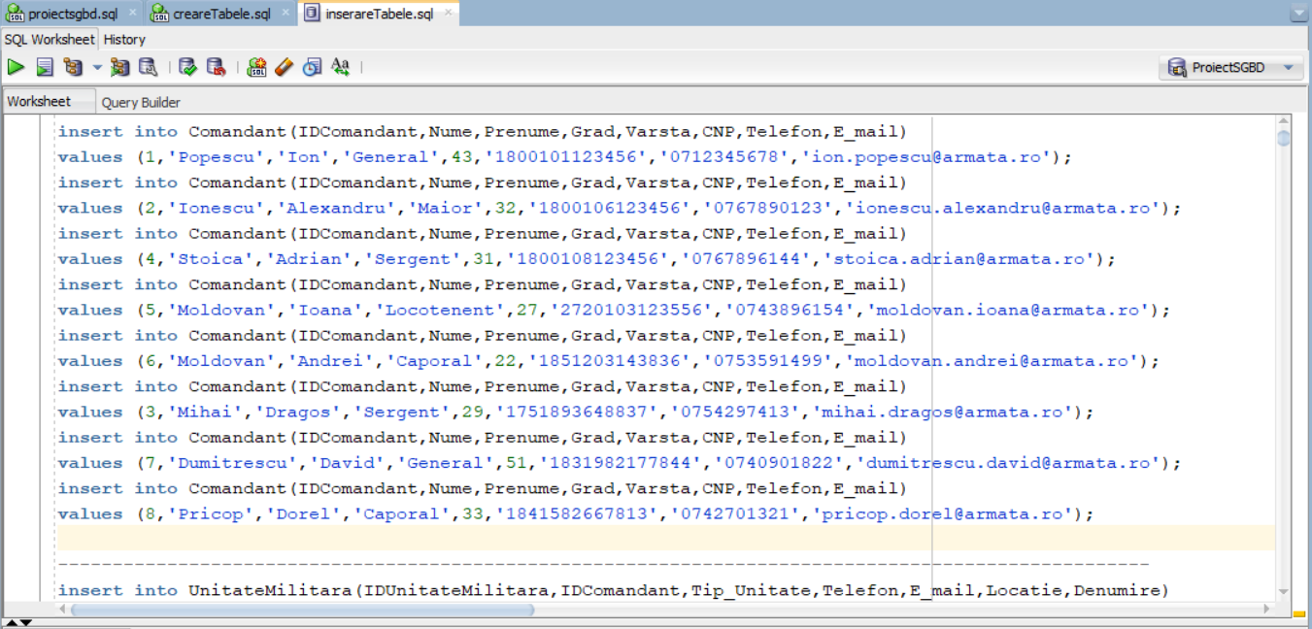 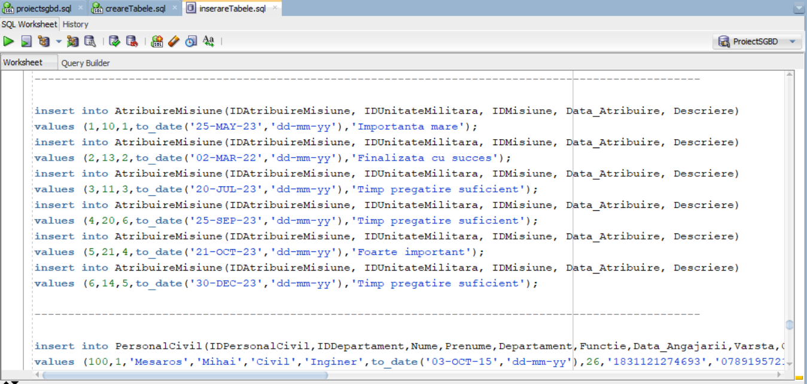

**Aici urmeaza cateva capturi de ecran care demonstreaza ca inserarile s-au efectuat cu succes si ca datele exista in tabele.**

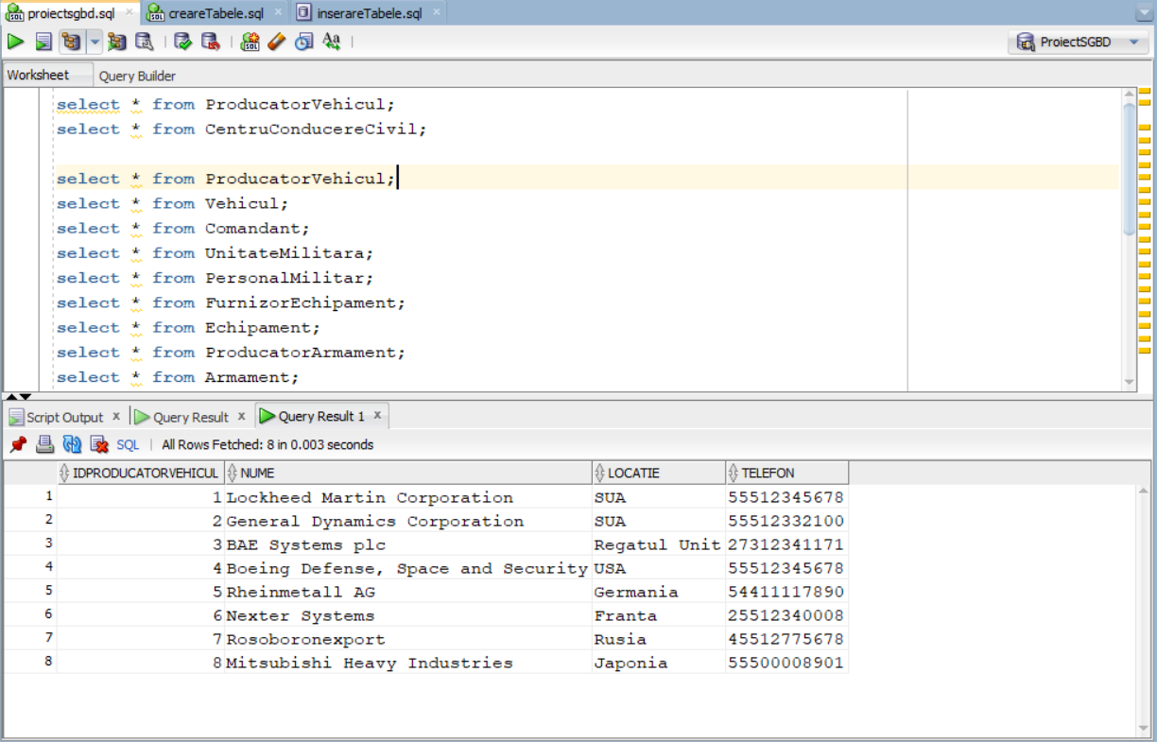

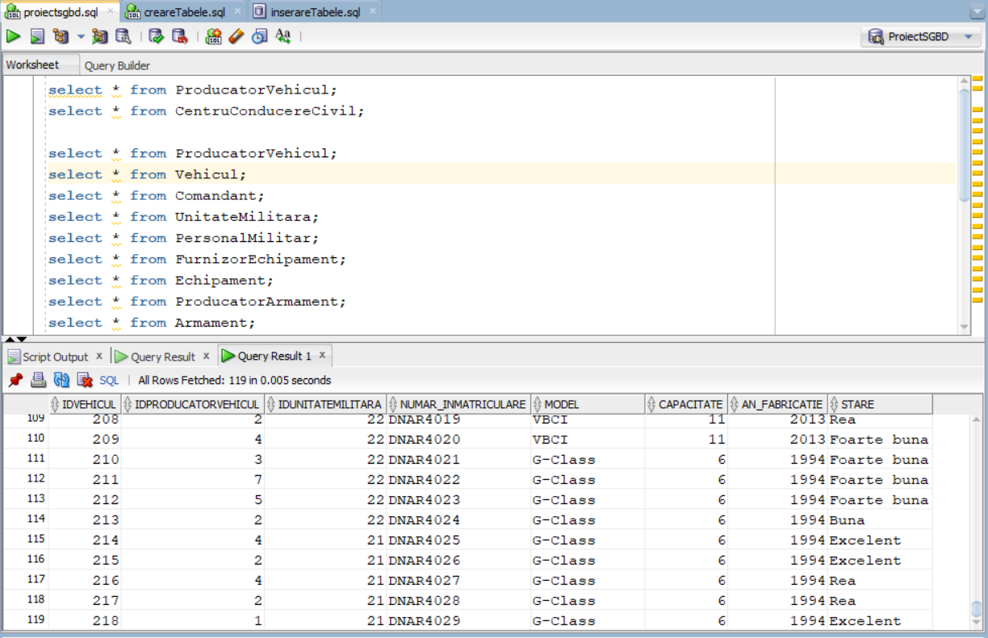

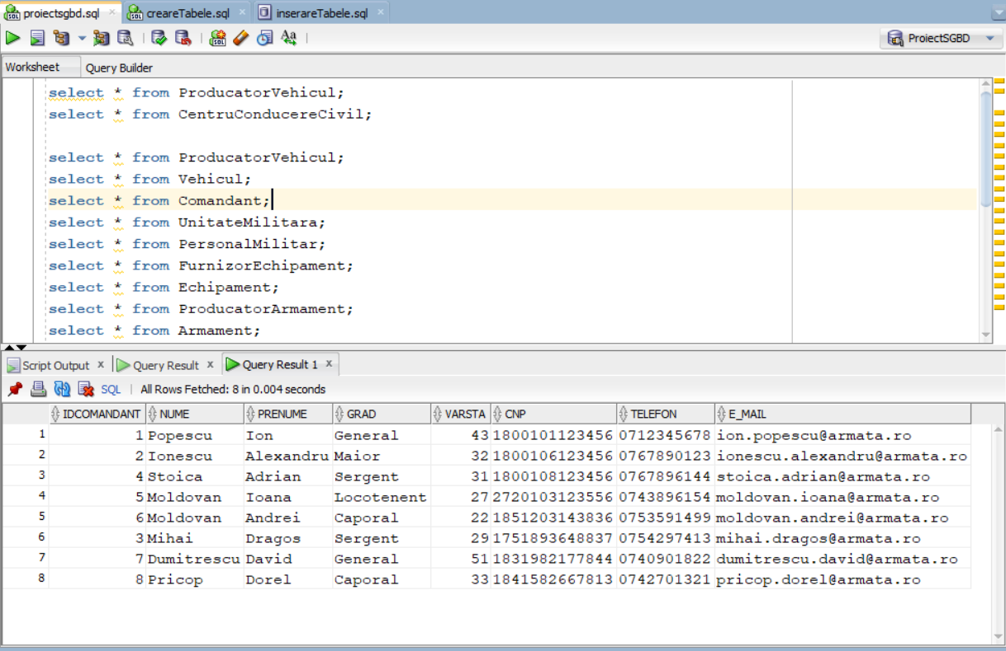

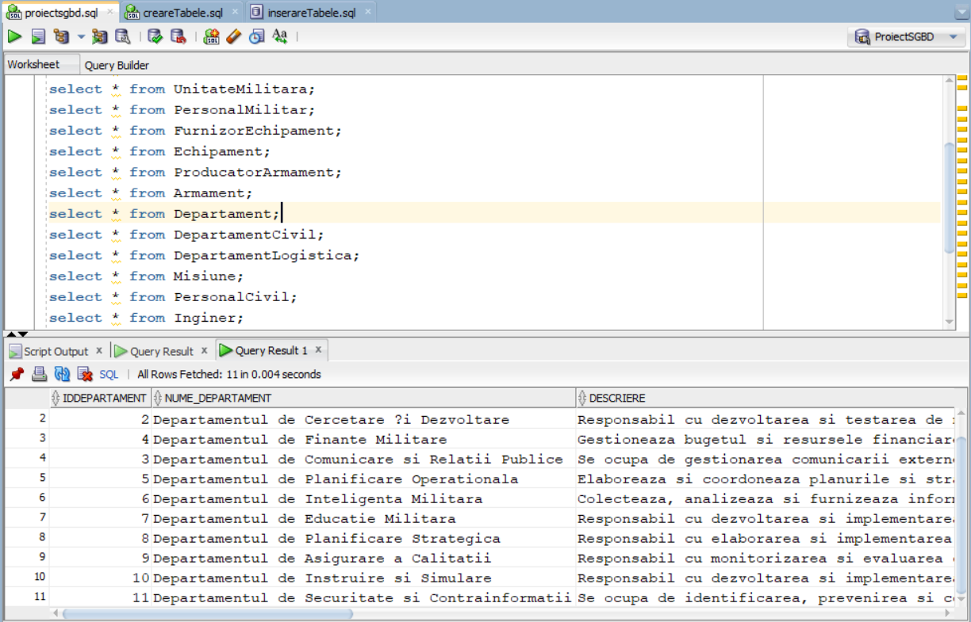

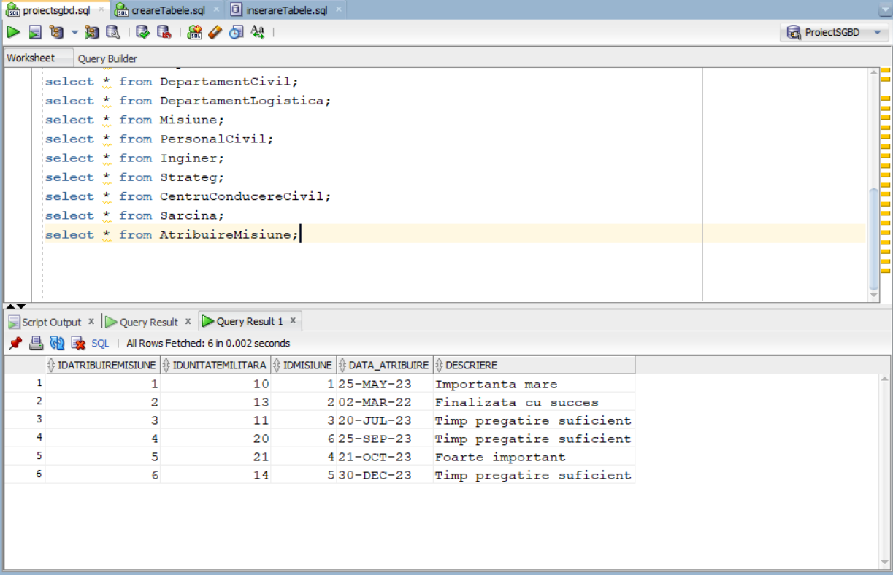

# Cerinta 6. Formulați în limbaj natural o problemă pe care să o rezolvați folosind un subprogram stocat independent care să utilizeze toate cele 3 tipuri de colecții studiate. Apelați subprogramul.

**Problema in limbaj natural este urmatoarea :**

Pentru fiecare membru al personalului militar inscris dupa 01.01.2015 ( inclusiv ) , aflati comandantii lor , acestia fiind comandantii unitatilor militare aferente acestor membrii, iar pentru fiecare din acesti comandanti, atribuiti-le la intamplare cate un vehicul a carei stare este Excelenta , vehicul care nu e necesar sa apartina aceleasi unitatii datorita posibilitatii de a nu exista un asemenea vehicul ( sau sa nu fie suficiente ).

|  |
| --- |
| **create** **or** **replace** **procedure** Problema6 **is**  **type** tablou_indexat **is** **table** **of** Personalmilitar%ROWTYPE **index** **by** pls_integer;  **type** tablou_imbricat **is** **table** **of** Unitatemilitara%ROWTYPE;  **type** vector1 **is** varray(**50**) **of** Comandant%ROWTYPE;  **type** vector2 **is** varray(**100**) **of** Vehicul%ROWTYPE;  **type** lista **is** varray(**100**) **of** number(**4**);    t_personal tablou_indexat;  t_unitate tablou_imbricat := tablou_imbricat();  v_comandant vector1 := vector1();  v_vehicul vector2 := vector2();  list_random lista := lista();  list_idcomand lista := lista();    v_cnt1 number(**3**) := **1**;  nr_random number(**3**);    idunit Unitatemilitara.IDUnitatemilitara%**TYPE**;  lastid Unitatemilitara.IDUnitatemilitara%**TYPE**;  linieUnitate Unitatemilitara%ROWTYPE;  linieComandant Comandant%ROWTYPE;  idcomand Comandant.IDComandant%**TYPE**;  ok number(**1**) := **0**;  continui number(**1**) := **0**;    **begin**    -----------------------------------------------------------  **select** *  bulk collect **into** t_personal  **from** Personalmilitar  **where** data_inscrierii >= TO_DATE('01-JAN-2015', 'DD-MON-YYYY')  **order** **by** IDUnitatemilitara;  -----------------------------------------------------------  lastid := **0**;    **for** i **in** t_personal.**first**..t_personal.**last** loop  idunit := t_personal(i).IDUnitatemilitara;    **select** *  **into** linieUnitate  **from** Unitatemilitara  **where** IDUnitatemilitara = idunit;    if idunit = lastid **then**  **continue**;  **end** if;    t_unitate.extend();  t_unitate(t_unitate.**last**) := linieUnitate;    lastid := idunit;  **end** loop;  -----------------------------------------------------------  v_cnt1 := **1**;    **for** i **in** t_unitate.**first**..t_unitate.**last** loop  idcomand := t_unitate(i).IDComandant;    continui := **0**;  if v_comandant.**count** > **0** **then**  **for** j **in** v_comandant.**first**..v_comandant.**last** loop  if v_comandant(j).IDComandant = idcomand **then**  continui := **1**;  **end** if;  **end** loop;  **end** if;      if continui = **1** **then**  **continue**;  **end** if;    **select** *  **into** linieComandant  **from** Comandant  **where** IDComandant = idcomand;    v_comandant.extend();  v_comandant(v_cnt1) := linieComandant;  v_cnt1 := v_cnt1 + **1**;    **end** loop;  v_cnt1 := v_cnt1 - **1**;    -----------------------------------------------------------    **select** *  bulk collect **into** v_vehicul  **from** Vehicul  **where** **lower**(Vehicul.stare) = 'excelent';    -----------------------------------------------------------    **for** i **in** v_comandant.**first**..v_comandant.**last** loop  -- comandantului i vreau sa-i atribui un vehicul la intamplare    ok := **0**;  while ok = **0** loop  nr_random := DBMS_RANDOM.VALUE(low => **1**, high => v_vehicul.**last**);  ok := **1**;  if list_random.**count** > **0** **then**  **for** j **in** list_random.**first**..list_random.**last** loop  if nr_random = list_random(j) **then**  ok := **0**;  **end** if;  **end** loop;  **end** if;    **end** loop;    list_random.extend();  list_random(list_random.**last**()) := nr_random;    dbms_output.put_line('Comandantului ''' || v_comandant(i).IDComandant || ' ' || v_comandant(i).nume || ' ' || v_comandant(i).prenume || ''' ii este atribuit vehiculul cu id-ul ' || v_vehicul(nr_random).idvehicul);    **end** loop;    **end**;  /  **begin**  Problema6;  **end**;  / |

**Aici urmeaza capturile de ecran cu o parte din cod , cu faptul ca a rulat cu succes precum si cu output-ul acestuia.**

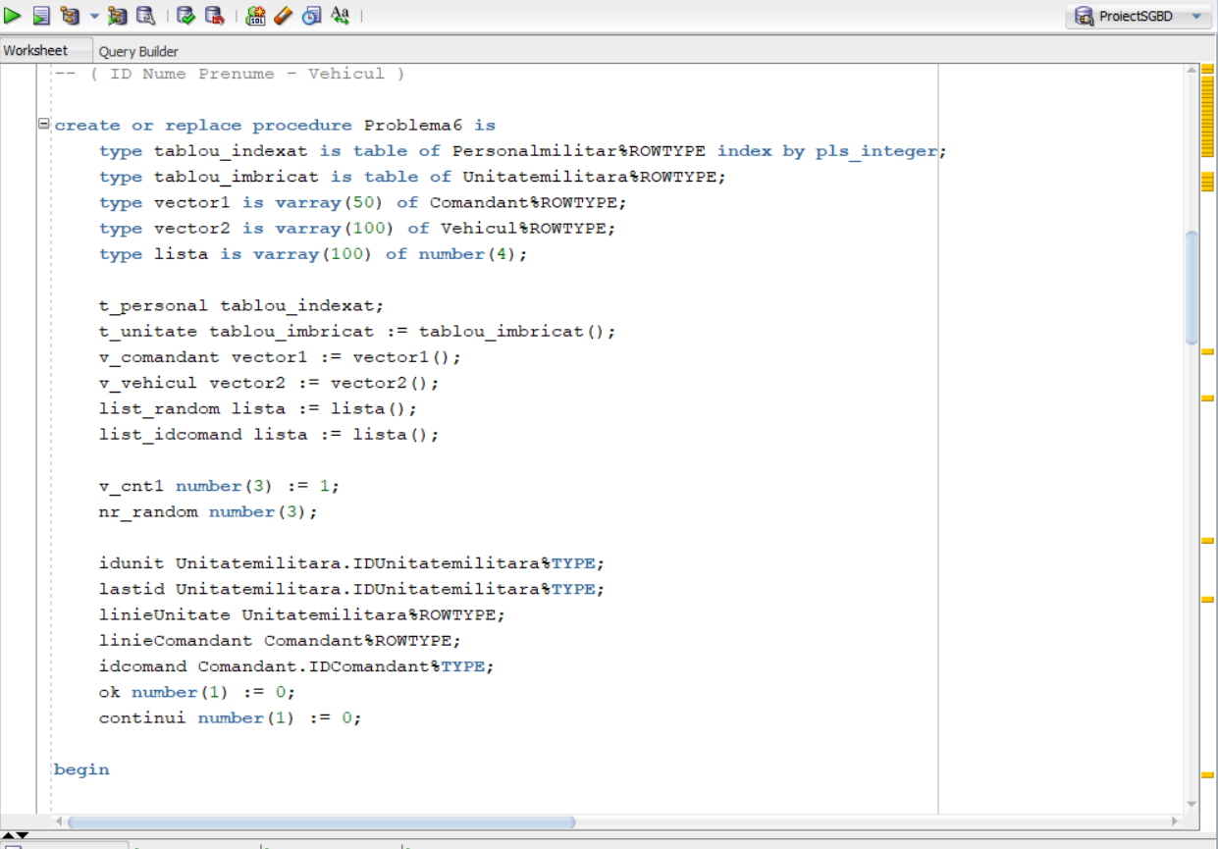 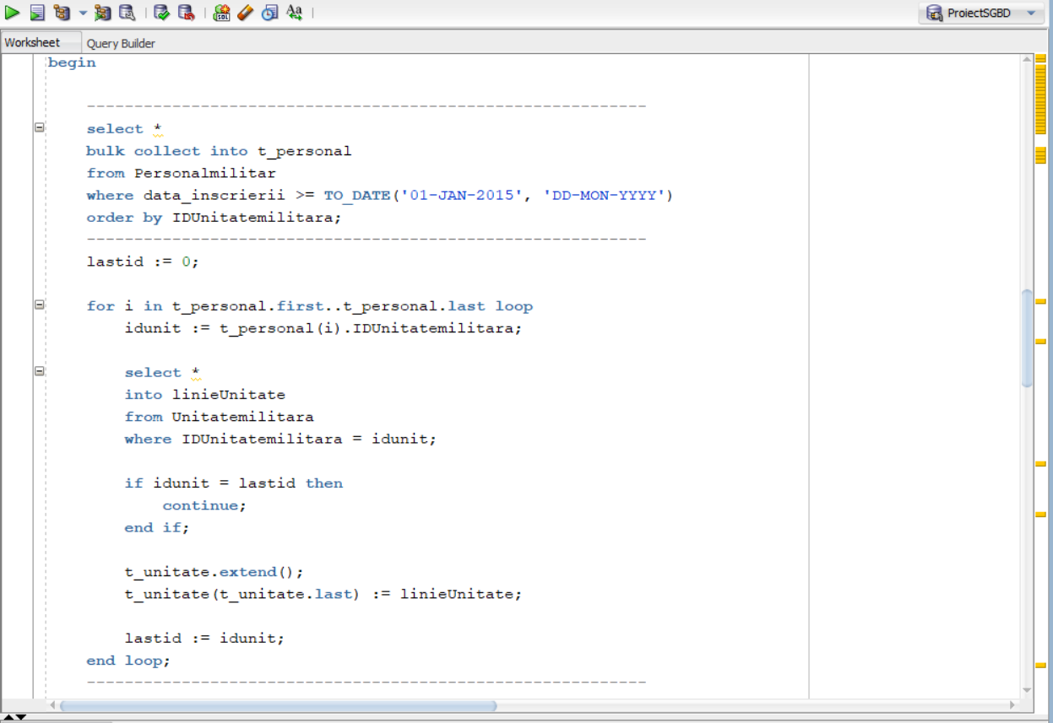

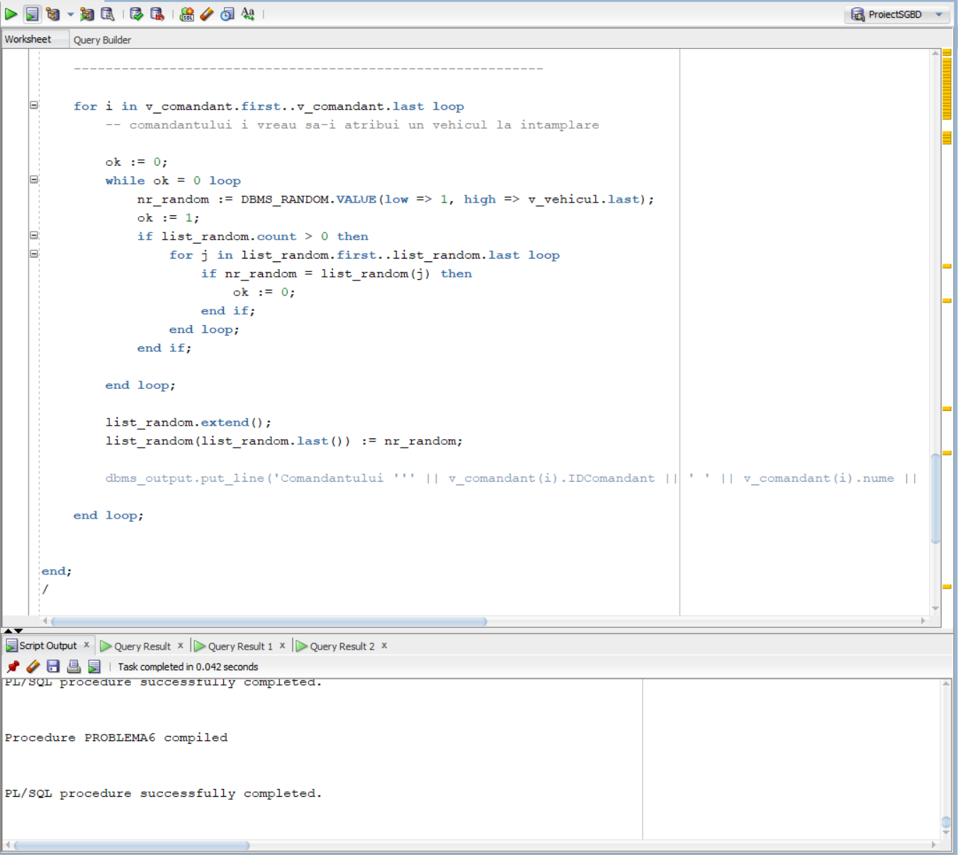



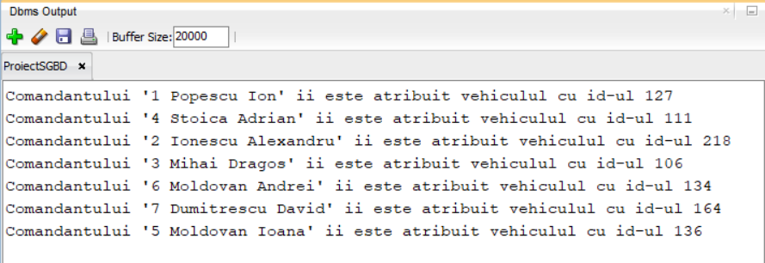

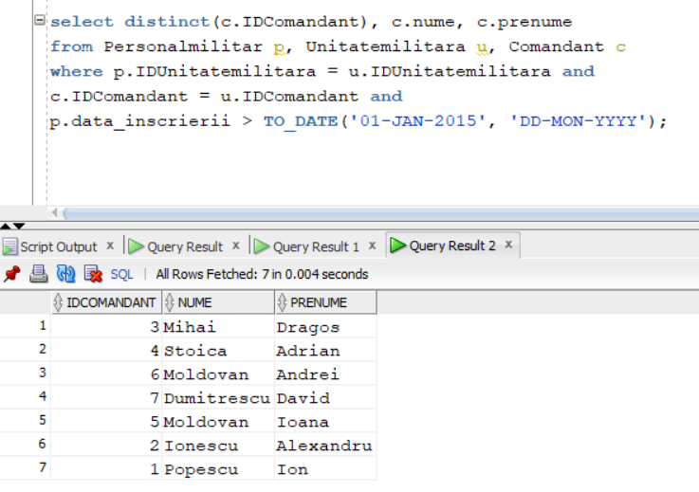

**Acesta este selectul prin care vedem ca s-au extras corect comandantii**

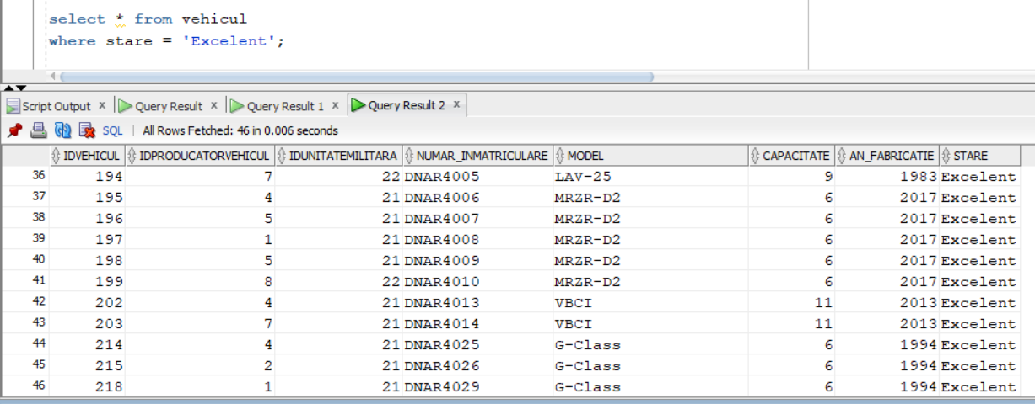

**Iar acesta este selectul ca sa vedem cate (si care) vehicule au starea Excelenta**

# Cerinta 7. Formulați în limbaj natural o problemă pe care să o rezolvați folosind un subprogram stocat independent care să utilizeze 2 tipuri diferite de cursoare studiate, unul dintre acestea fiind cursor parametrizat, dependent de celălalt cursor. Apelați subprogramul.

Problema in limbaj natural este:

Pentru toate departamentele care au indicat macar o misiune obtineti numele acestora , precum si lista de angajati ( personal civil ) care lucreaza acolo si care au varsta mai mare sau egala cu 30 (ani) .

|  |
| --- |
| **create** **or** **replace** **procedure** Problema7 **is**  **cursor** c1 **is** ( **select** **distinct**(d.IDDepartament), d.Nume_departament  **from** Departament d, Misiune m  **where** d.IDDepartament = m.IDDepartament );  **cursor** c2 ( id_dep Departament.IDDepartament%**TYPE** ) **is**  ( **select** nume, prenume  **from** Personalcivil  **where** IDDepartament = id_dep **and** varsta >= **30** );  idDep Departament.IDDepartament%**TYPE**;  numeDep Departament.Nume_departament%**TYPE**;  numePers Personalcivil.nume%**TYPE**;  prenumePers Personalcivil.prenume%**TYPE**;    **begin**  **open** c1;  loop  **fetch** c1 **into** idDep, numeDep;  exit **when** c1%NOTFOUND;    dbms_output.put_line(idDep || ' - ' || numeDep);  dbms_output.put_line('Angajatii:');  **for** personal **in** c2(idDep) loop  numePers := personal.nume;  prenumePers := personal.prenume;  dbms_output.put_line(numePers || ' ' || prenumePers);  **end** loop;  dbms_output.new_line();    **end** loop;  **close** c1;    **end**;  /  **begin**  Problema7;  **end**;  / |

**Aici urmeaza capturile de ecran cu codul precum si output-ul.**

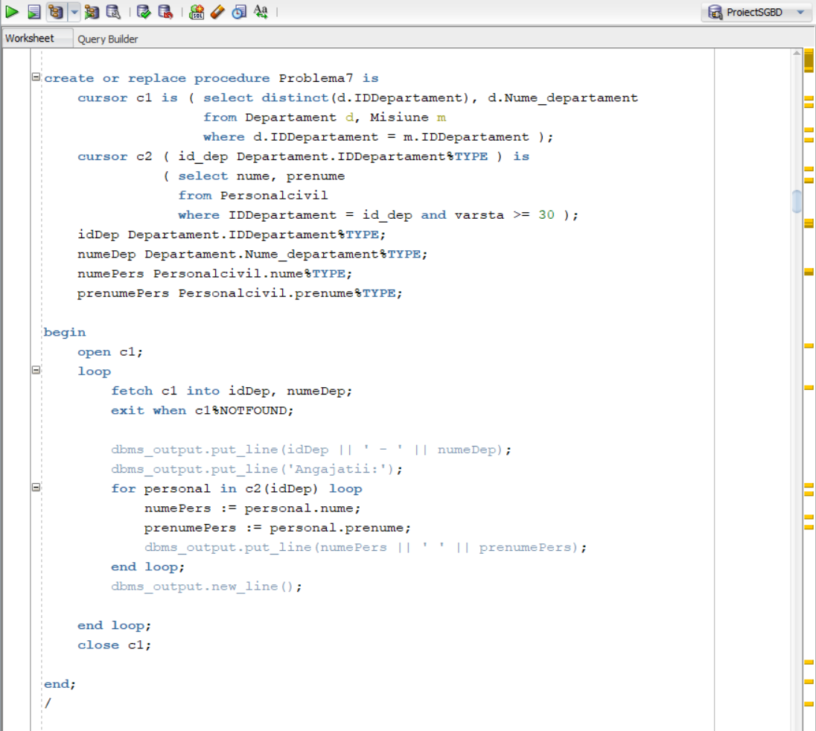

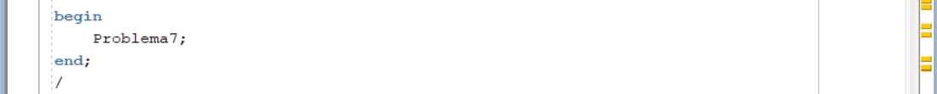

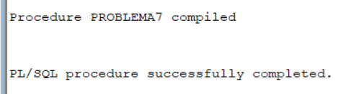

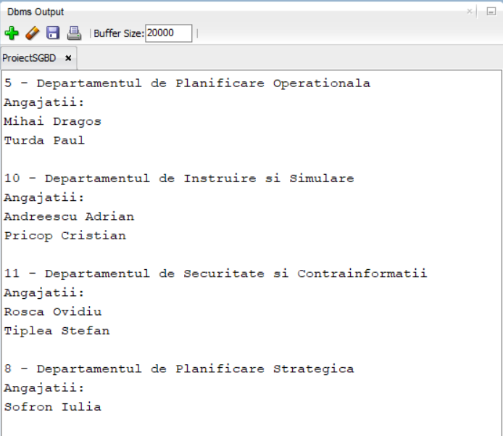

**Acesta este selectul prin care obtinem departamentele care au atribuit macar o misiune**

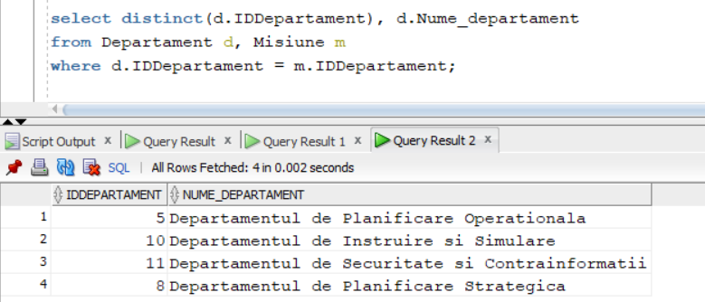

# Cerinta 8. Formulați în limbaj natural o problemă pe care să o rezolvați folosind un subprogram stocat independent de tip funcție care să utilizeze într-o singură comandă SQL 3 dintre tabelele definite. Definiți minim 2 excepții proprii. Apelați subprogramul astfel încât să evidențiați toate cazurile definite și tratate.

**Problema in limbaj natural :** Pentru un angajat ( personalcivil ) cu numele introdus , aflati cate misiuni sunt atribuite de departamentul in care lucreaza.

|  |
| --- |
| **create** **or** **replace** **function** Problema8 (v_nume Personalcivil.nume%**TYPE**) **return** number **is**  count_nume number(**3**) := **0**;  nr_misiuni number(**3**) := **0**;    NICIUN_NUME exception;  PREA_MULTI exception;  **begin**  **select** **count**(p.prenume)  **into** count_nume  **from** Departament d, Personalcivil p  **where** p.IDDepartament = d.IDDepartament **and**  **lower**(p.nume) = **lower**(v_nume);    if count_nume = **0** **then**  raise NICIUN_NUME;  **end** if;    if count_nume > **1** **then**  raise PREA_MULTI;  **end** if;    **select** **count**(m.IDMisiune)  **into** nr_misiuni  **from** Misiune m, Departament d, Personalcivil p  **where** p.IDDepartament = d.IDDepartament **and**  d.IDDepartament = m.IDDepartament **and**  **lower**(p.nume) = **lower**(v_nume);    **return** nr_misiuni;    exception  **when** NICIUN_NUME **then** raise_application_error(-**20005**,'Nu s-a gasit niciun angajat cu numele ' || **upper**(v_nume) );  **when** PREA_MULTI **then** raise_application_error(-**20006**,'Exista mai multi angajati cu numele ' || **upper**(v_nume) );  **end**;  /  **declare**  nume_introdus varchar2(**50**) := '&nume';  **begin**  dbms_output.put_line('Departamentul in care lucreaza ' || **upper**(nume_introdus) || ' a atribuit ' || Problema8(nume_introdus) || ' misiuni');  **end**;  / |

Capturile de ecran cu codul, outputul si tratarile erorilor:

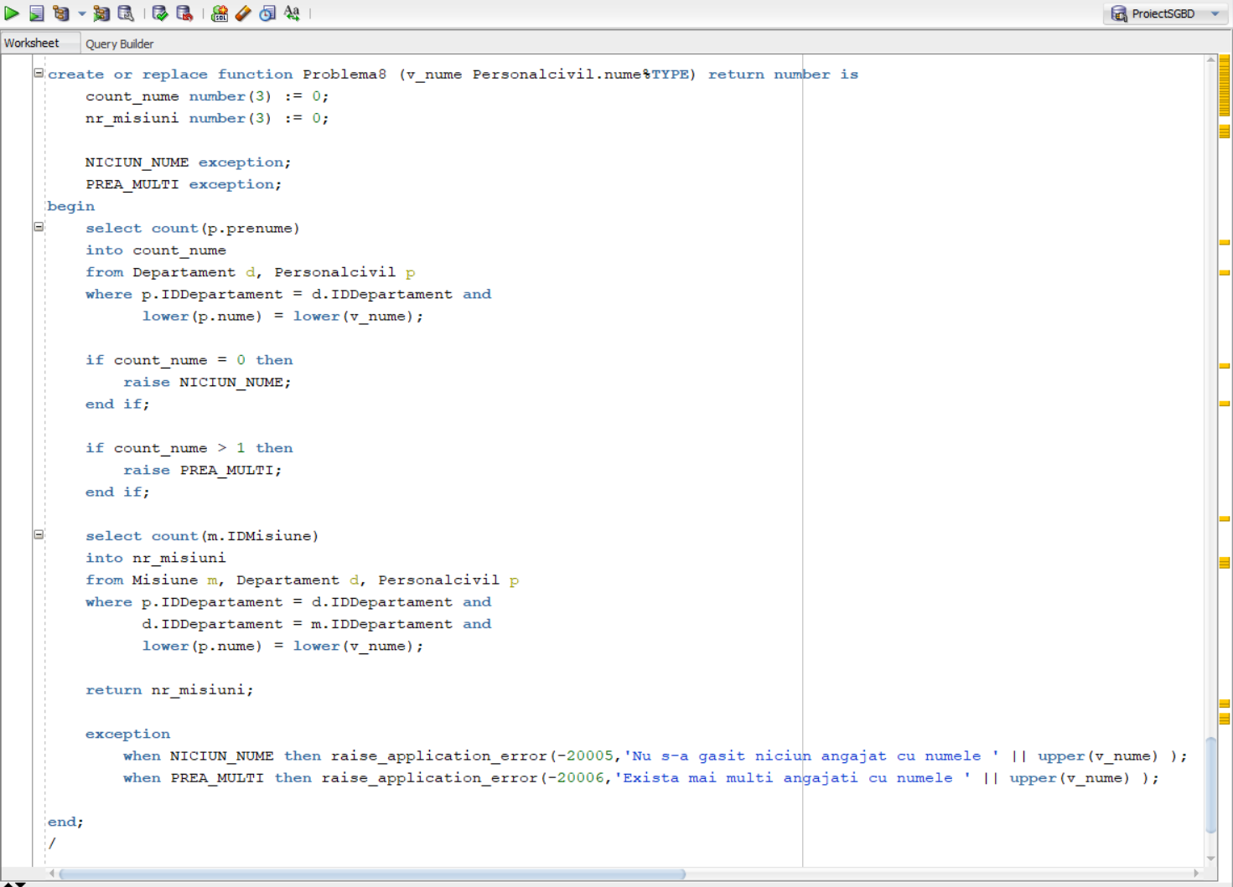

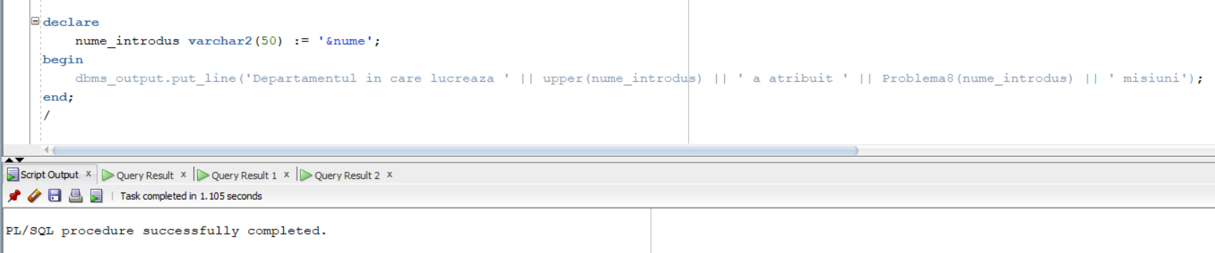

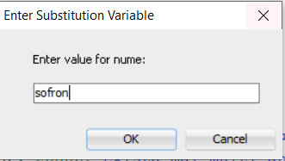

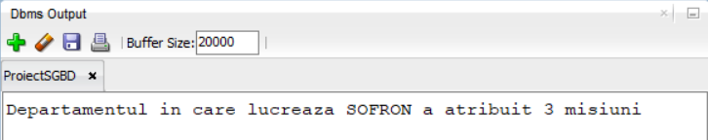

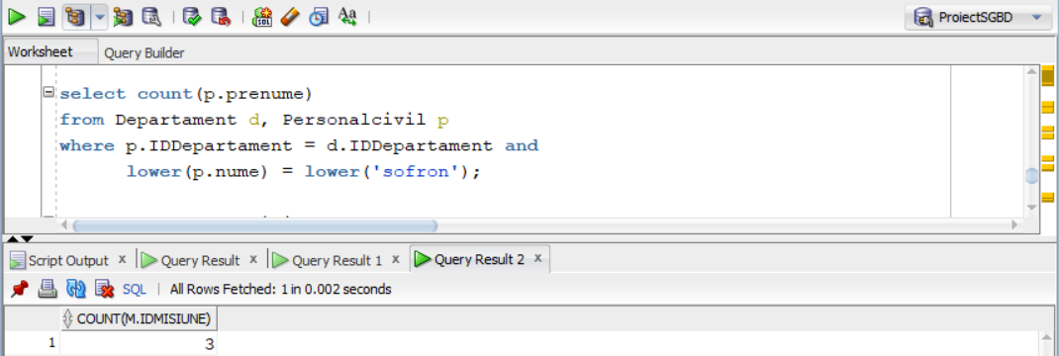

Se poate vedea din selectul facut in afara functiei ca intr-adevar raspunsul pentru inputul “sofron” este 3.

Acum , pentru erorile tratate :

**Pentru inputul “Pricop”, eroarea o sa semnaleze ca avem mai multi angajati cu acest nume, deci nu poate rezolva problema.**

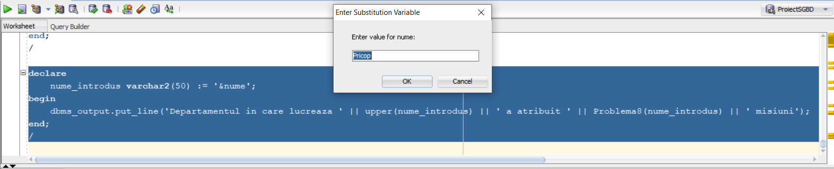



**Pentru inputul “Pop”, eroarea o sa semnaleze ca nu avem niciun angajat cu acest nume, deci nu poate rezolva problema.**

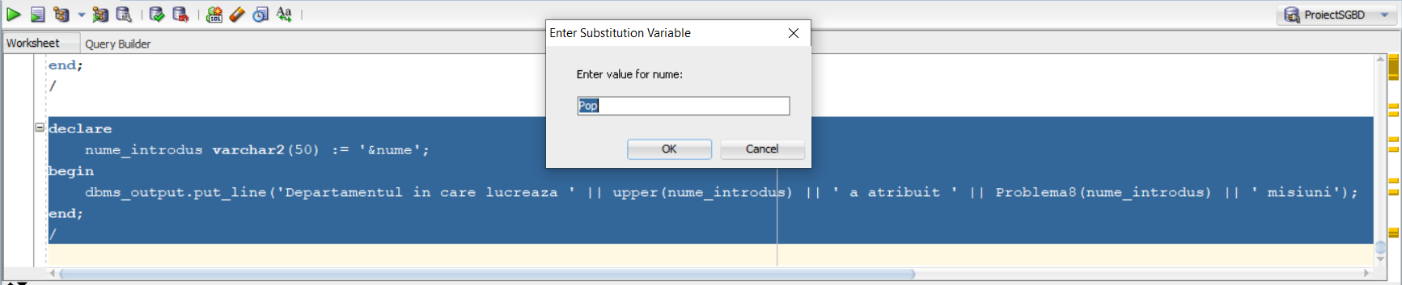



**Comanda in care au fost utilizate 3 dintre tabelele definite este :**

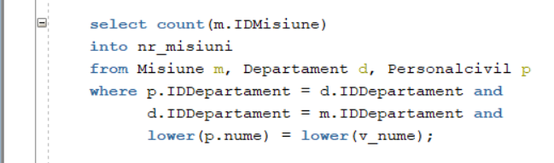

# 

# Cerinta 9. Formulați în limbaj natural o problemă pe care să o rezolvați folosind un subprogram stocat independent de tip procedură care să utilizeze într-o singură comandă SQL 5 dintre tabelele definite. Tratați toate excepțiile care pot apărea, incluzând excepțiile NO_DATA_FOUND și TOO_MANY_ROWS. Apelați subprogramul astfel încât să evidențiați toate cazurile tratate.

**Problema in limbaj natural este urmatoarea :**

Un comandant trebuie sa ia legatura telefonica cu furnizorii de echipament responsabili pentru furnizarea echipamentelor catre personalul militar care lucreaza in unitatea militara pe care comandantul o gestioneaza. Drept urmare, pentru un comandant al carui nume este dat (de la tastatura) afisati lista de furnizori de echipament cu care acesta trebuie sa ia legatura precum si numarul de telefon al acestor furnizori.

|  |
| --- |
| **create** **or** **replace** **procedure** Problema9 ( nume_comandant Comandant.nume%**TYPE** ) **is**  **type** tablou_indexat **is** **table** **of** Furnizorechipament%ROWTYPE **index** **by** pls_integer;    lista_furnizori tablou_indexat;  nume_aux Furnizorechipament.nume%**TYPE**;    nr_comandanti number(**3**) := **0**;  **begin**    **select** **count**(**distinct**(**c**.idcomandant))  **into** nr_comandanti  **from** comandant **c**,unitatemilitara u, personalmilitar p, echipament e, furnizorechipament f  **where** **c**.IDComandant = u.IDComandant **and**  u.IDUnitatemilitara = p.IDUnitatemilitara **and**  p.IDPersonalmilitar = e.IDPersonalmilitar **and**  e.IDFurnizor = f.IDFurnizor **and**  **lower**(**c**.nume) = **lower**(nume_comandant);    if nr_comandanti = **0** **then**  raise NO_DATA_FOUND;  **end** if;    if nr_comandanti > **1** **then**  raise TOO_MANY_ROWS;  **end** if;  **select** f.*  bulk collect **into** lista_furnizori  **from** comandant **c**,unitatemilitara u, personalmilitar p, echipament e, furnizorechipament f  **where** **c**.IDComandant = u.IDComandant **and**  u.IDUnitatemilitara = p.IDUnitatemilitara **and**  p.IDPersonalmilitar = e.IDPersonalmilitar **and**  e.IDFurnizor = f.IDFurnizor **and**  **lower**(**c**.nume) = **lower**(nume_comandant);    **for** i **in** lista_furnizori.**first**..lista_furnizori.**last** loop  nume_aux := lista_furnizori(i).nume;  **for** j **in** **1**..i-**1** loop  if lista_furnizori(j).nume = **null** **then**  **continue**;  **end** if;  if lista_furnizori(j).nume = nume_aux **then**  lista_furnizori(j).nume := **null**;  **end** if;  **end** loop;  **end** loop;    **for** i **in** lista_furnizori.**first**..lista_furnizori.**last** loop  if lista_furnizori(i).nume **is** **null** **then**  **continue**;  **end** if;  dbms_output.put_line('Nume: ' || lista_furnizori(i).nume || ', tel: ' || lista_furnizori(i).telefon);  **end** loop;    exception  **when** NO_DATA_FOUND **then** raise_application_error(-**20015**,'Nu s-a gasit niciun comandant cu numele ' || **upper**(nume_comandant) );  **when** TOO_MANY_ROWS **then** raise_application_error(-**20016**,'Exista mai multi comandanti cu numele ' || **upper**(nume_comandant) );    **end**;  /  **begin**  Problema9('&nume');  **end**;  / |

**Capturile de ecran cu codul, outputul precum si erorile tratate:**

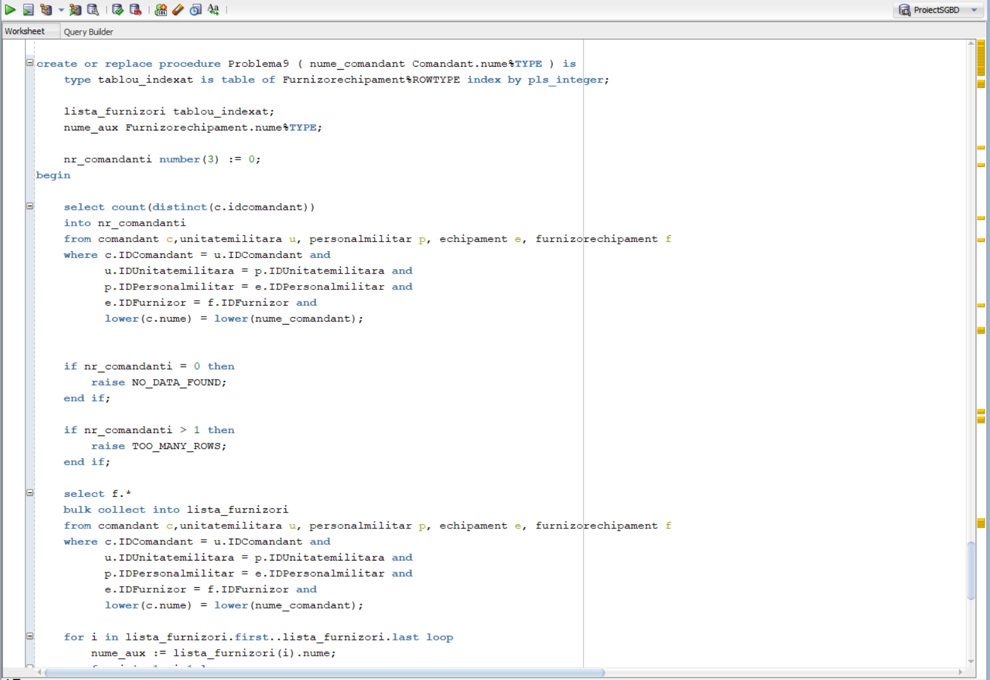

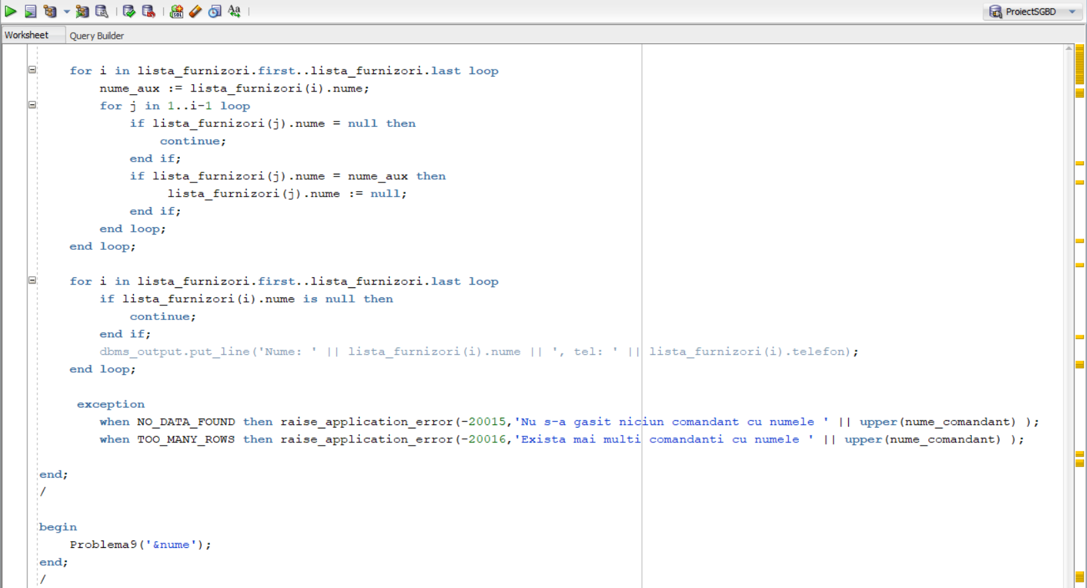

**Pentru inputul “Stoica” avem acest output**

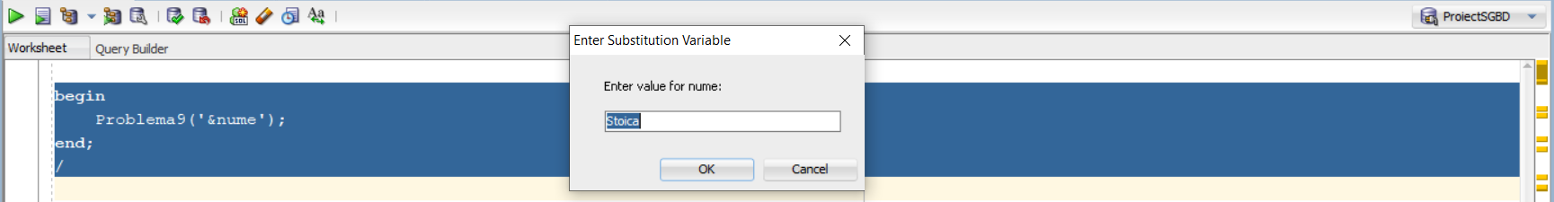

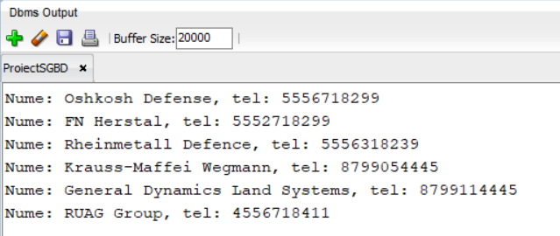

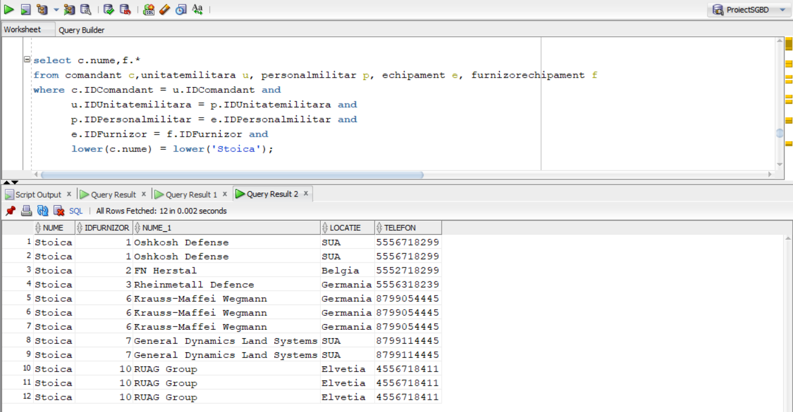

**Se poate vedea ca pentru Comandantul “Stoica” avem urmatorii furnizori cu care are de vorbit , outputul fiind corect ( in output nu avem dubluri )**

**Acum pentru tratarea erorilor :**

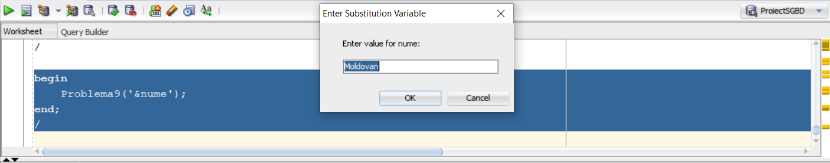 

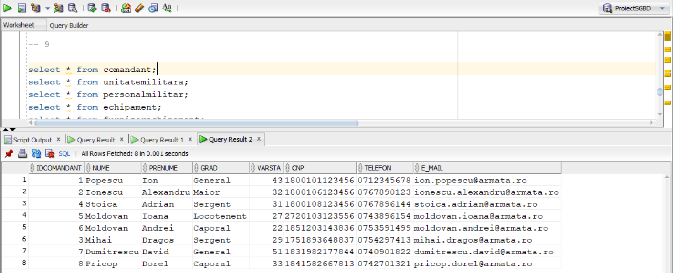

**Se poate observa ca in selectul din afara cu toti comandantii avem mai multi comandanti cu numele de “Moldovan” deci se va produce eroare**

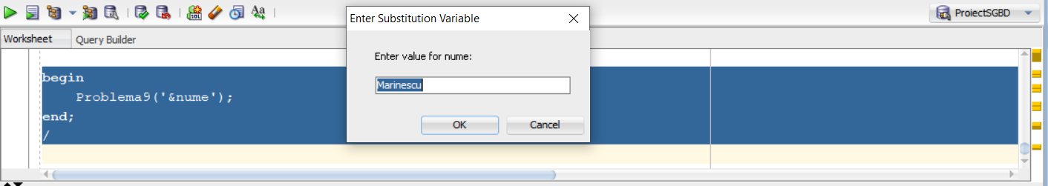 

**Iar pentru numele “Marinescu” nu avem niciun astfel de comandant deci va intoarce eroare**

**Inca un exemplu pentru care functioneaza este numele “Mihai” :**

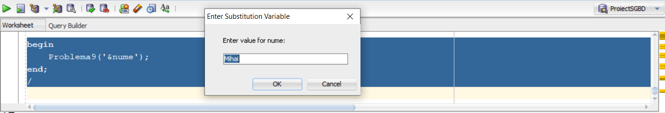



**Care are urmatorul output :**

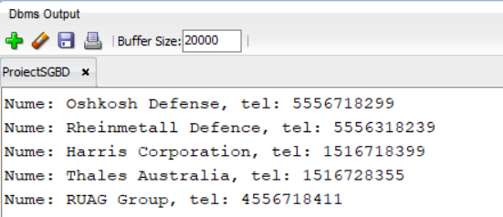

# Cerinta 10. Definiți un trigger de tip LMD la nivel de comandă. Declanșați trigger-ul.

**Problema in limbaj natural :** Deoarece nu se fac recrutari pentru noi ingineri in luna ianuarie, definiti un declansator care nu permite inserarea in tabelul “Inginer” in luna ianuarie.

|  |
| --- |
| **create** **or** **replace** **trigger** trig10  **before** **insert** **or** **update** **or** **delete** **on** inginer  **declare**  data_curenta date;  **begin**  **select** sysdate  **into** data_curenta  **from** dual;    if to_char(data_curenta, 'MM') = '01' **then**  raise_application_error(-**20031**, 'Nu sunt permise recrutarile in luna ianuarie');  **end** if;    **end**;  /  **insert** **into** inginer(IDPersonalcivil, Specializare, Experienta)  **values** (**165**, 'Constructii', **4**); |

**Capturi de ecran cu codul precum si output-ul :**

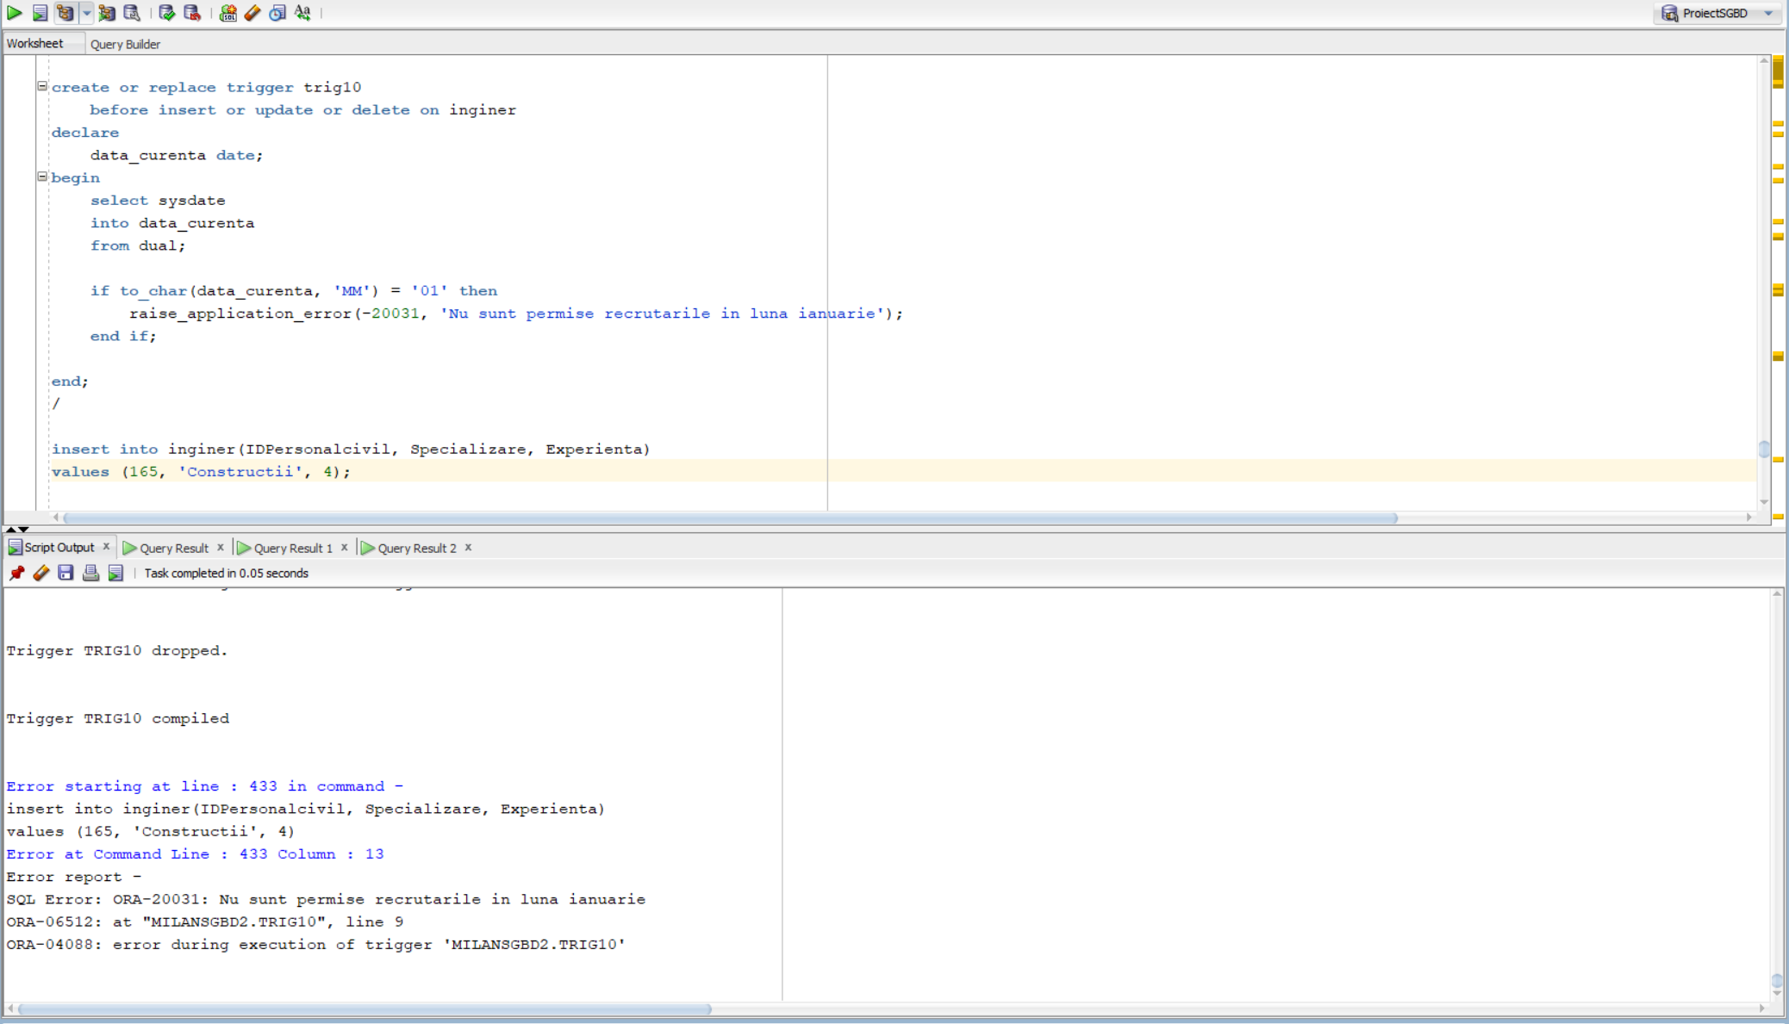

**Deoarece ne aflam in luna ianuarie si incercam sa inseram in tabela inginer o linie , se declanseaza triggerul “trig10”.**

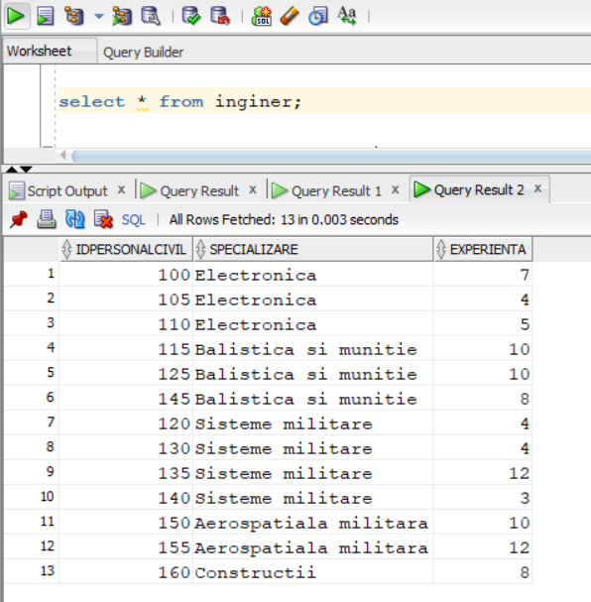

**Se poate observa ca insertul nu a avut loc.**

# Cerinta 11. Definiți un trigger de tip LMD la nivel de linie. Declanșați trigger-ul.

**Problema in limbaj natural :** Nu se pot adauga noi misiuni care provin de la un departament care are deja atribuita o misiune activa , prin misiune activa ne referim la o misiune care nu s-a terminat inca ( pana in data de astazi ). Definiti un declansator care impiedica acest lucru.

|  |
| --- |
| **create** **or** **replace** **trigger** trig11  **before** **insert** **on** Misiune  **for** **each** **row**  **declare**  misiune_activa number(**1**) := **0**;  **begin**  **select** **count**(*)  **into** misiune_activa  **from** Misiune  **where** :**NEW**.IDDepartament = IDDepartament  **and** Data_terminare > sysdate;    if misiune_activa = **1** **then**  raise_application_error(-**20021**,'Departamentul are deja o misiune activa atribuita');  **end** if;    **end**;  /  **insert** **into** misiune (IDMisiune, IDDepartament, Nume_misiune, locatie, data_incepere, data_terminare, descriere)  **values** (**7**,**3**,'nume misiune7','locatie7',sysdate, sysdate+**10**, 'Descriere7');  **insert** **into** misiune (IDMisiune, IDDepartament, Nume_misiune, locatie, data_incepere, data_terminare, descriere)  **values** (**8**,**3**,'nume misiune8','locatie8',sysdate, sysdate+**2**, 'Descriere8');  **insert** **into** misiune (IDMisiune, IDDepartament, Nume_misiune, locatie, data_incepere, data_terminare, descriere)  **values** (**9**,**10**,'nume misiune9','locatie9',sysdate, sysdate+**3**, 'Descriere9');  **select** * **from** misiune;  **drop** **trigger** trig11; |

**Capturi de ecran cu codul precum si output-urile :**

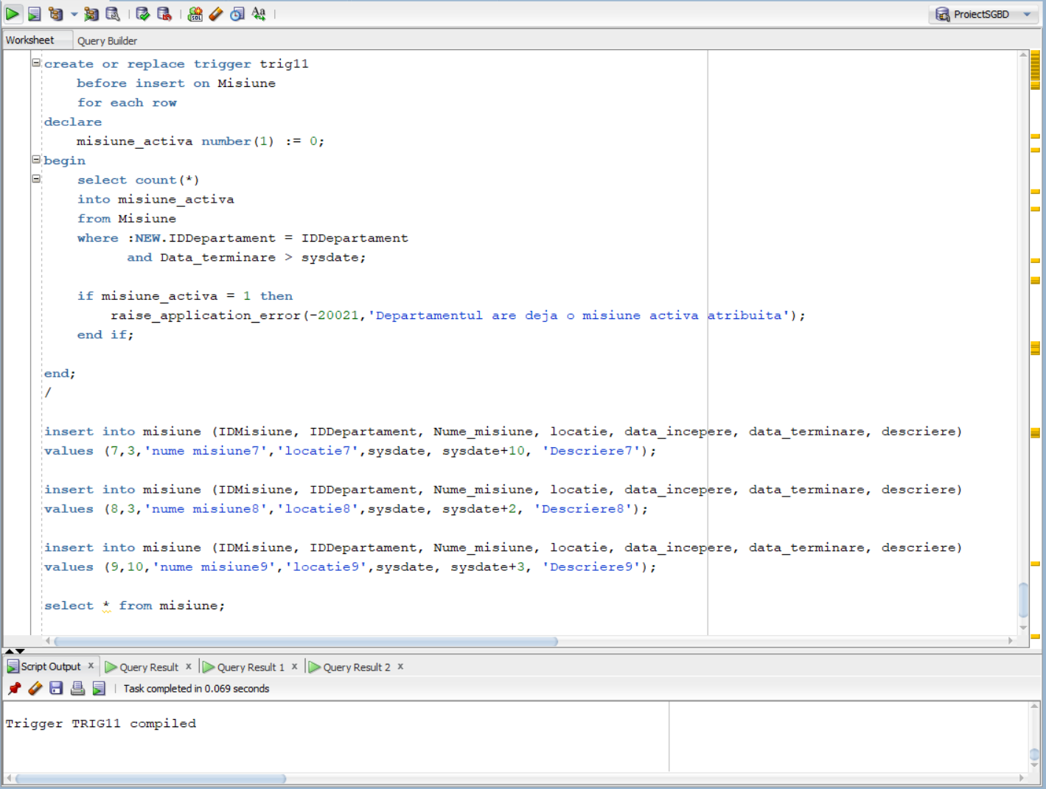

**Tabelul ‘Misiune’ arata in felul urmator ( inainte de inserturile cu care vom demonstra ca triggerul functioneaza corect )**

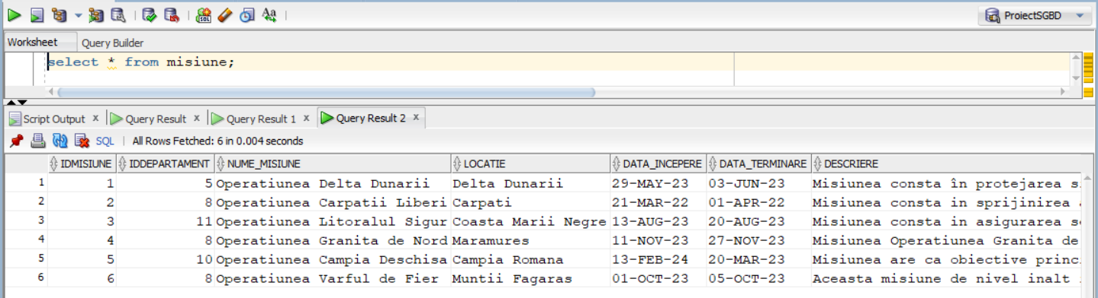

**Acum urmeaza sa facem 3 inserturi in aceasta tabela si sa explicam cum functioneaza acestea ( si triggerul ).**

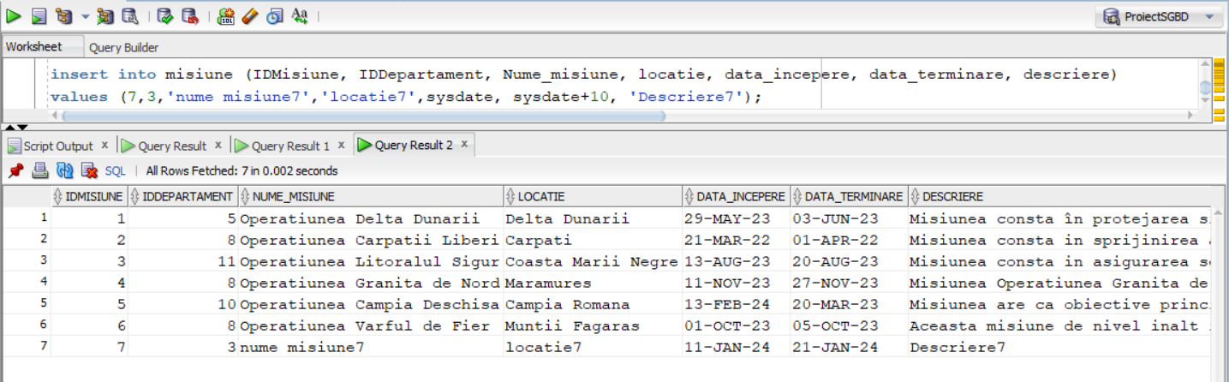

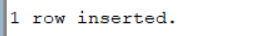

**Primul insert se realizeaza cu succes deoarece Departamentul cu ID = 3 nu mai are nicio alta misiune activa , deci tabela va arata ca in captura de ecran de mai sus.**

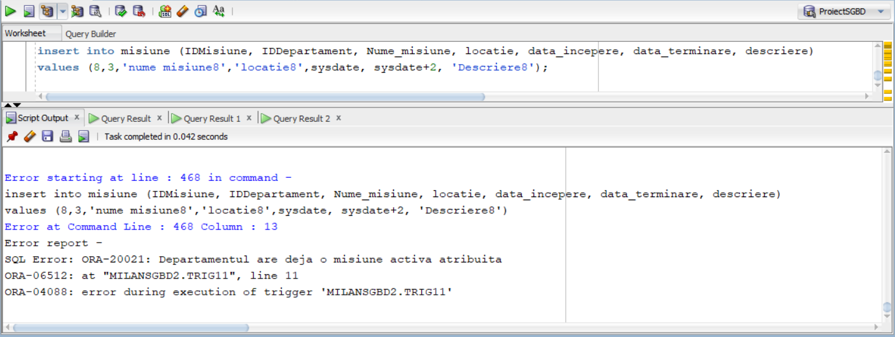

**Al doilea insert declanseaza triggerul “trig11” deoarece incercam sa inseram in tablea “Misiune” pentru Departamentul cu ID = 3 inca o misiune , dar cum mai sus am introdus deja o misiune , iar aceasta este activa ( inca nu s-a terminat ) , se va declansa triggerul si nu va permite insertul :**

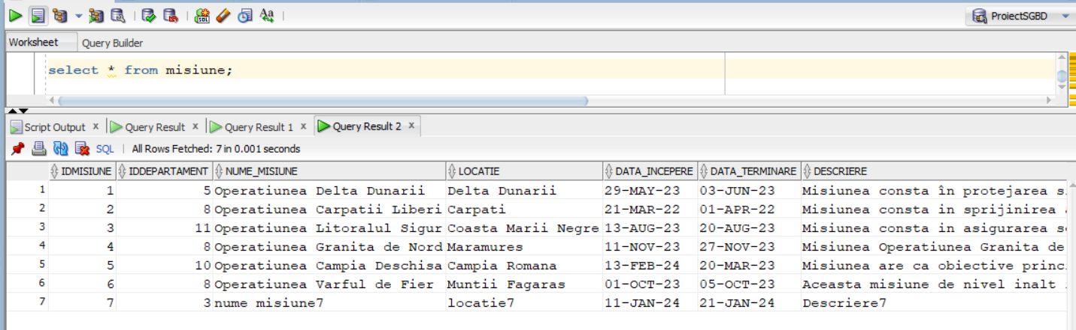

**Tabela Misiune ramanand neschimbata.**

**In schimb :**



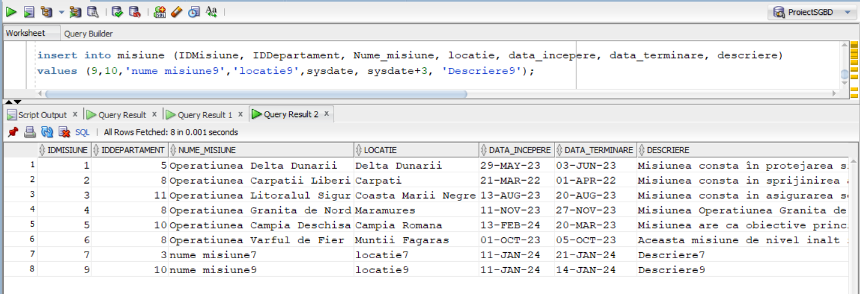

**Al treilea insert se va efectua cu succes , fara a declansa triggerul , deoarece, desi Departamentul cu ID = 10 a mai atribuit misiuni in trecut acestea nu mai sunt active in momentul de fata deci putem adauga o misiune din Departamentul cu ID = 10.**

# Cerinta 12. Definiți un trigger de tip LDD. Declanșați trigger-ul.

**Problema in limbaj natural :** Dupa ce un utilizator a folosit o comanda de tipul LDD voi retine in niste tabele diferite date despre comanda apelata in felul urmator: o tabela pentru comenzi LDD legate de tabele , o tabela pentru comenzi LDD legate de index , o tabela pentru comenzi LDD legate de secvente si o tabela pentru comenzi LDD pentru orice altceva ( spre exemplu crearea unui “type” ) , insa pentru aceasta ultima tabela retinem evident si object_type - ul.

|  |
| --- |
| **create** **table** LDD_LOG_TABLE (  user_ varchar2(**50**),  event_type varchar2(**50**),  event_date date,  object_name varchar2(**50**)  );  **create** **table** LDD_LOG_INDEX (  user_ varchar2(**50**),  event_type varchar2(**50**),  event_date date,  object_name varchar2(**50**)  );  **create** **table** LDD_LOG_SEQUENCE (  user_ varchar2(**50**),  event_type varchar2(**50**),  event_date date,  object_name varchar2(**50**)  );  **create** **table** LDD_LOG_OTHERS (  user_ varchar2(**50**),  event_type varchar2(**50**),  event_date date,  object_name varchar2(**50**),  object_type varchar2(**50**)    );  **create** **or** **replace** **trigger** trig12  **after** **create** **or** **alter** **or** **drop** **on** **schema**  **declare**  objType varchar2(**50**);  **begin**  objType := sys.dictionary_obj_type;    if **lower**(objType) = 'table' **then**  **insert** **into** LDD_LOG_TABLE  **values** (sys.login_user, sys.sysevent, sysdate, sys.dictionary_obj_name);  elsif **lower**(objType) = 'index' **then**  **insert** **into** LDD_LOG_INDEX  **values** (sys.login_user, sys.sysevent, sysdate, sys.dictionary_obj_name);  elsif **lower**(objType) = 'sequence' **then**  **insert** **into** LDD_LOG_SEQUENCE  **values** (sys.login_user, sys.sysevent, sysdate, sys.dictionary_obj_name);  **else**  **insert** **into** LDD_LOG_OTHERS  **values** (sys.login_user, sys.sysevent, sysdate, sys.dictionary_obj_name, sys.dictionary_obj_type);  **end** if;    **end**;  /  --------------------------------------  **create** **table** CEVA (  numar1 number(**3**),  numar2 number(**4**)  );  **create** **index** CEVA2 **on** CEVA(numar1);  **create** sequence SECVENTA  **start** **with** **1**  **increment** **by** **1**;  **create** **type** TIP **as** **table** **of** number;  --------------------------------------  **drop** **table** CEVA;  **drop** **index** CEVA2;  **drop** sequence SECVENTA;  **drop** **type** TIP;  **select** * **from** LDD_LOG_TABLE;  **select** * **from** LDD_LOG_INDEX;  **select** * **from** LDD_LOG_SEQUENCE;  **select** * **from** LDD_LOG_OTHERS;  **drop** **table** LDD_LOG_OTHERS;  **drop** **trigger** trig12; |

**Acum urmeaza capturile de ecran care arata codul si explica functionalitatea acestuia :**

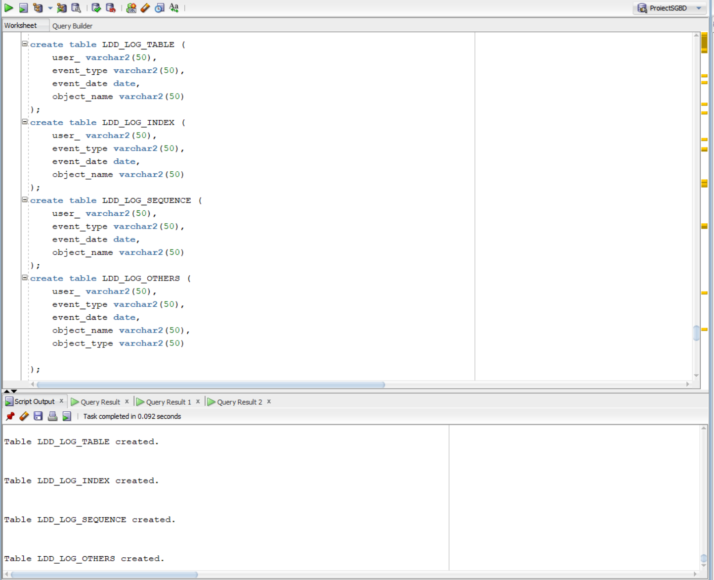

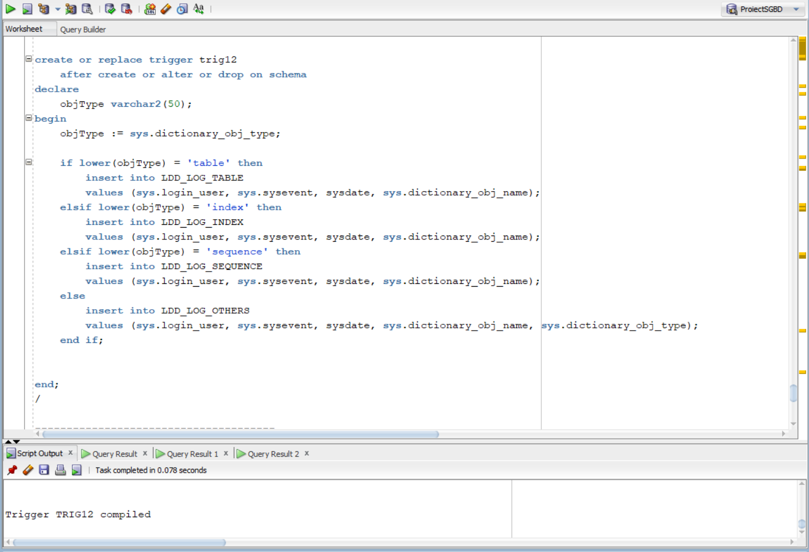

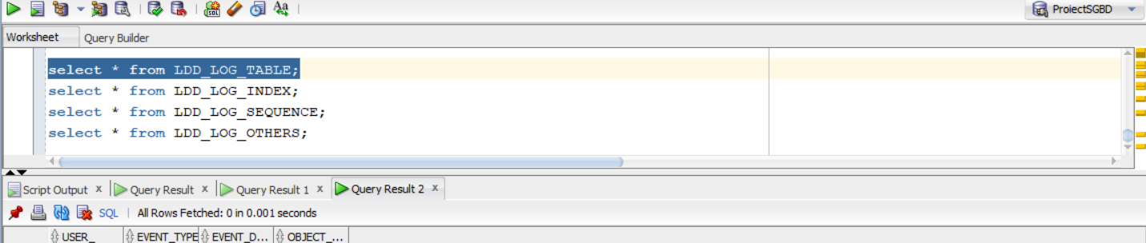

**Evident initial tabelele create sunt goale**

**Dar dupa ce am creat aceste 4 obiecte :**

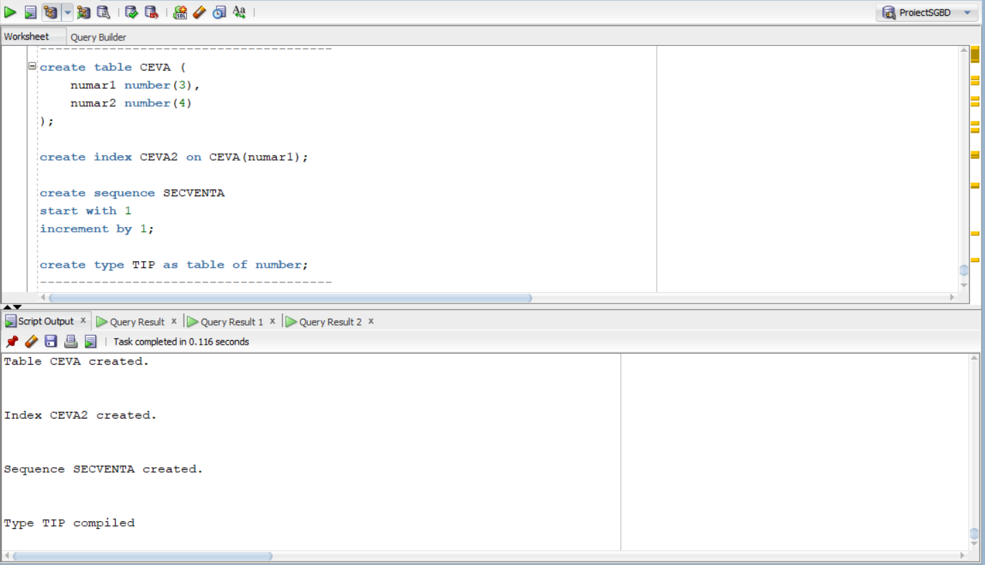

**Acum daca verificam tabelele create anterior putem observa ca s-au retinut toate informatiile legate de crearile anterioare:**

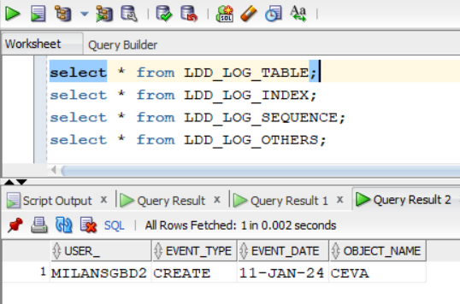 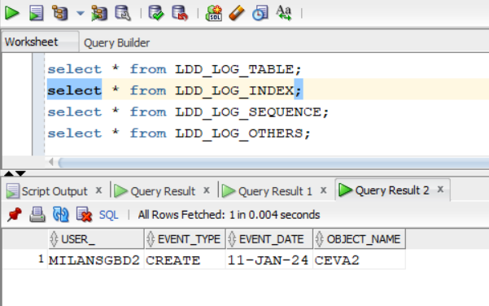

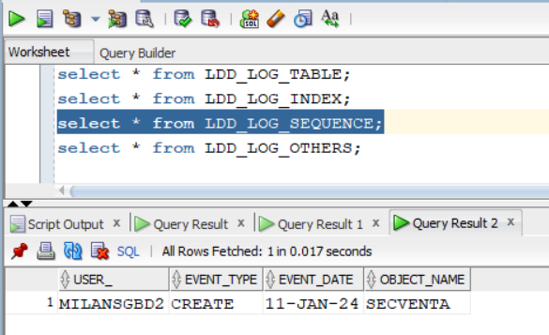 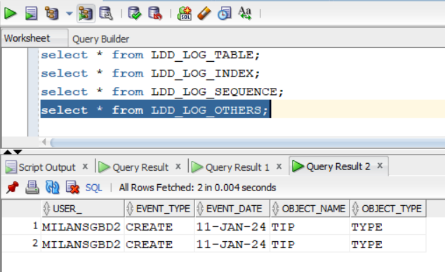

**Iar dupa ce dropam obiectele create mai devreme:**

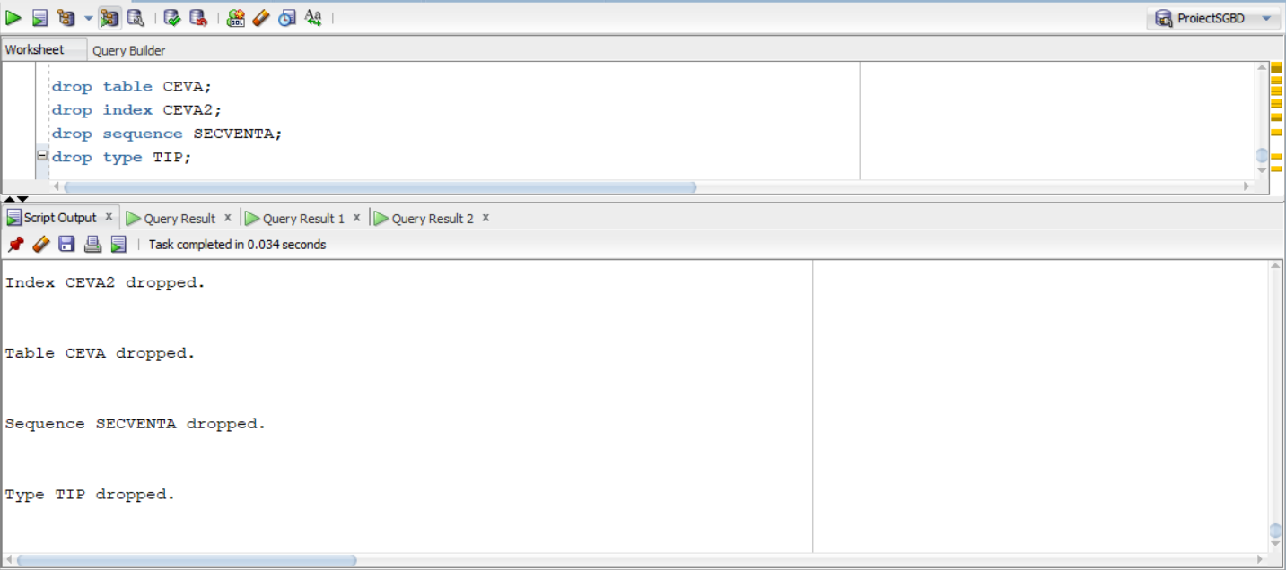

**Tabelele s-au modificat si ele aratand si instructiunile de drop pentru fiecare :**

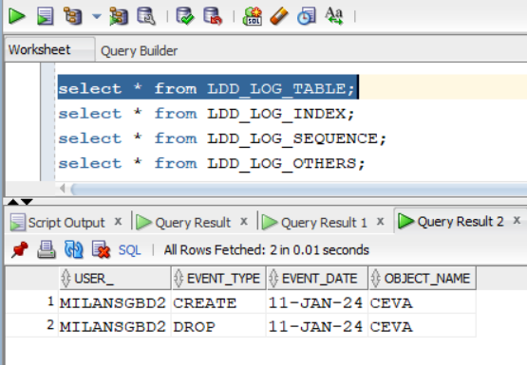 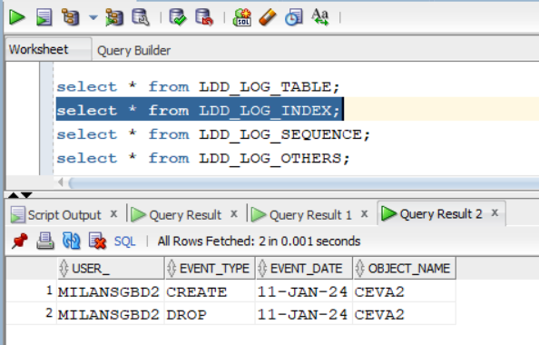

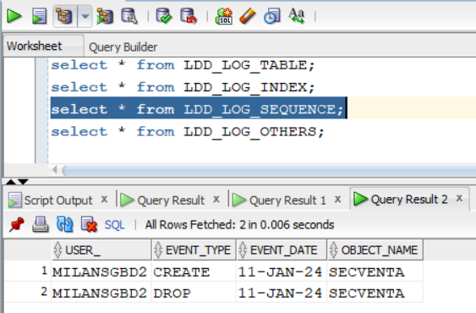 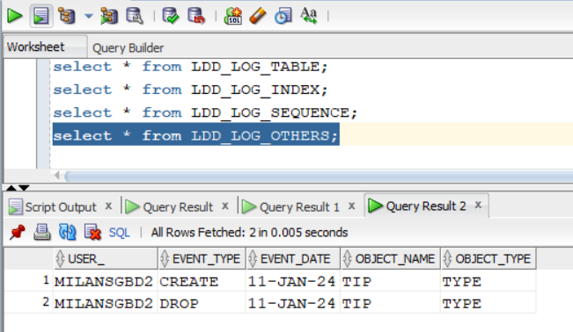

**Trigerul a fost declansat la fiecare create si drop in parte .**

# Cerinta 13. Definiți un pachet care să conțină toate obiectele definite în cadrul proiectului.

|  |
| --- |
| **create** **or** **replace** package pachet13 **as**  **procedure** Problema6;  **procedure** Problema7;  **function** Problema8 (v_nume Personalcivil.nume%**TYPE**) **return** number;  **procedure** Problema9 ( nume_comandant Comandant.nume%**TYPE** );  **end** pachet13;  /  **create** **or** **replace** package body pachet13 **as**  -----------------------------------------------------------------------------------------  -- aici incepe procedura de la problema 6  **procedure** Problema6 **is**  **type** tablou_indexat **is** **table** **of** Personalmilitar%ROWTYPE **index** **by** pls_integer;  **type** tablou_imbricat **is** **table** **of** Unitatemilitara%ROWTYPE;  **type** vector1 **is** varray(**50**) **of** Comandant%ROWTYPE;  **type** vector2 **is** varray(**100**) **of** Vehicul%ROWTYPE;  **type** lista **is** varray(**100**) **of** number(**4**);    t_personal tablou_indexat;  t_unitate tablou_imbricat := tablou_imbricat();  v_comandant vector1 := vector1();  v_vehicul vector2 := vector2();  list_random lista := lista();  list_idcomand lista := lista();    v_cnt1 number(**3**) := **1**;  nr_random number(**3**);    idunit Unitatemilitara.IDUnitatemilitara%**TYPE**;  lastid Unitatemilitara.IDUnitatemilitara%**TYPE**;  linieUnitate Unitatemilitara%ROWTYPE;  linieComandant Comandant%ROWTYPE;  idcomand Comandant.IDComandant%**TYPE**;  ok number(**1**) := **0**;  continui number(**1**) := **0**;    **begin**    -----------------------------------------------------------  **select** *  bulk collect **into** t_personal  **from** Personalmilitar  **where** data_inscrierii >= TO_DATE('01-JAN-2015', 'DD-MON-YYYY')  **order** **by** IDUnitatemilitara;  -----------------------------------------------------------  lastid := **0**;    **for** i **in** t_personal.**first**..t_personal.**last** loop  idunit := t_personal(i).IDUnitatemilitara;    **select** *  **into** linieUnitate  **from** Unitatemilitara  **where** IDUnitatemilitara = idunit;    if idunit = lastid **then**  **continue**;  **end** if;    t_unitate.extend();  t_unitate(t_unitate.**last**) := linieUnitate;    lastid := idunit;  **end** loop;  -----------------------------------------------------------  v_cnt1 := **1**;    **for** i **in** t_unitate.**first**..t_unitate.**last** loop  idcomand := t_unitate(i).IDComandant;    continui := **0**;  if v_comandant.**count** > **0** **then**  **for** j **in** v_comandant.**first**..v_comandant.**last** loop  if v_comandant(j).IDComandant = idcomand **then**  continui := **1**;  **end** if;  **end** loop;  **end** if;      if continui = **1** **then**  **continue**;  **end** if;    **select** *  **into** linieComandant  **from** Comandant  **where** IDComandant = idcomand;    v_comandant.extend();  v_comandant(v_cnt1) := linieComandant;  v_cnt1 := v_cnt1 + **1**;    **end** loop;  v_cnt1 := v_cnt1 - **1**;    -----------------------------------------------------------    **select** *  bulk collect **into** v_vehicul  **from** Vehicul  **where** **lower**(Vehicul.stare) = 'excelent';    -----------------------------------------------------------    **for** i **in** v_comandant.**first**..v_comandant.**last** loop  -- comandantului i vreau sa-i atribui un vehicul la intamplare    ok := **0**;  while ok = **0** loop  nr_random := DBMS_RANDOM.VALUE(low => **1**, high => v_vehicul.**last**);  ok := **1**;  if list_random.**count** > **0** **then**  **for** j **in** list_random.**first**..list_random.**last** loop  if nr_random = list_random(j) **then**  ok := **0**;  **end** if;  **end** loop;  **end** if;    **end** loop;    list_random.extend();  list_random(list_random.**last**()) := nr_random;    dbms_output.put_line('Comandantului ''' || v_comandant(i).IDComandant || ' ' || v_comandant(i).nume || ' ' || v_comandant(i).prenume || ''' ii este atribuit vehiculul cu id-ul ' || v_vehicul(nr_random).idvehicul);    **end** loop;      **end** Problema6;  -----------------------------------------------------------------------------------------  -----------------------------------------------------------------------------------------  -- aici incepe procedura de la problema 7  **procedure** Problema7 **is**  **cursor** c1 **is** ( **select** **distinct**(d.IDDepartament), d.Nume_departament  **from** Departament d, Misiune m  **where** d.IDDepartament = m.IDDepartament );  **cursor** c2 ( id_dep Departament.IDDepartament%**TYPE** ) **is**  ( **select** nume, prenume  **from** Personalcivil  **where** IDDepartament = id_dep **and** varsta >= **30** );  idDep Departament.IDDepartament%**TYPE**;  numeDep Departament.Nume_departament%**TYPE**;  numePers Personalcivil.nume%**TYPE**;  prenumePers Personalcivil.prenume%**TYPE**;    **begin**  **open** c1;  loop  **fetch** c1 **into** idDep, numeDep;  exit **when** c1%NOTFOUND;    dbms_output.put_line(idDep || ' - ' || numeDep);  dbms_output.put_line('Angajatii:');  **for** personal **in** c2(idDep) loop  numePers := personal.nume;  prenumePers := personal.prenume;  dbms_output.put_line(numePers || ' ' || prenumePers);  **end** loop;  dbms_output.new_line();    **end** loop;  **close** c1;    **end** Problema7;  -----------------------------------------------------------------------------------------  -----------------------------------------------------------------------------------------  -- aici incepe functia de la problema 8  **function** Problema8 (v_nume Personalcivil.nume%**TYPE**) **return** number **is**  count_nume number(**3**) := **0**;  nr_misiuni number(**3**) := **0**;    NICIUN_NUME exception;  PREA_MULTI exception;  **begin**  **select** **count**(p.prenume)  **into** count_nume  **from** Departament d, Personalcivil p  **where** p.IDDepartament = d.IDDepartament **and**  **lower**(p.nume) = **lower**(v_nume);    if count_nume = **0** **then**  raise NICIUN_NUME;  **end** if;    if count_nume > **1** **then**  raise PREA_MULTI;  **end** if;    **select** **count**(m.IDMisiune)  **into** nr_misiuni  **from** Misiune m, Departament d, Personalcivil p  **where** p.IDDepartament = d.IDDepartament **and**  d.IDDepartament = m.IDDepartament **and**  **lower**(p.nume) = **lower**(v_nume);    **return** nr_misiuni;    exception  **when** NICIUN_NUME **then** raise_application_error(-**20005**,'Nu s-a gasit niciun angajat cu numele ' || **upper**(v_nume) );  **when** PREA_MULTI **then** raise_application_error(-**20006**,'Exista mai multi angajati cu numele ' || **upper**(v_nume) );    **end** Problema8;  -----------------------------------------------------------------------------------------  -----------------------------------------------------------------------------------------  -- aici incepe procedura de la problema 9  **procedure** Problema9 ( nume_comandant Comandant.nume%**TYPE** ) **is**  **type** tablou_indexat **is** **table** **of** Furnizorechipament%ROWTYPE **index** **by** pls_integer;    lista_furnizori tablou_indexat;  nume_aux Furnizorechipament.nume%**TYPE**;    nr_comandanti number(**3**) := **0**;  **begin**    **select** **count**(**distinct**(**c**.idcomandant))  **into** nr_comandanti  **from** comandant **c**,unitatemilitara u, personalmilitar p, echipament e, furnizorechipament f  **where** **c**.IDComandant = u.IDComandant **and**  u.IDUnitatemilitara = p.IDUnitatemilitara **and**  p.IDPersonalmilitar = e.IDPersonalmilitar **and**  e.IDFurnizor = f.IDFurnizor **and**  **lower**(**c**.nume) = **lower**(nume_comandant);      if nr_comandanti = **0** **then**  raise NO_DATA_FOUND;  **end** if;    if nr_comandanti > **1** **then**  raise TOO_MANY_ROWS;  **end** if;    **select** f.*  bulk collect **into** lista_furnizori  **from** comandant **c**,unitatemilitara u, personalmilitar p, echipament e, furnizorechipament f  **where** **c**.IDComandant = u.IDComandant **and**  u.IDUnitatemilitara = p.IDUnitatemilitara **and**  p.IDPersonalmilitar = e.IDPersonalmilitar **and**  e.IDFurnizor = f.IDFurnizor **and**  **lower**(**c**.nume) = **lower**(nume_comandant);    **for** i **in** lista_furnizori.**first**..lista_furnizori.**last** loop  nume_aux := lista_furnizori(i).nume;  **for** j **in** **1**..i-**1** loop  if lista_furnizori(j).nume = **null** **then**  **continue**;  **end** if;  if lista_furnizori(j).nume = nume_aux **then**  lista_furnizori(j).nume := **null**;  **end** if;  **end** loop;  **end** loop;    **for** i **in** lista_furnizori.**first**..lista_furnizori.**last** loop  if lista_furnizori(i).nume **is** **null** **then**  **continue**;  **end** if;  dbms_output.put_line('Nume: ' || lista_furnizori(i).nume || ', tel: ' || lista_furnizori(i).telefon);  **end** loop;    exception  **when** NO_DATA_FOUND **then** raise_application_error(-**20015**,'Nu s-a gasit niciun comandant cu numele ' || **upper**(nume_comandant) );  **when** TOO_MANY_ROWS **then** raise_application_error(-**20016**,'Exista mai multi comandanti cu numele ' || **upper**(nume_comandant) );    **end** Problema9;    **end** pachet13;  /  **begin**  dbms_output.put_line('*PROBLEMA 6 INCEPE AICI*');  dbms_output.new_line();  pachet13.Problema6;  dbms_output.new_line();  dbms_output.put_line('*PROBLEMA 7 INCEPE AICI*');  dbms_output.new_line();  pachet13.Problema7;  dbms_output.new_line();  dbms_output.put_line('*PROBLEMA 8 INCEPE AICI*');  dbms_output.new_line();  dbms_output.put_line(pachet13.Problema8('Sofron'));  dbms_output.new_line();  dbms_output.put_line('*PROBLEMA 9 INCEPE AICI*');  dbms_output.new_line();  pachet13.Problema9('Stoica');  **end**;  / |

**Capturile de ecran cu codul precum si outputul :**

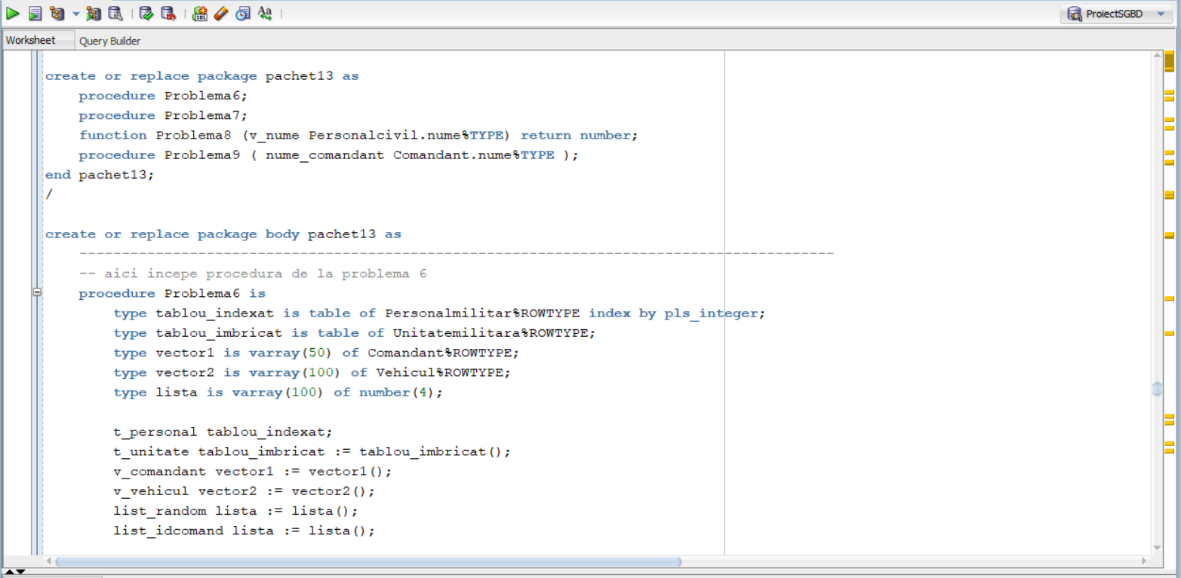

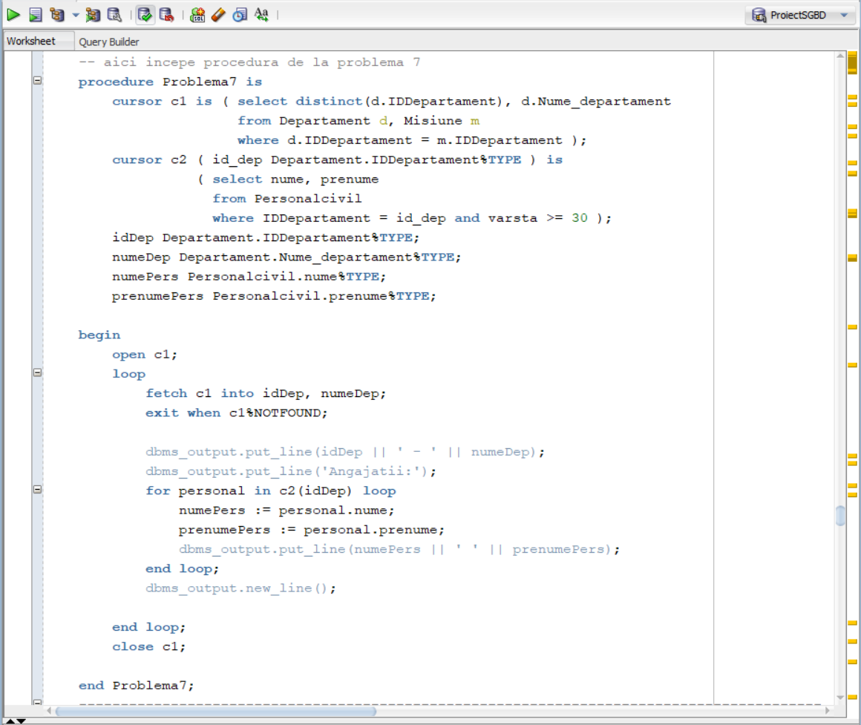

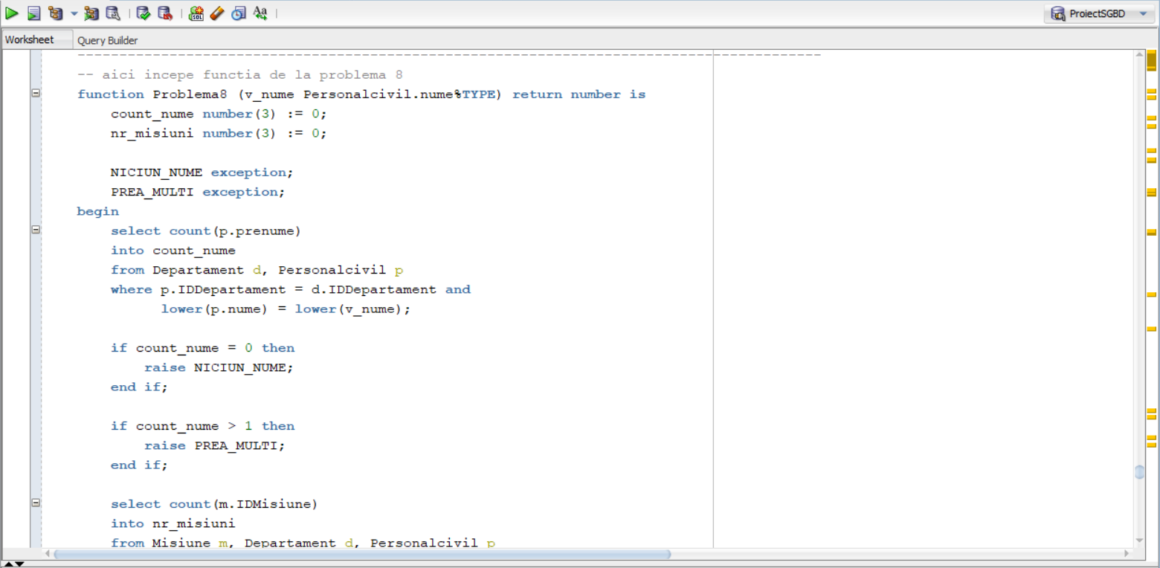

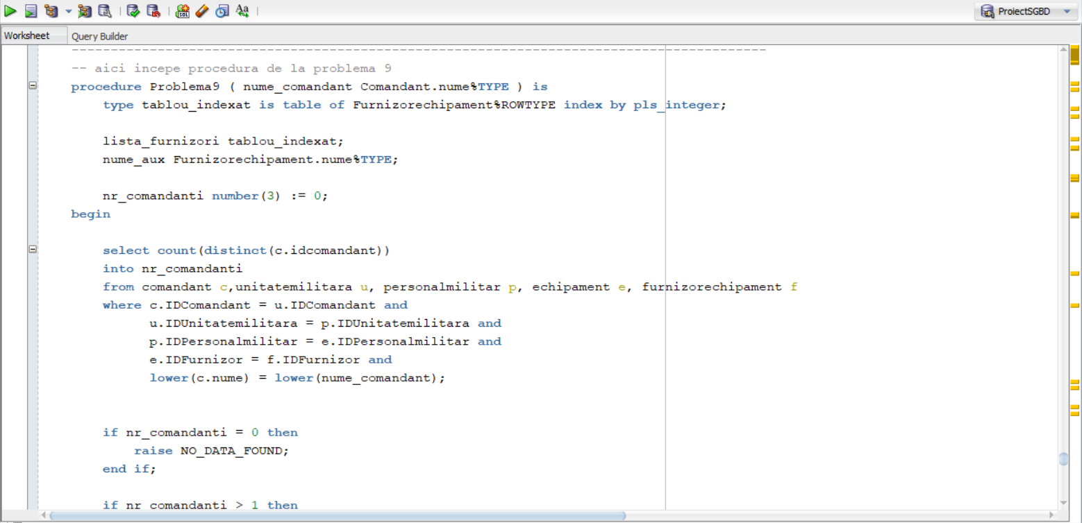

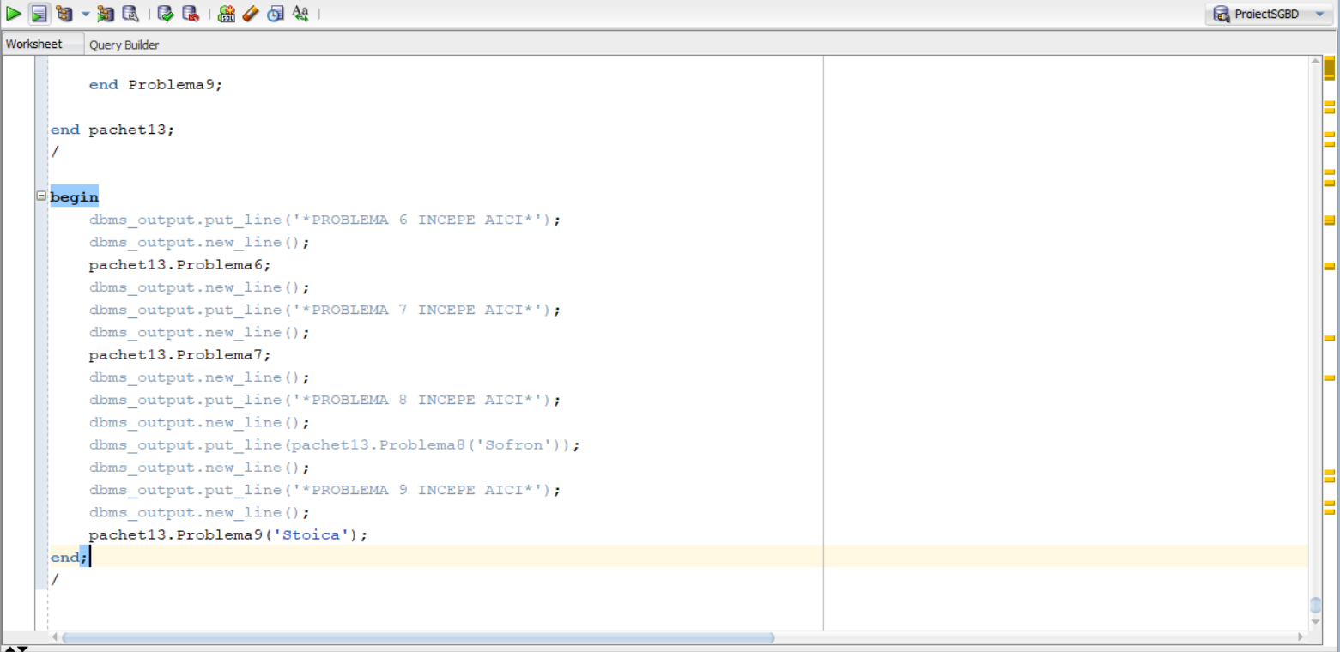





**Outputul in urma apelarii procedurilor si functiei prin intermediul pachetului este:**

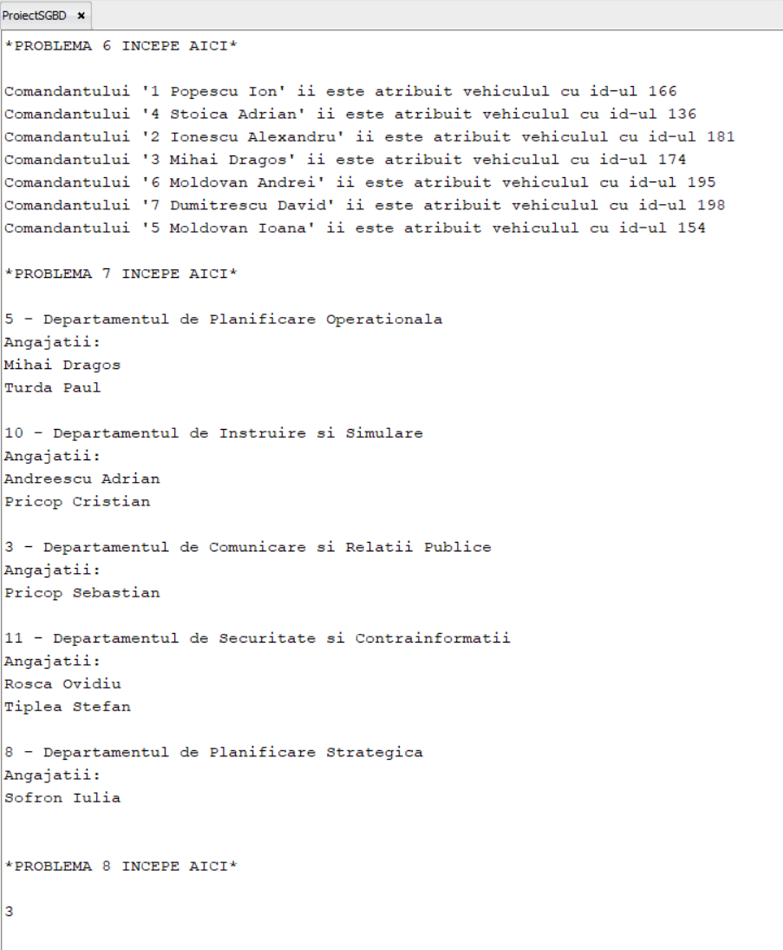 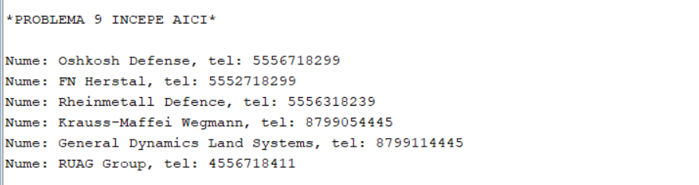

# Cerinta 14. Definiți un pachet care să includă tipuri de date complexe și obiecte necesare unui flux de acțiuni integrate, specifice bazei de date definite (minim 2 tipuri de date, minim 2 funcții, minim 2 proceduri).

Am facut pachetul **‘Problema14’** care contine **2 tipuri** ( PersonalType – care retine cateva informatii despre un personal militar si UnitateMilitaraType – care retine informatii despre unitati militare ) , **2 functii** ( CalculeazaUrmatorulGrad – care pentru un grad dat calculeaza urmatorul grad in ierarhie , tratand exceptia in care incercam sa calculam urmatorul grad dupa cel mai mare ( General ) , si GetPersonalByID care imi returneaza PersonalType -ul aferent ID-ului introdus ca parametru ) , si **3 proceduri** ( UpdatePersonalGrad – care updateaza in tabelul PersonalMilitar gradul personalului dat prin id , AfisPersonalMilitarInformatii – care afiseaza informatii legate de un personal militar, si AfisUnitateMilitaraInformatii – care afiseaza informatii legate de o unitate militara data prin ID ) .

Codul :

|  |
| --- |
| **create** **or** **replace** package Problema14 **as**  -- Tipuri de date  **type** PersonalType **is** record (  PersonalID number,  Nume varchar2(**50**),  Prenume varchar2(**50**),  GradMilitar varchar2(**50**)  );  **type** UnitateMilitaraType **is** record (  UnitateID number,  Denumire varchar2(**50**),  Locatie varchar2(**50**)  );    -- Functii  **function** CalculeazaUrmatorulGrad ( prev_grad varchar2 ) **return** varchar2;  **function** GetPersonalByID ( id_personal number ) **return** PersonalType;    -- Proceduri  **procedure** UpdatePersonalGrad ( id_personal number, nou_grad varchar2 );  **procedure** AfisPersonalMilitarInformatii ( pers PersonalType );  **procedure** AfisUnitateMilitaraInformatii ( id_unitate number );    **end** Problema14;  /  **select** * **from** personalmilitar;  **create** **or** **replace** package body Problema14 **as**  -- implementare functii :  **function** CalculeazaUrmatorulGrad ( prev_grad varchar2 ) **return** varchar2 **is**  nume_grad varchar2(**50**);  **begin**  nume_grad := prev_grad;    if **lower**(nume_grad) = 'general' **then**  raise_application_error(-**20051**, 'Nu exista un grad mai mare de General');  **end** if;    if **lower**(nume_grad) = 'colonel' **then**  nume_grad := 'General';  elsif **lower**(nume_grad) = 'maior' **then**  nume_grad := 'Colonel';  elsif **lower**(nume_grad) = 'locotenent' **then**  nume_grad := 'Maior';  elsif **lower**(nume_grad) = 'sublocotenent' **then**  nume_grad := 'Locotenent';  elsif **lower**(nume_grad) = 'sergent' **then**  nume_grad := 'Sublocotenent';  **end** if;    **return** nume_grad;  **end** CalculeazaUrmatorulGrad;  -------------------------------------------------------------------------------  **function** GetPersonalByID ( id_personal number ) **return** PersonalType **is**  v_personal PersonalType;  personalmilitarInformation Personalmilitar%ROWTYPE;  **begin**  **select** *  **into** personalmilitarInformation  **from** Personalmilitar  **where** IDPersonalmilitar = id_personal;    v_personal.PersonalID := personalmilitarInformation.IDPersonalmilitar;  v_personal.Nume := personalmilitarInformation.nume;  v_personal.Prenume := personalmilitarInformation.prenume;  v_personal.GradMilitar := personalmilitarInformation.grad;    **return** v_personal;  **end** GetPersonalByID;  --------------------------------------------------------------------------------  -- implementare proceduri  **procedure** UpdatePersonalGrad ( id_personal number, nou_grad varchar2 ) **is**  **begin**  **update** Personalmilitar  **set** grad = nou_grad  **where** IDPersonalmilitar = id_personal;  dbms_output.put_line('Am modificat gradul personalului cu ID ' || id_personal);  dbms_output.put_line('Noul grad: ' || nou_grad);  **end** UpdatePersonalGrad;    **procedure** AfisUnitateMilitaraInformatii ( id_unitate number ) **is**  v_unitate UnitateMilitaraType;  **begin**  **select** IDUnitatemilitara,Denumire,Locatie  **into** v_unitate  **from** Unitatemilitara  **where** IDUnitatemilitara = id_unitate;    dbms_output.put_line('Informatiile unitatii militare cu id ' || id_unitate || ' sunt urmatoarele :');  dbms_output.put_line('ID: ' || v_unitate.UnitateID);  dbms_output.put_line('Denumire: ' || v_unitate.Denumire);  dbms_output.put_line('Locatie: ' || v_unitate.Locatie);    **end** AfisUnitateMilitaraInformatii;    **procedure** AfisPersonalMilitarInformatii ( pers PersonalType ) **is**  v_pers PersonalType;  **begin**  v_pers := pers;    dbms_output.put_line('Informatiile personalului militar cu id ' || v_pers.PersonalID || ' sunt urmatoarele :');  dbms_output.put_line('ID: ' || v_pers.PersonalID);  dbms_output.put_line('Nume: ' || v_pers.Nume);  dbms_output.put_line('Prenume: ' || v_pers.Prenume);  dbms_output.put_line('Grad: ' || v_pers.GradMilitar);    **end** AfisPersonalMilitarInformatii;    **end** Problema14;  /  **select** * **from** personalmilitar;  **declare**  grad_vechi Personalmilitar.grad%**TYPE**;  grad_nou Personalmilitar.grad%**TYPE**;  id_pers Personalmilitar.IDPersonalmilitar%**TYPE**;  PersMilitar Problema14.PersonalType;  **begin**  id_pers := **100**;    **select** grad  **into** grad_vechi  **from** Personalmilitar  **where** IDPersonalmilitar = id_pers;    grad_nou := Problema14.CalculeazaUrmatorulGrad(grad_vechi);    Problema14.UpdatePersonalGrad(id_pers, grad_nou);  PersMilitar := Problema14.GetPersonalByID(id_pers);  Problema14.AfisPersonalMilitarInformatii(PersMilitar);  dbms_output.new_line();  Problema14.AfisUnitateMilitaraInformatii(**10**);  **end**;  /  **rollback**; |

**Ultimul block ( PL/SQL ) exemplifica funcitonalitatea acestui pachet .**

**Capturile de ecran cu codul precum si outputurile si functionalitatea :**

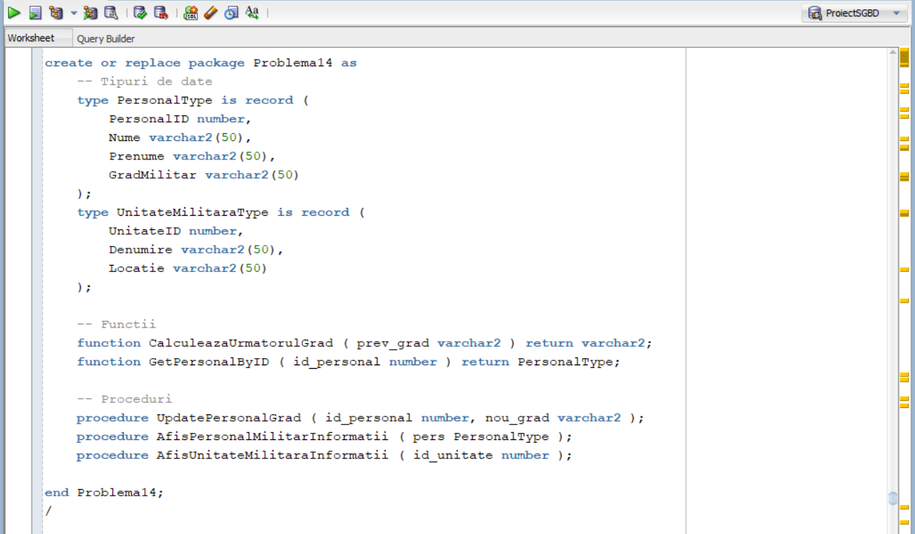

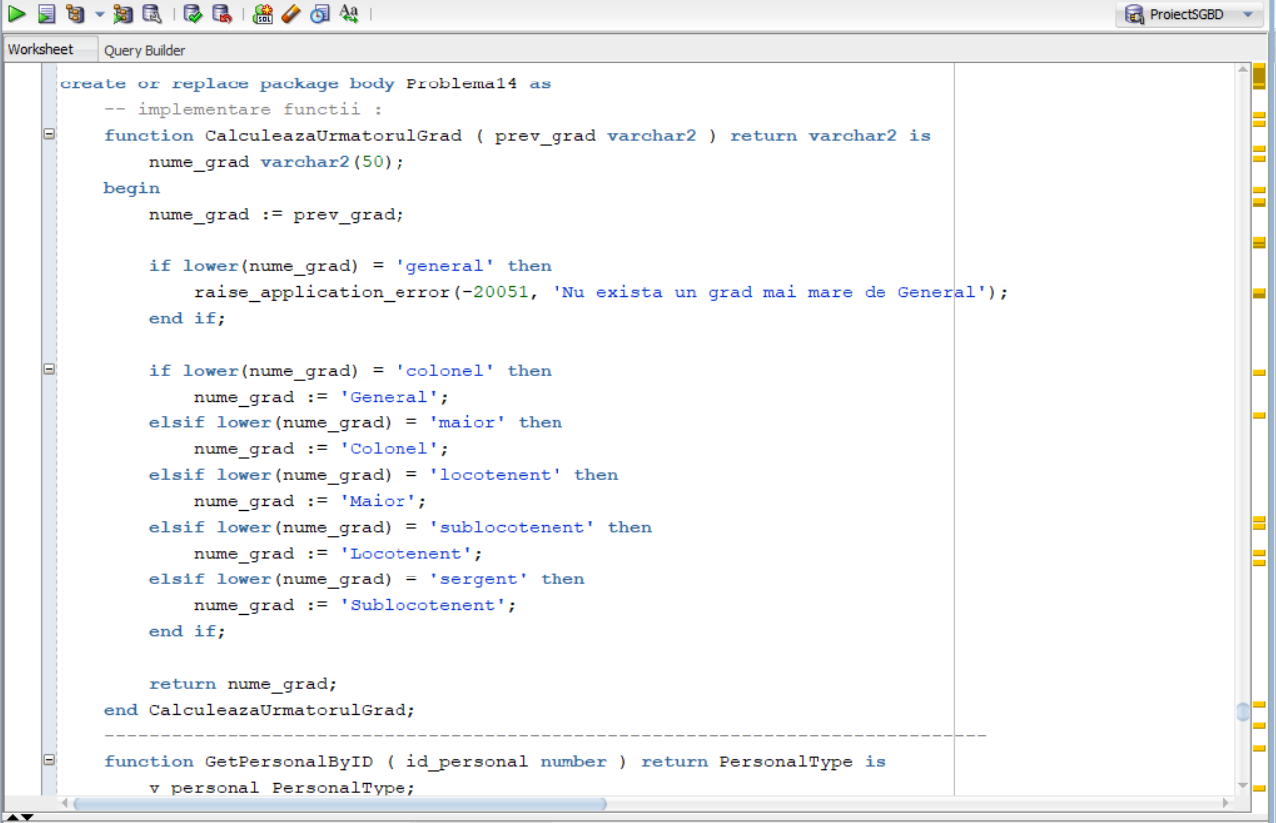

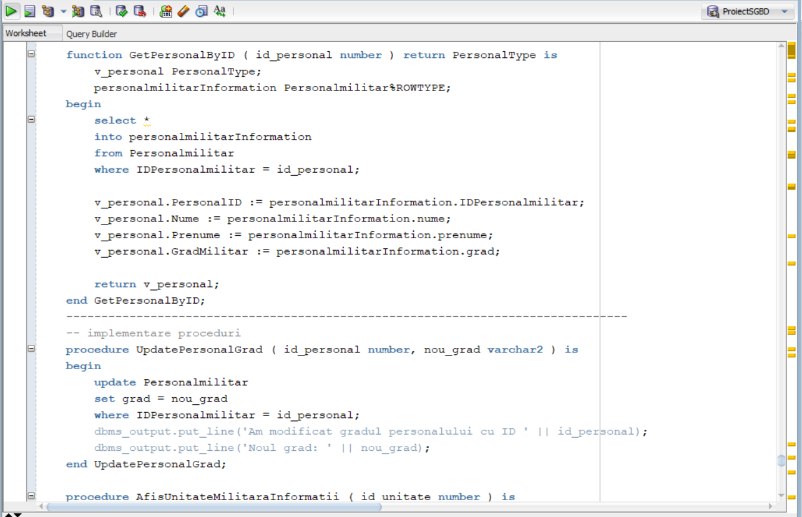

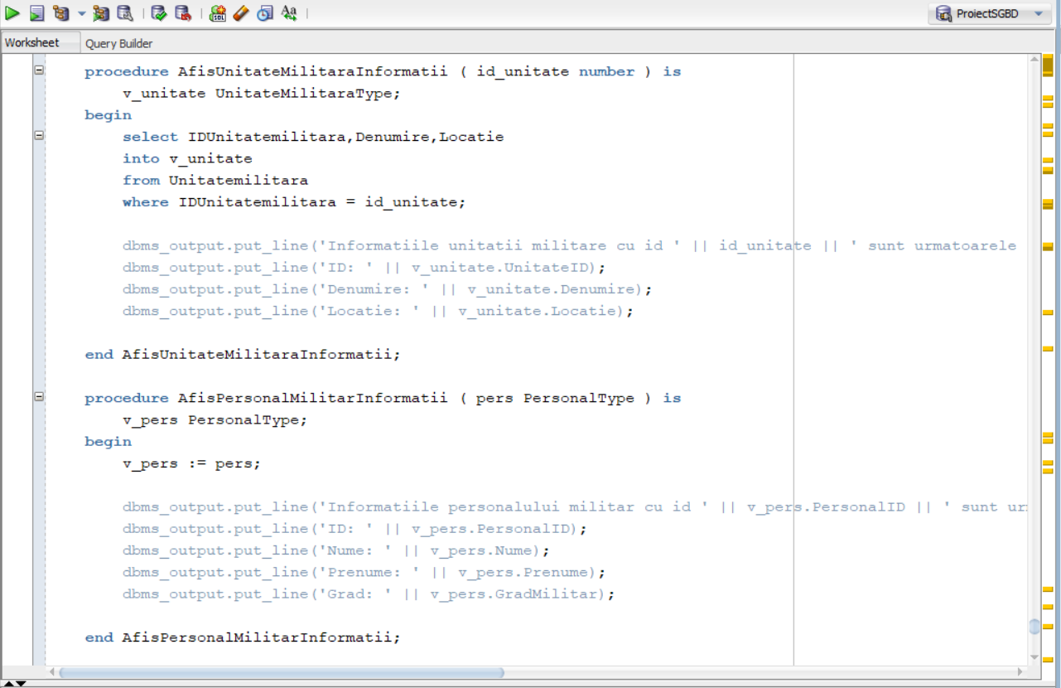

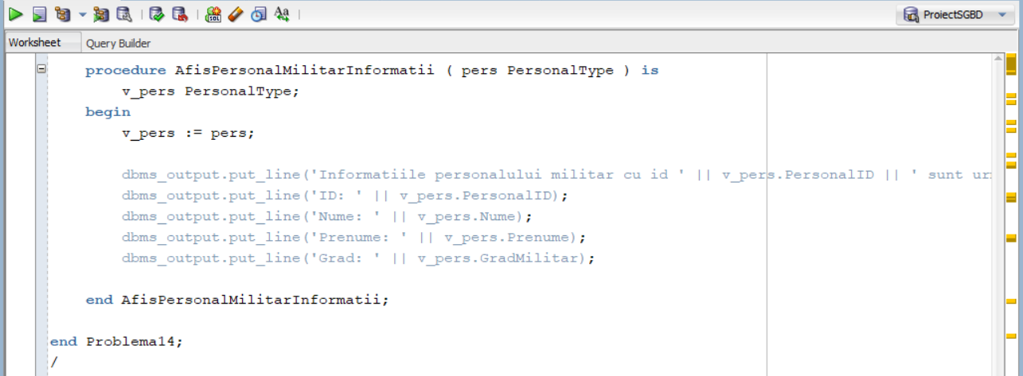

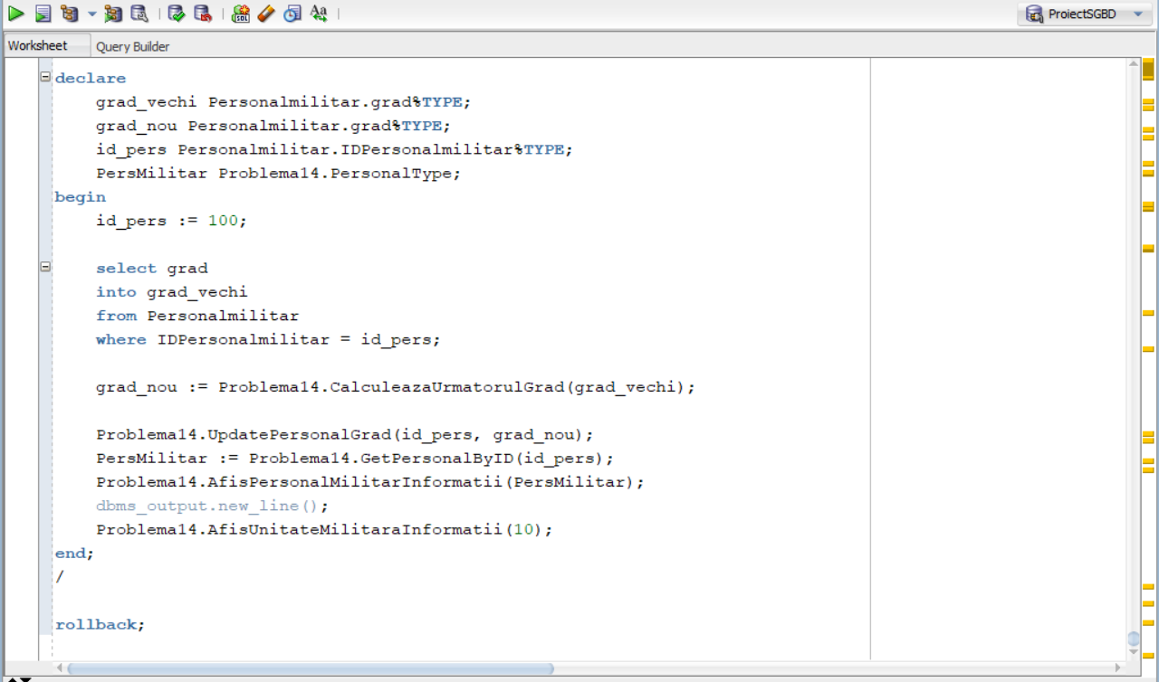

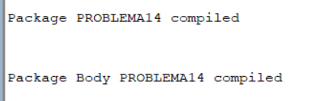

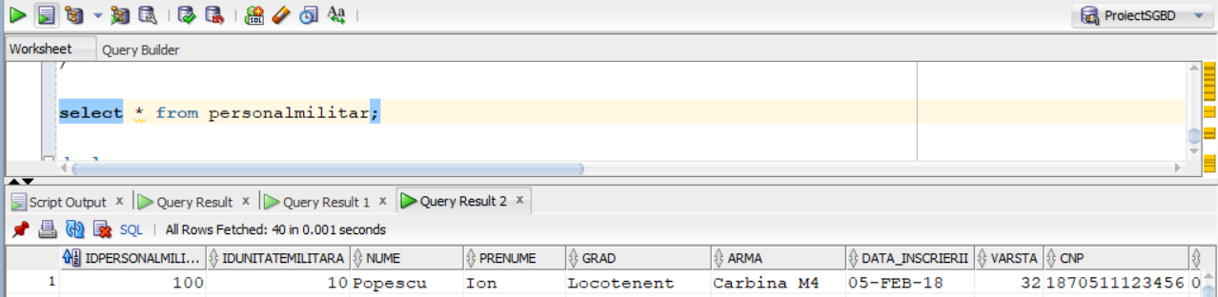

**Initial, in Personalmilitar , Popescu Ion (ID 100) este Locotenent**

**In ultimul bloc , facem ca , pentru personalul cu ID = 100 sa ii marim gradul o singura data , iar apoi afisam informatiile lui precum si informatiile unitatii militare cu IDUnitate = 10.**



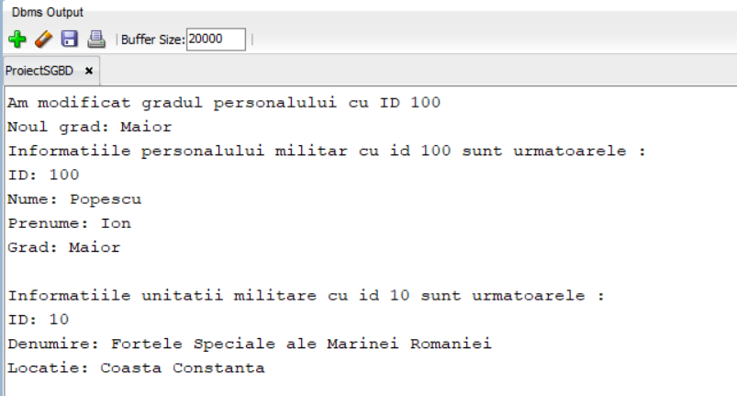

**Iar daca dam select din personalmilitar putem observa schimbarea:**

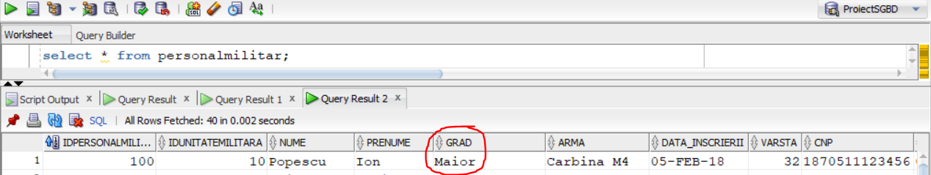

**Acum , vom executa din nou aceste operatii sa vedem cum gradul continua sa creasca :**



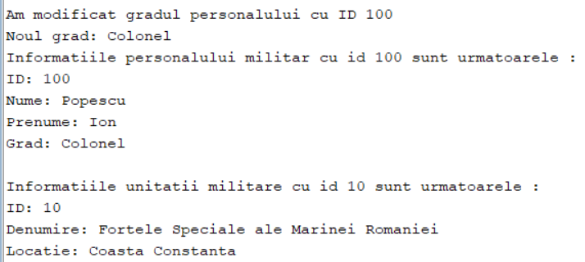

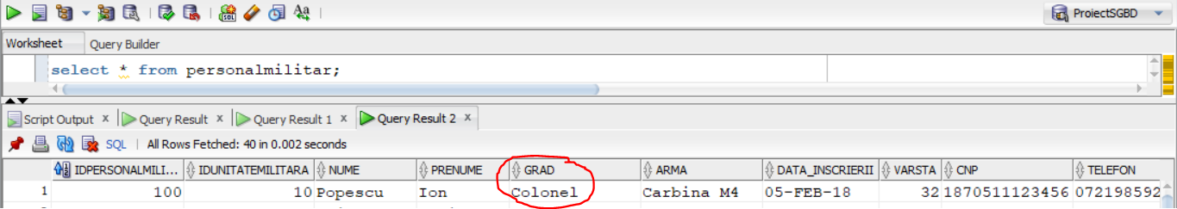

**Executam inca o data :**



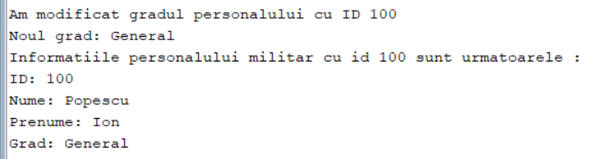

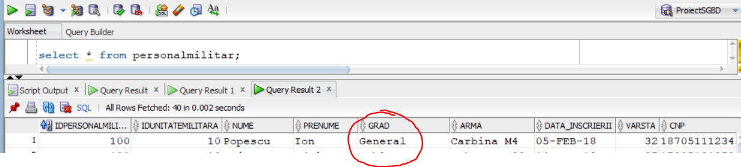

**Acum Popescu Ion este General , care este cel mai inalt grad.**

**Daca vom incerca executia blocului inca o data , o exceptie va fi aruncata deoarece nu putem mari gradul de General :**

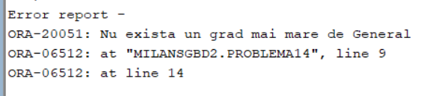

**Iar tabela PersonalMilitar nu a fost modificata**